Thursday, February 16, 2017

4:54 PM

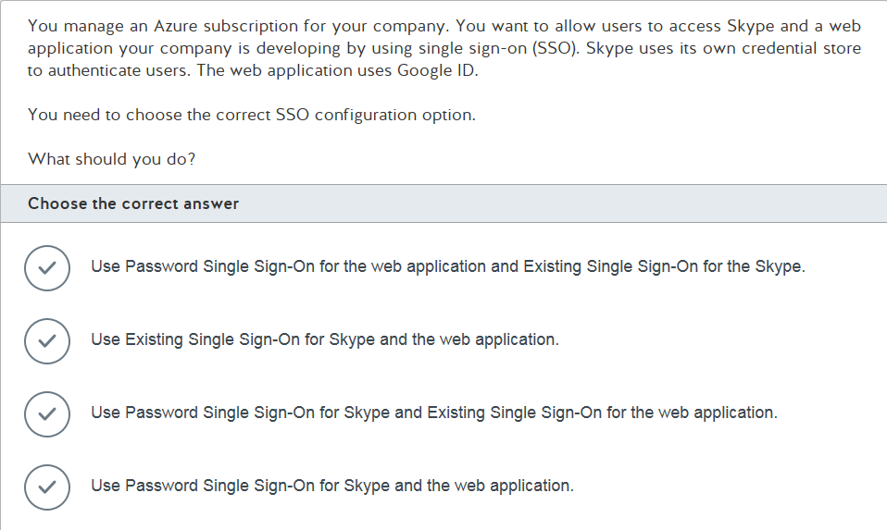

x

Thursday, February 16, 2017

4:58 PM

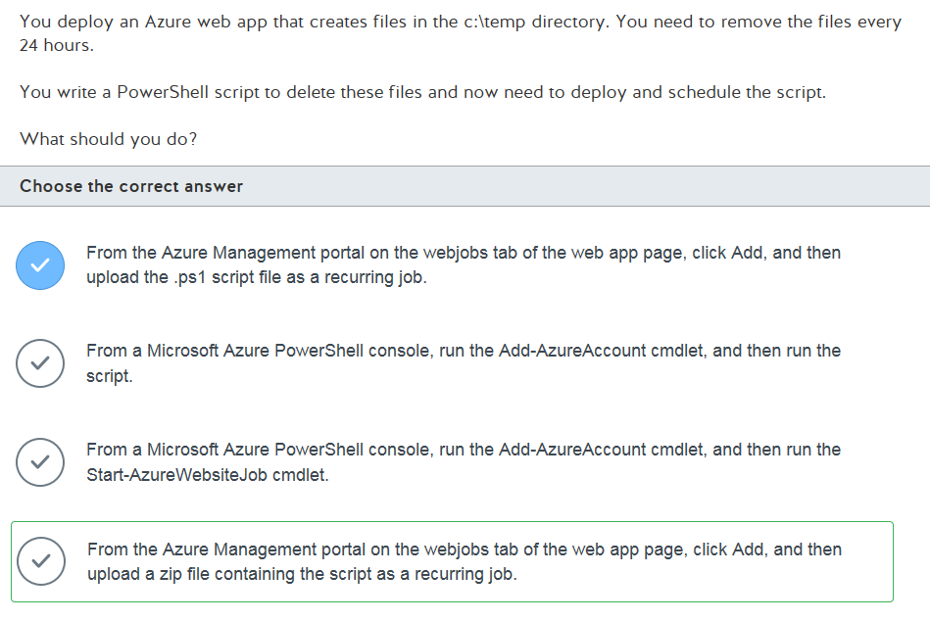

<https://blogs.msdn.microsoft.com/nicktrog/2014/01/22/running-powershell-web-jobs-on-azure-websites/>

<https://docs.microsoft.com/en-us/azure/app-service-web/web-sites-create-web-jobs>

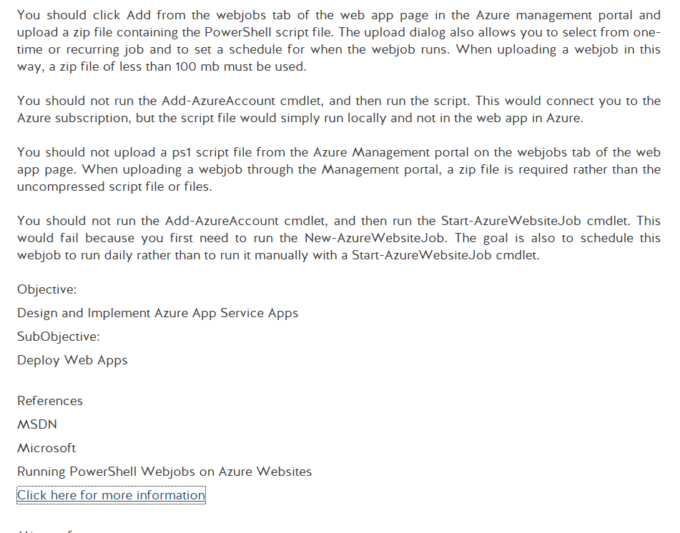

Thursday, February 16, 2017

5:01 PM

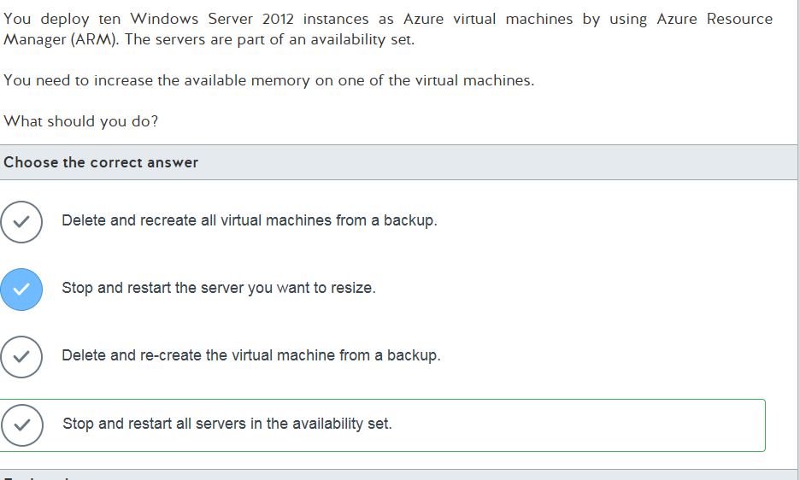

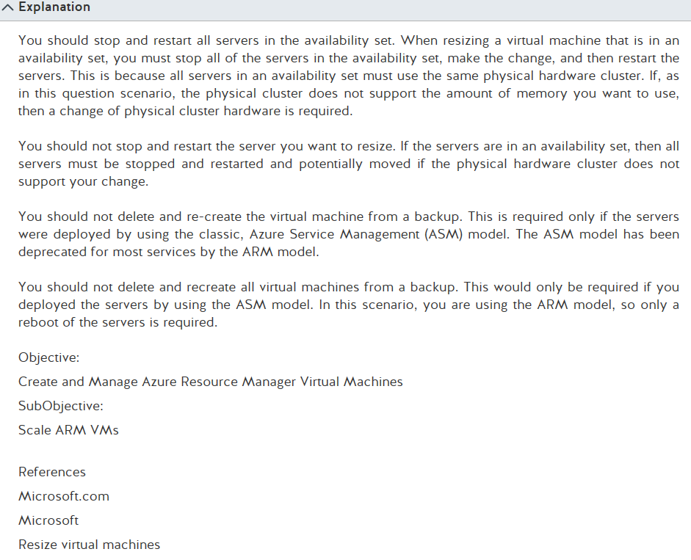

<https://azure.microsoft.com/en-us/blog/resize-virtual-machines/>

<https://docs.microsoft.com/en-us/azure/virtual-machines/windows/sql/virtual-machines-windows-sql-high-availability-dr>

Monday, February 20, 2017

2:13 PM

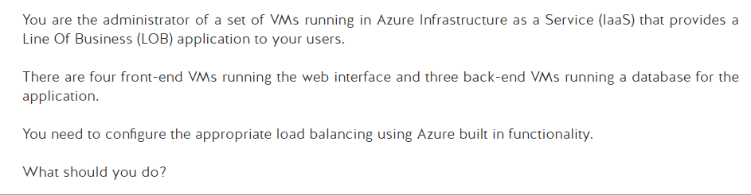

|  |  |
| --- | --- |
|  | Machine generated alternative text: Choose the correct answer  V  V  V  Configure the front-end VMS to run in one cloud service with internal load balancing.  Configure the back-end VMS to run in another cloud service with load balancing.  Configure all VMS in the same virtual network.  Configure the front-end VMS to run in one cloud service with load balancing.  Configure the back-end VMS to run in the same cloud service with internal load balancing.  Configure all VMS in the same virtual network.  Configure the front-end VMS to run in one cloud service with load balancing in one virtual network.  Configure the back-end VMS to run in another cloud service with internal load balancing in another  virtual neb,vork.  Configure the front-end VMS to run in one cloud service with internal load balancing in one virtual  net,vork.  Configure the back-end VMS to run in another cloud service with load balancing in another virtual  net,vork. |

Monday, February 20, 2017

2:37 PM

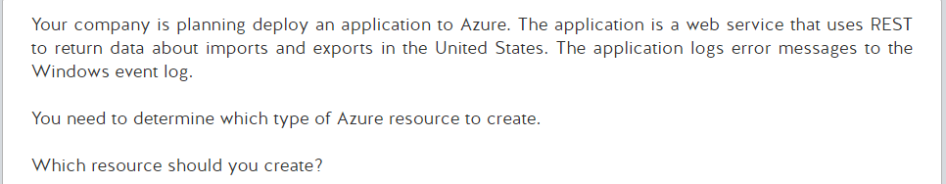

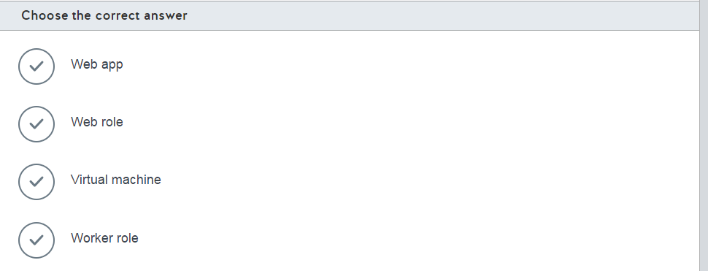

Monday, February 20, 2017

2:40 PM

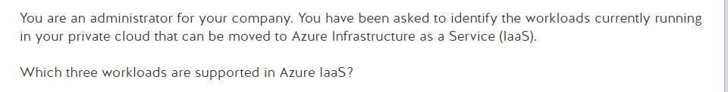

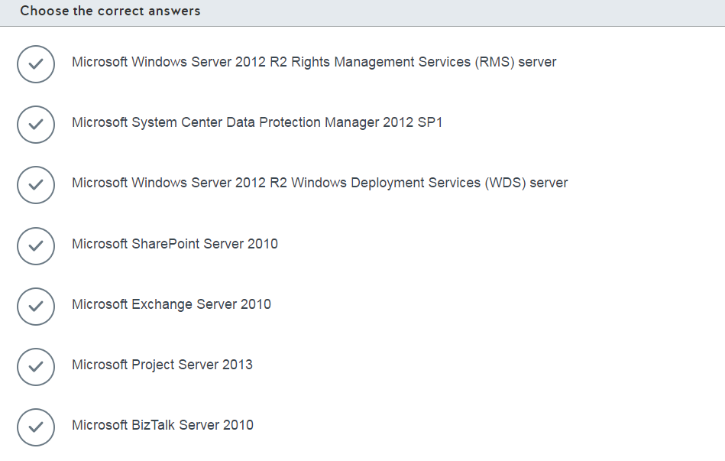

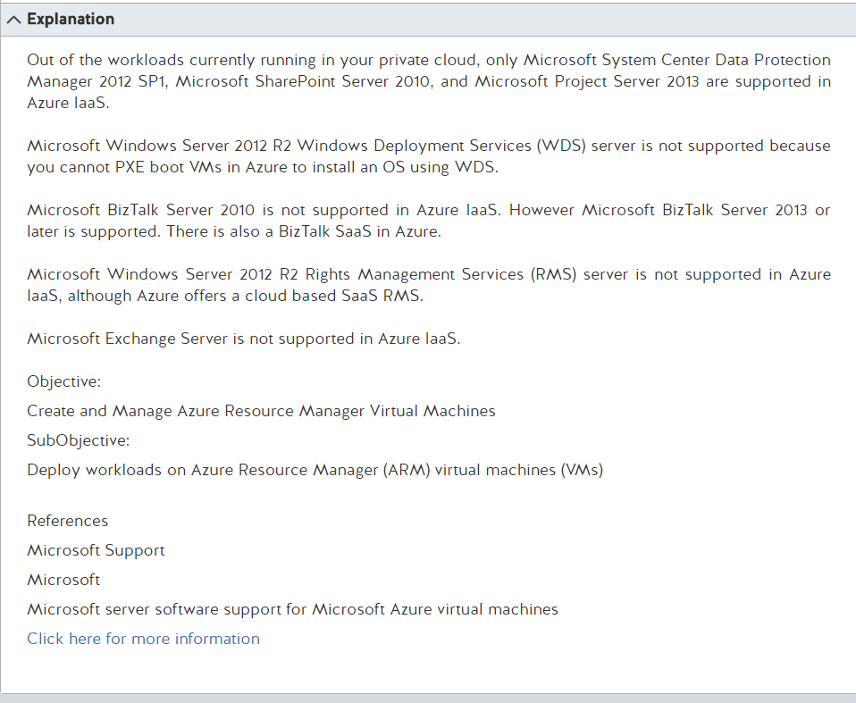

<https://support.microsoft.com/en-us/help/2721672/microsoft-server-software-support-for-microsoft-azure-virtual-machines>

Monday, February 20, 2017

2:56 PM

|  |  |
| --- | --- |
|  | Machine generated alternative text: You manage an on-premises network and an Azure subscription. Your environment does not use site-to-site,  point-to-site, or ExpressRoute connectivity.  You need to back up the data on the on-premises network to Azure Backup by using Data Protection  Manager (DPM).  In which two locations can you deploy DPM? Each correct answer presents a complete solution.  Choose the correct answers  A Hyper-V virtual machine in Azure.  An Azure virtual machine.  A Hyper-V virtual machine on the on-premises network.  A physical server on the on-premises network. |

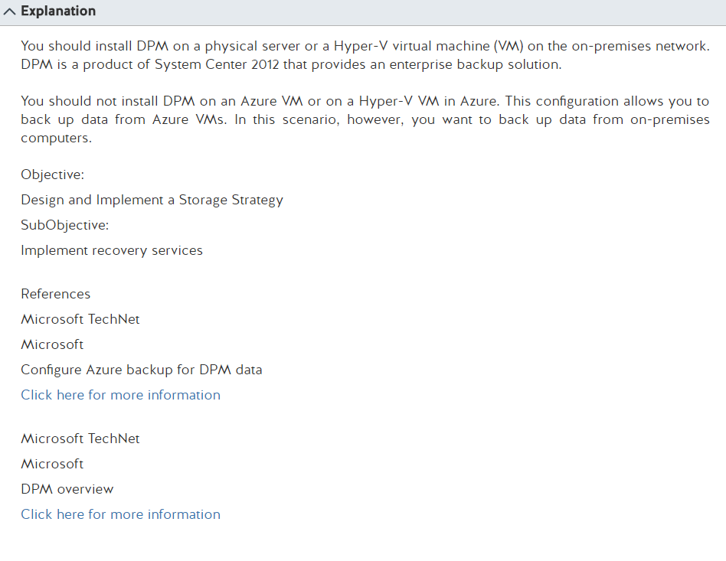

<https://technet.microsoft.com/en-us/library/jj728752.aspx>

<https://technet.microsoft.com/en-us/library/hh758104.aspx>

Monday, February 20, 2017

3:09 PM

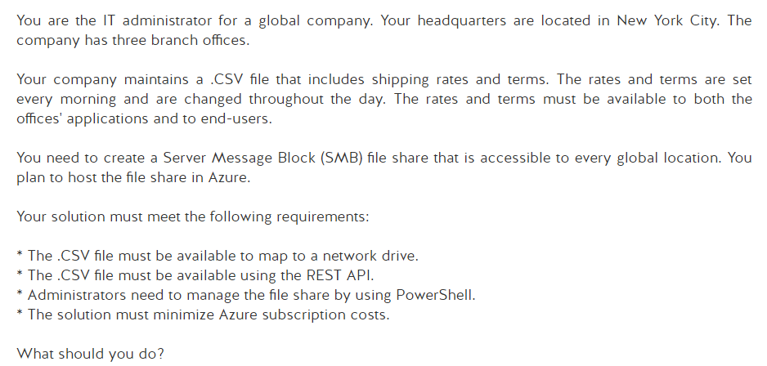

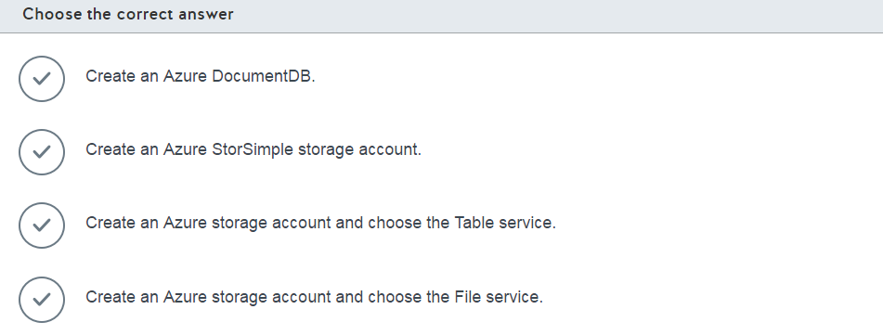

Monday, February 20, 2017

3:13 PM

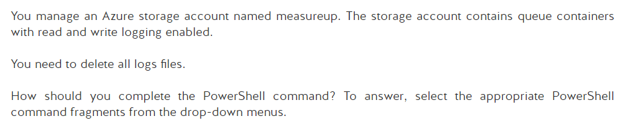

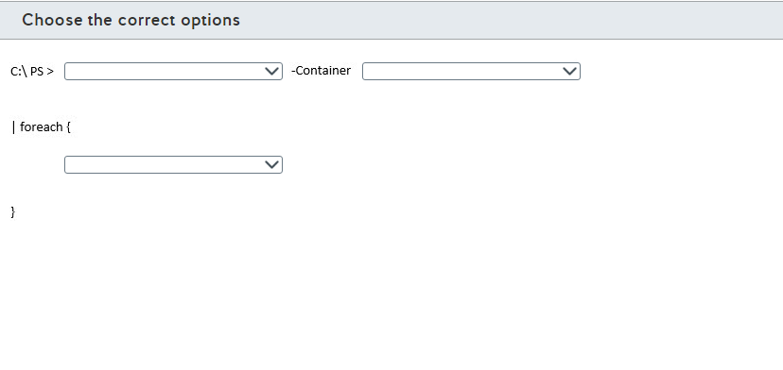

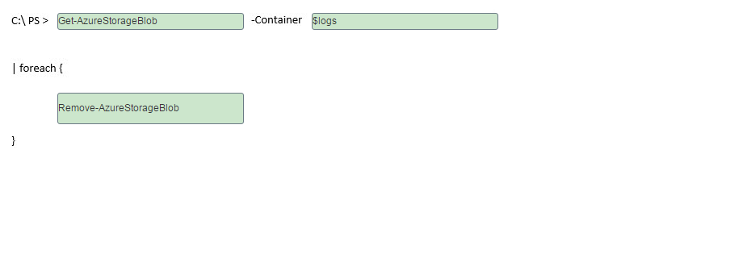

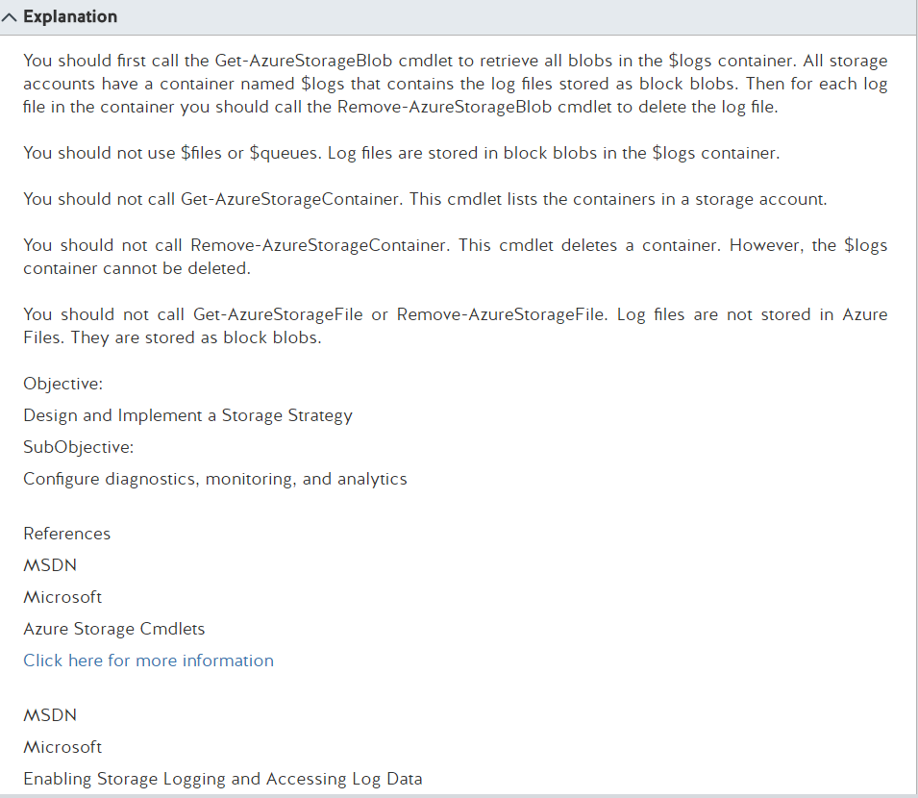

<https://docs.microsoft.com/en-us/powershell/storage/azure.storage/v2.1.0/azure.storage?redirectedfrom=msdn>

<https://docs.microsoft.com/en-us/rest/api/storageservices/fileservices/Enabling-Storage-Logging-and-Accessing-Log-Data?redirectedfrom=MSDN#DownloadingStorageLogginglogdata>

<https://docs.microsoft.com/en-us/rest/api/storageservices/fileservices/About-Storage-Analytics-Logging?redirectedfrom=MSDN>

Tuesday, February 21, 2017

8:25 AM

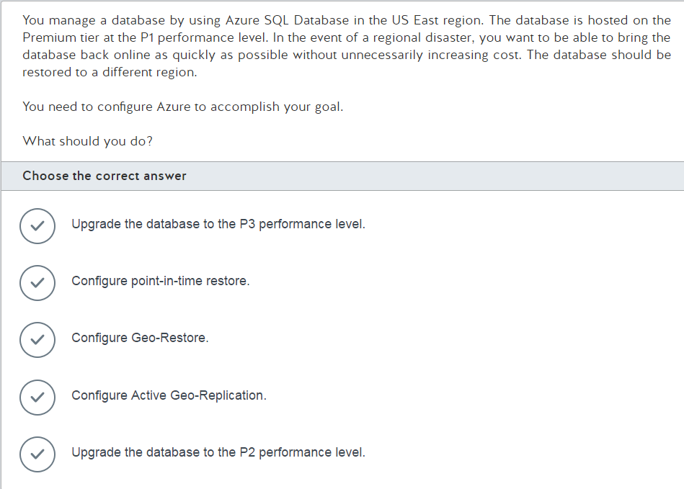

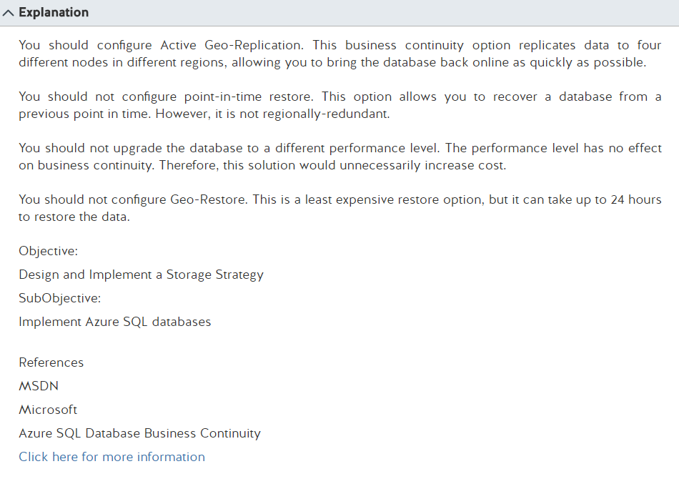

<https://docs.microsoft.com/en-us/azure/sql-database/sql-database-business-continuity>

Tuesday, February 21, 2017

8:30 AM

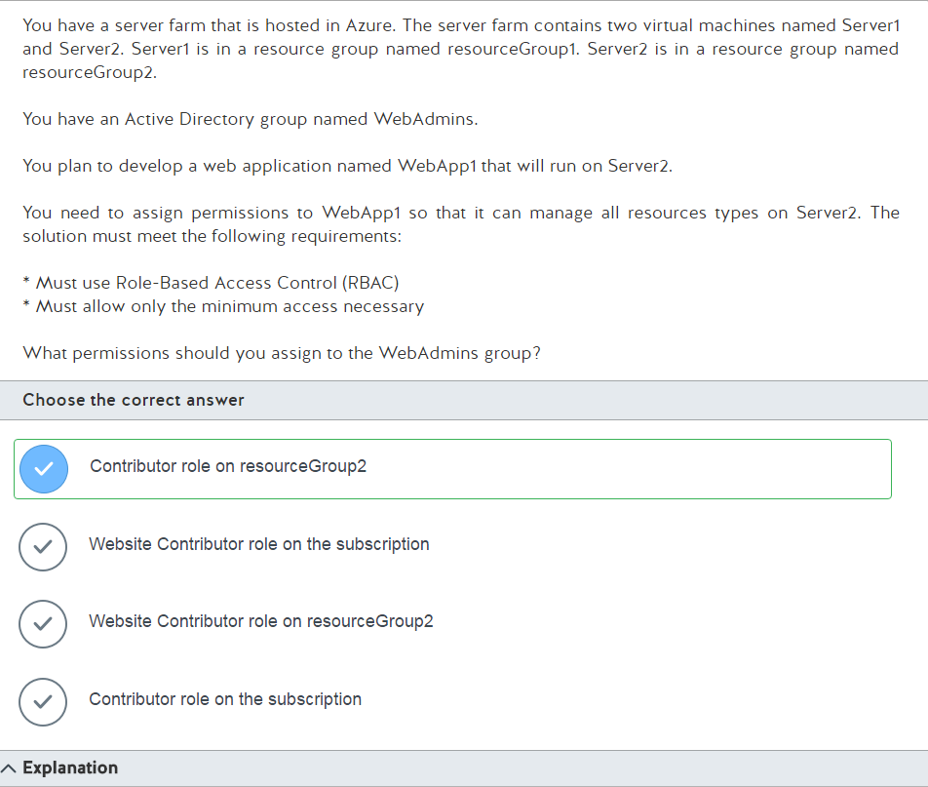

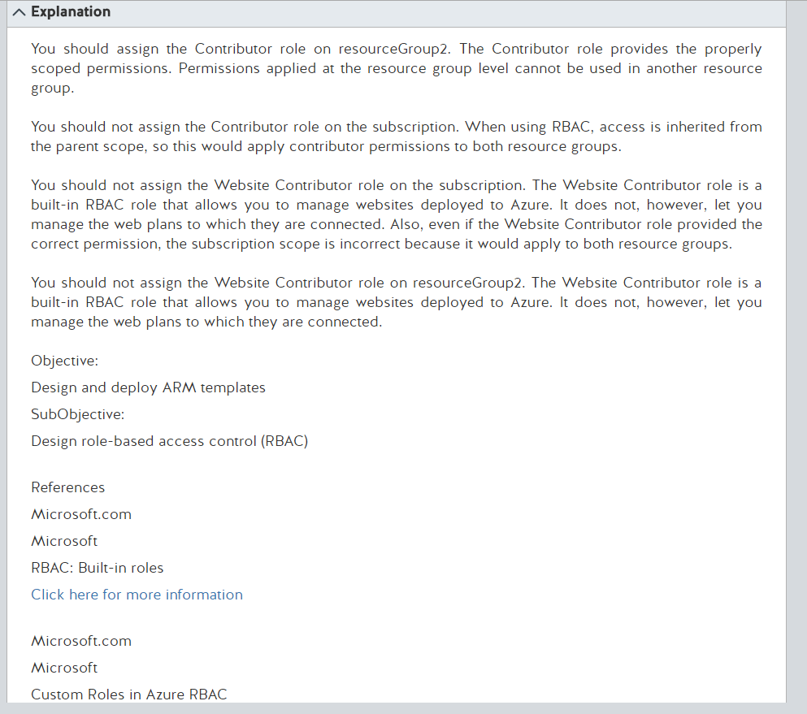

<https://docs.microsoft.com/en-us/azure/active-directory/role-based-access-built-in-roles>

<https://docs.microsoft.com/en-us/azure/active-directory/role-based-access-control-custom-roles>

Tuesday, February 21, 2017

8:34 AM

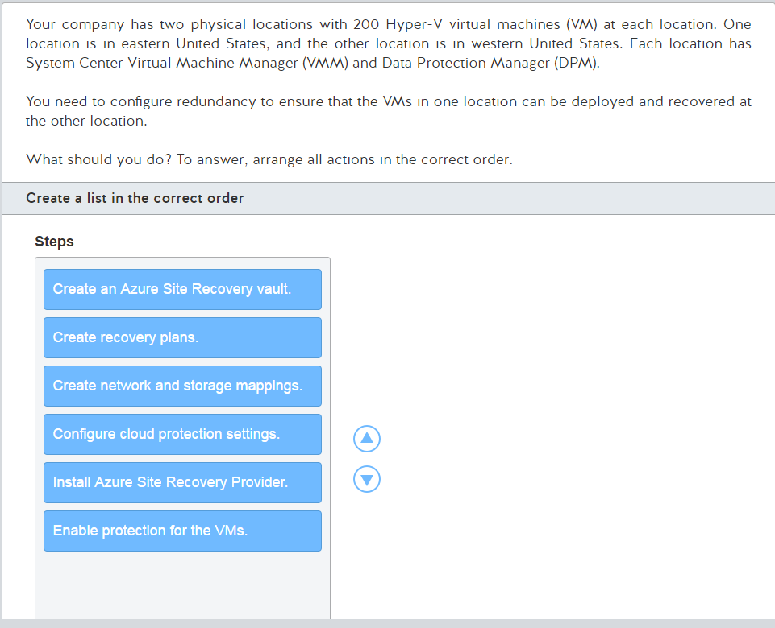

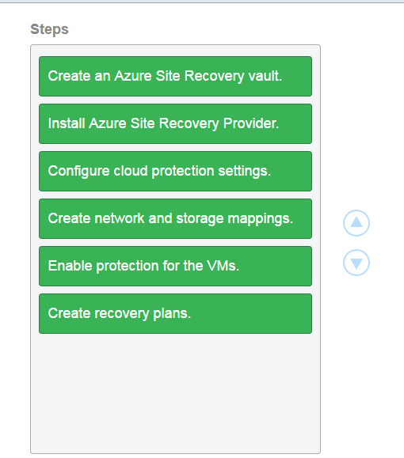

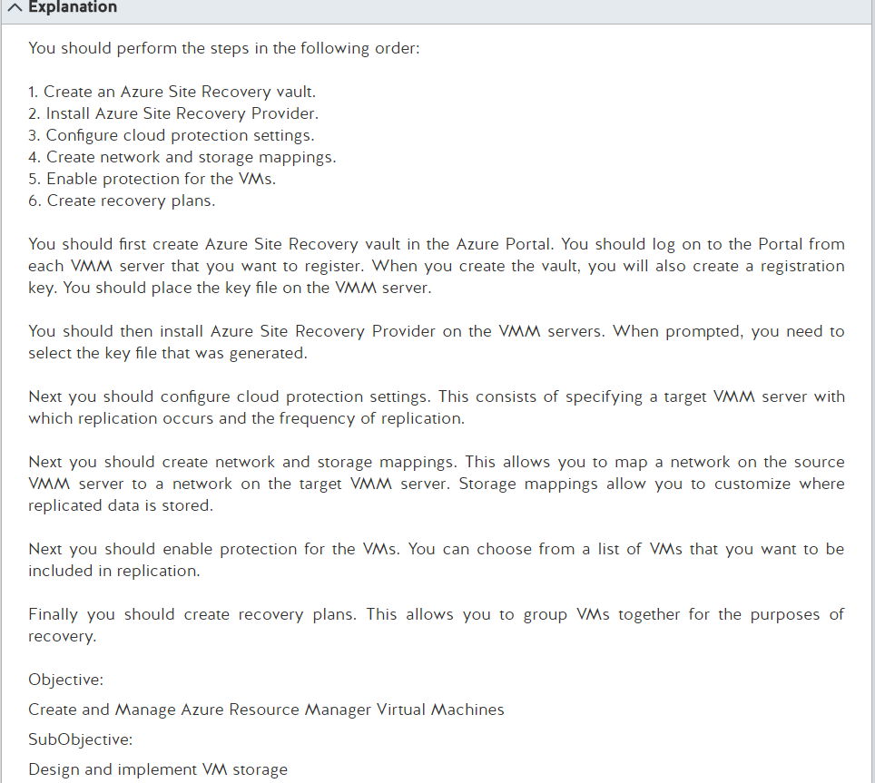

Replicate Hyper-V virtual machines in VMM clouds to a secondary VMM site using the Azure portal

From <<https://docs.microsoft.com/en-us/azure/site-recovery/site-recovery-vmm-to-vmm>>

<https://docs.microsoft.com/en-us/azure/site-recovery/site-recovery-vmm-to-vmm>

Tuesday, February 21, 2017

8:40 AM

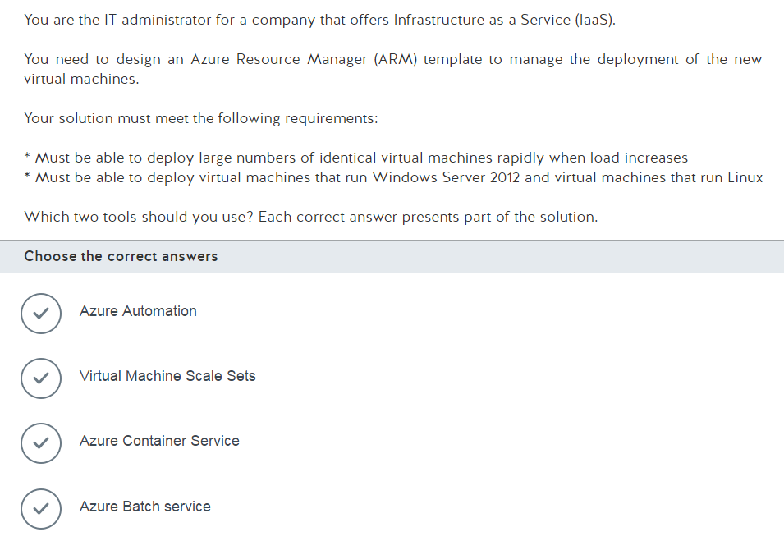

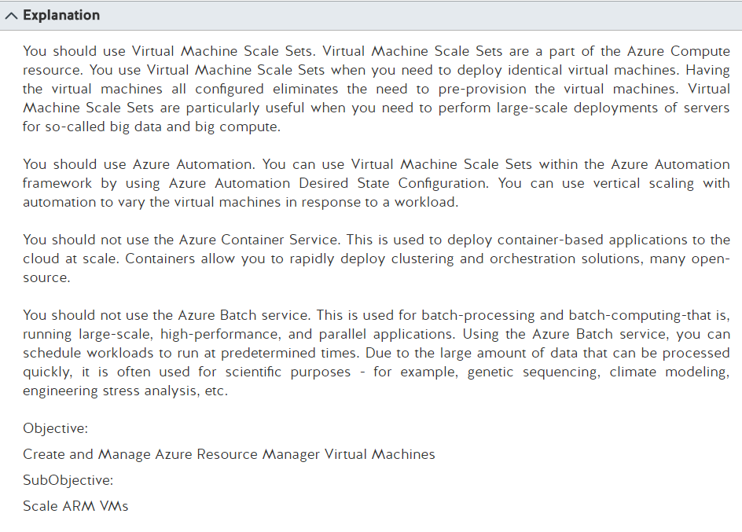

Vertical autoscale with Virtual Machine Scale sets

From <<https://docs.microsoft.com/en-us/azure/virtual-machine-scale-sets/virtual-machine-scale-sets-vertical-scale-reprovision>>

VM Scale Set Configuration managed by Azure Automation

From <<https://azure.microsoft.com/en-us/resources/templates/201-vmss-automation-dsc/>>

Basics of Azure Batch

From <<https://docs.microsoft.com/en-us/azure/batch/batch-technical-overview>>

Tuesday, February 21, 2017

9:10 AM

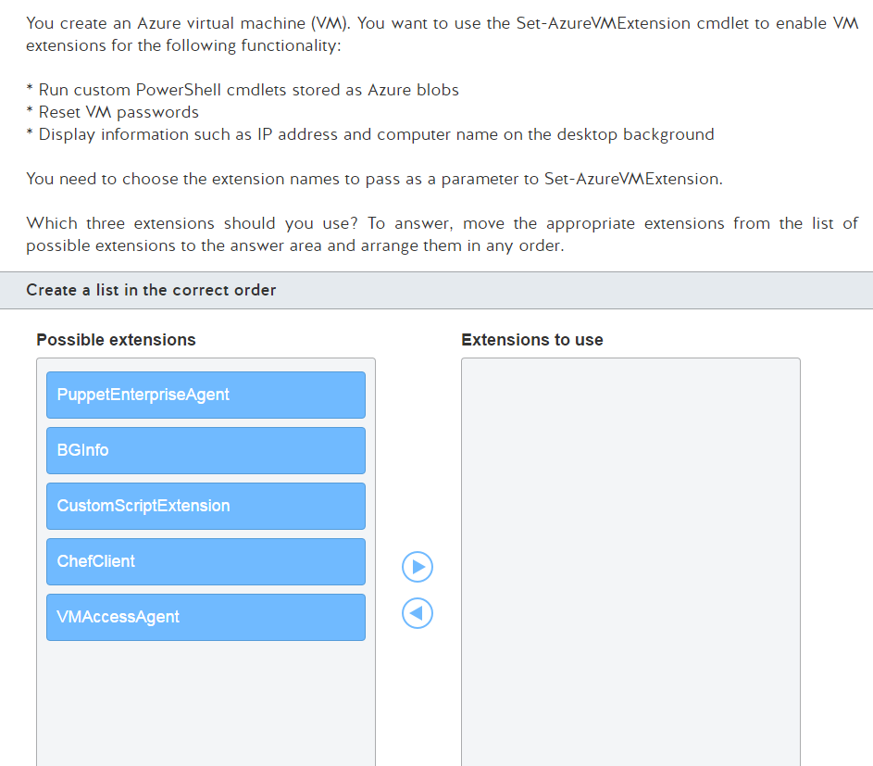

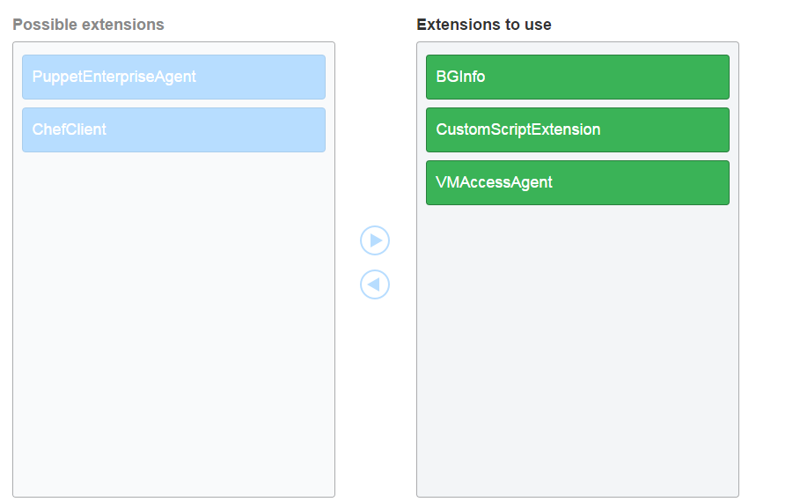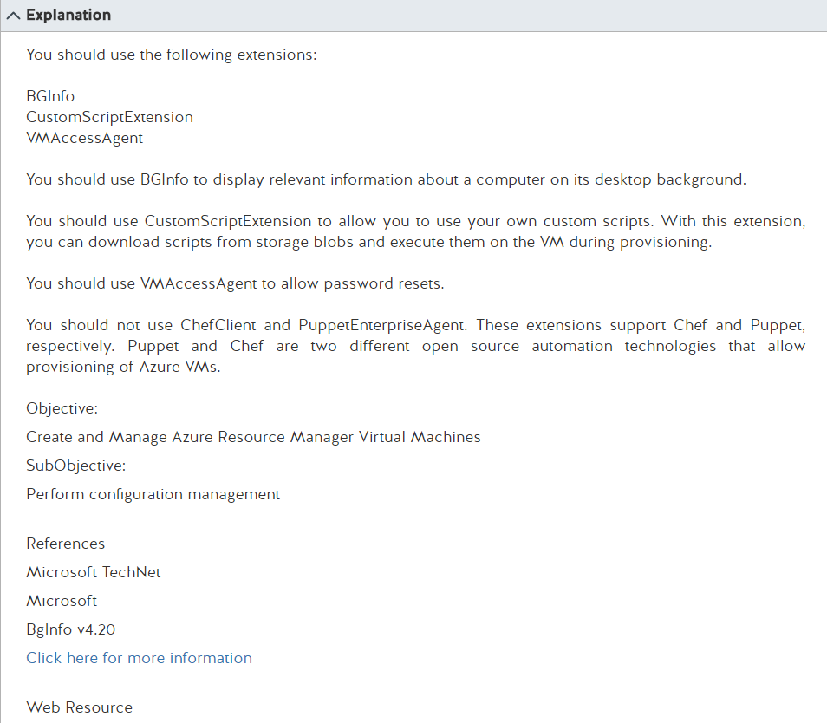

BgInfo v4.21

From <<https://technet.microsoft.com/en-us/library/bb897557.aspx>>

**Puppet or Chef: The configuration management dilemma**

From <<http://www.infoworld.com/article/2614204/data-center/puppet-or-chef--the-configuration-management-dilemma.html>>

Understanding Azure Custom Script Extension

From <<http://www.powershellmagazine.com/2014/04/30/understanding-azure-custom-script-extension/>>

Set-AzureVMExtension

From <<https://msdn.microsoft.com/en-us/library/azure/dn722522.aspx>>

Tuesday, January 31, 2017

10:27 AM

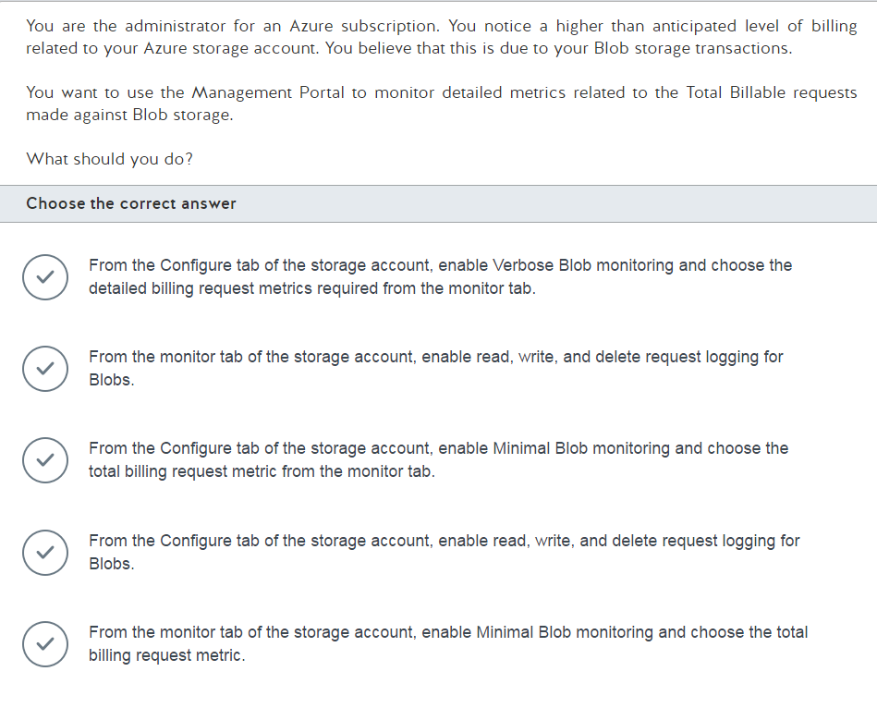

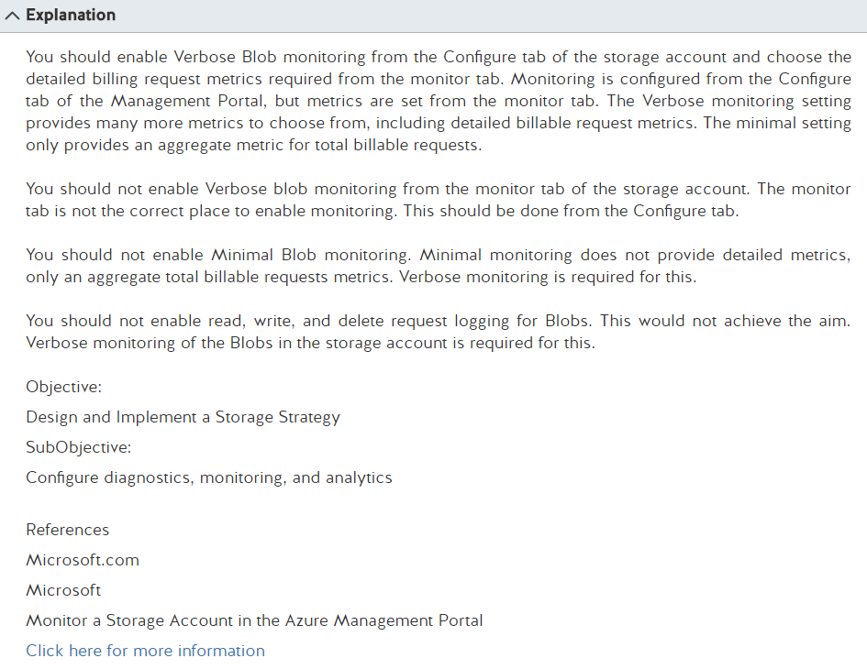

Monitor a storage account in the Azure Portal

From <<https://docs.microsoft.com/en-us/azure/storage/storage-monitor-storage-account>>

Tuesday, February 21, 2017

9:38 AM

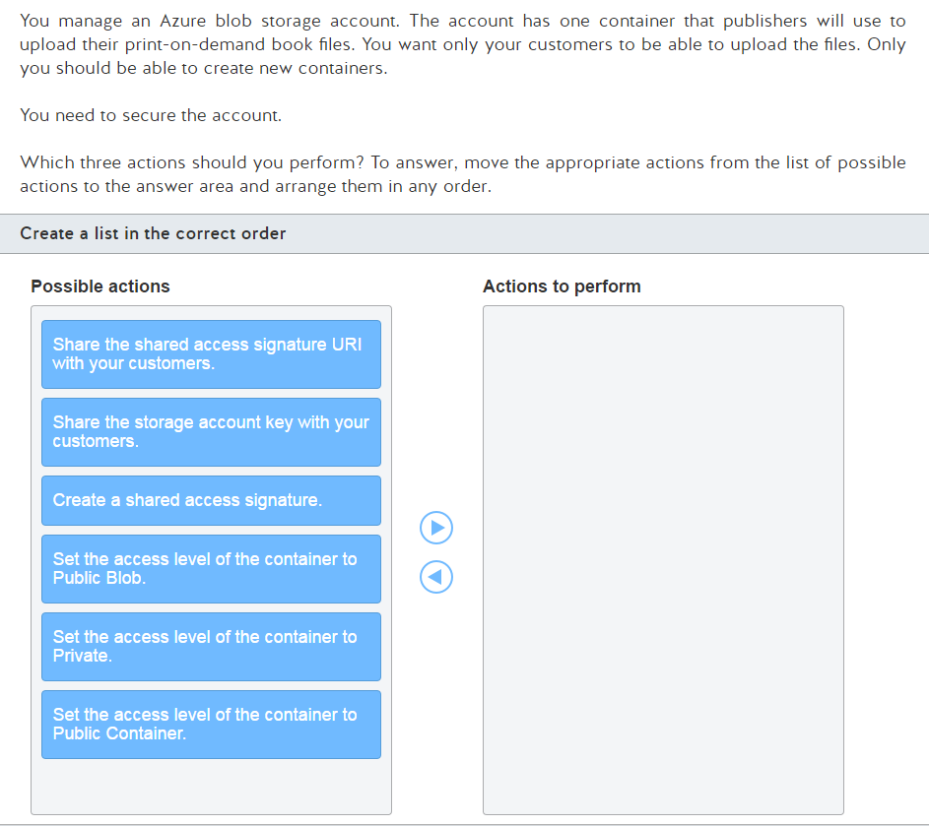

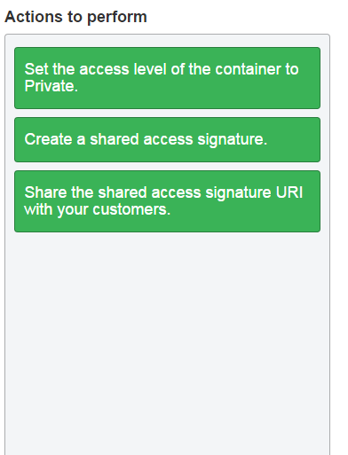

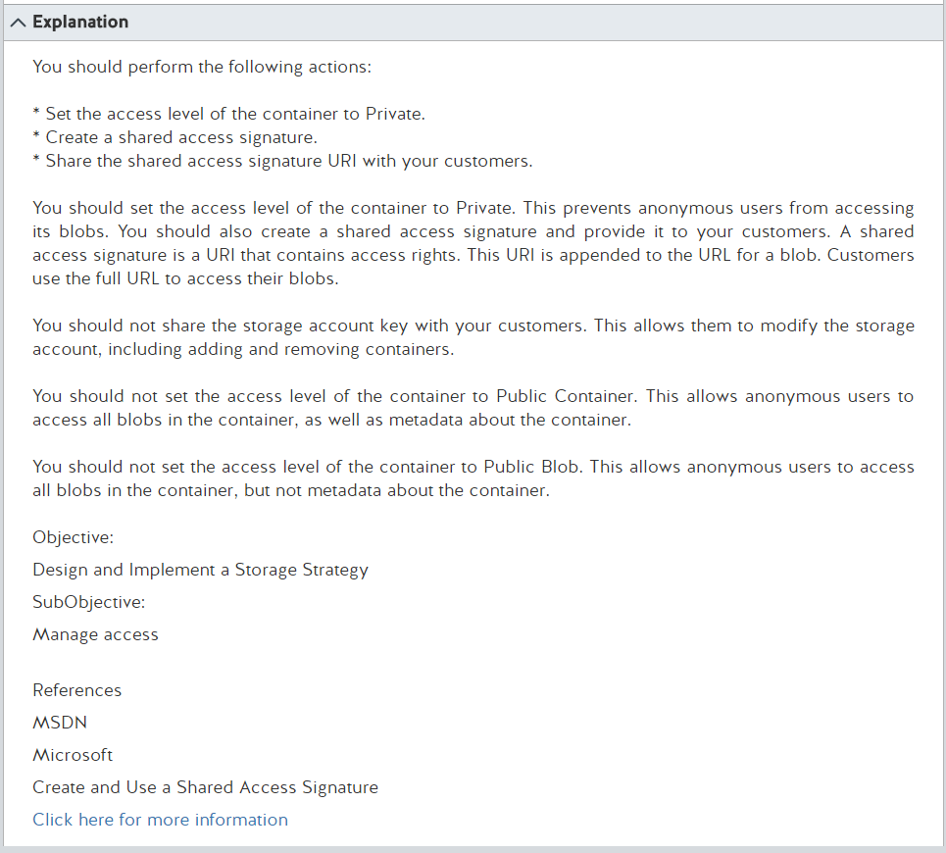

Manage anonymous read access to containers and blobs

From <<https://docs.microsoft.com/en-us/azure/storage/storage-manage-access-to-resources>>

Tuesday, February 21, 2017

9:52 AM

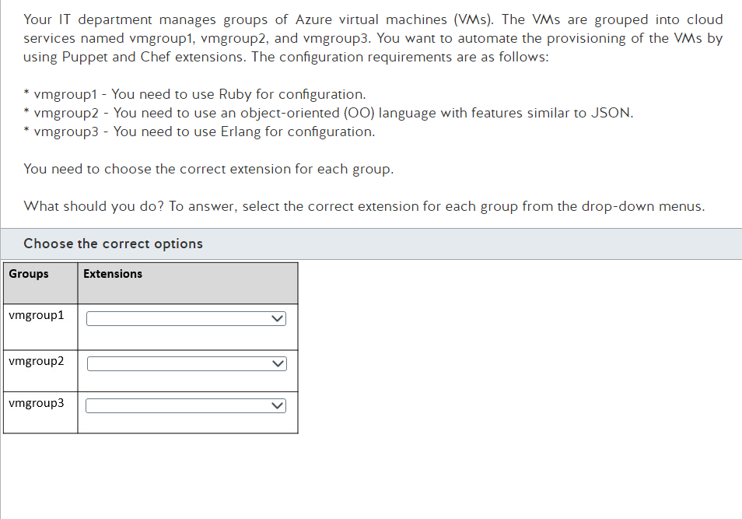

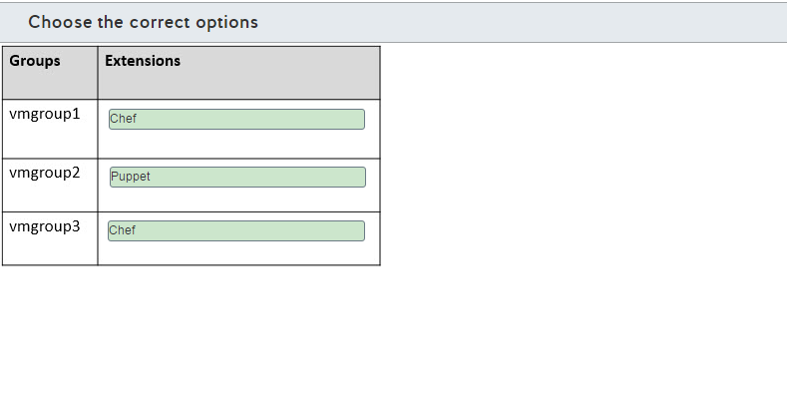

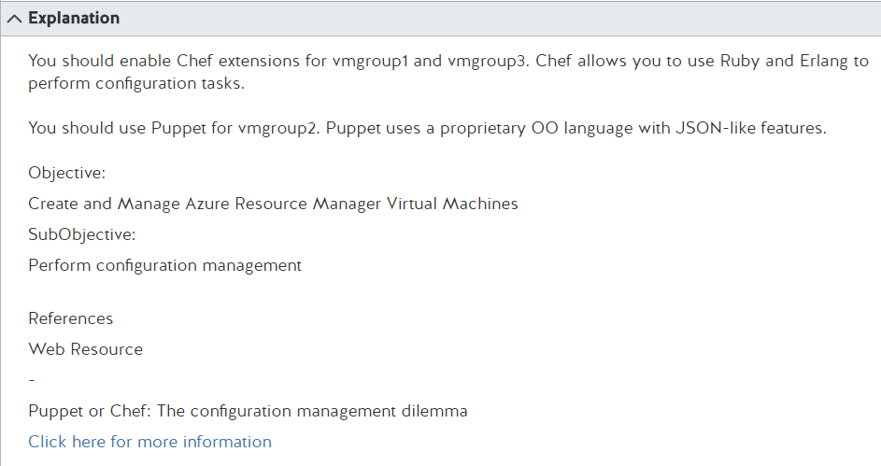

**Puppet or Chef: The configuration management dilemma**

From <<http://www.infoworld.com/article/2614204/data-center/puppet-or-chef--the-configuration-management-dilemma.html>>

Tuesday, February 21, 2017

10:06 AM

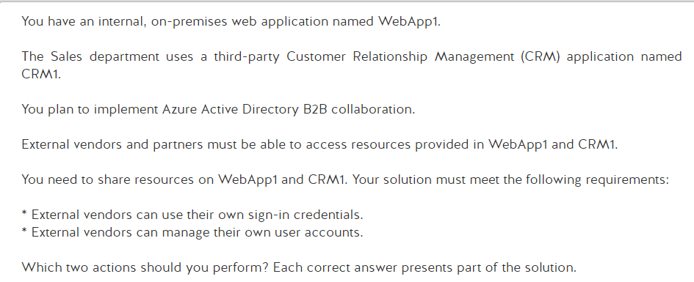

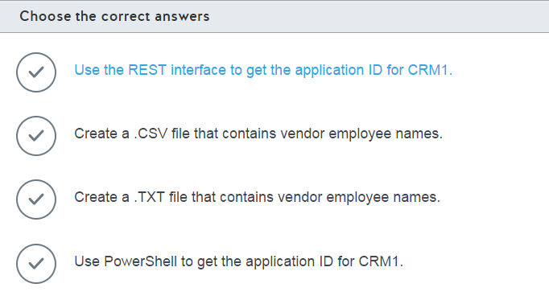

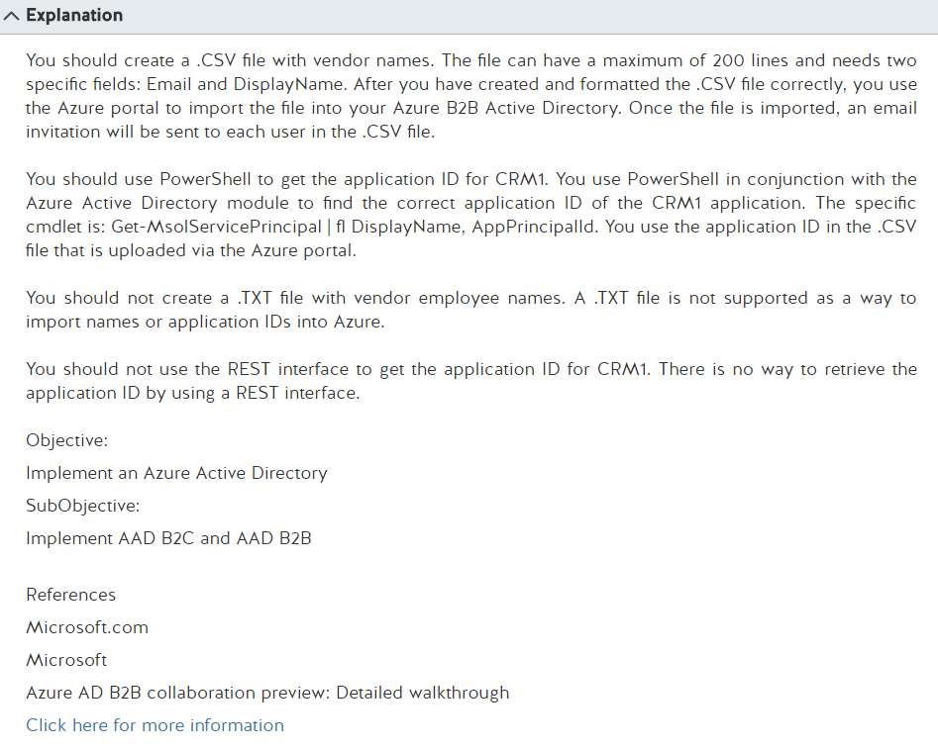

What is Azure AD B2B collaboration preview?

From <<https://docs.microsoft.com/en-us/azure/active-directory/active-directory-b2b-what-is-azure-ad-b2b>>

The elements of the B2B collaboration invitation email

From <<https://docs.microsoft.com/en-us/azure/active-directory/active-directory-b2b-invitation-email>>

Tuesday, February 21, 2017

10:11 AM

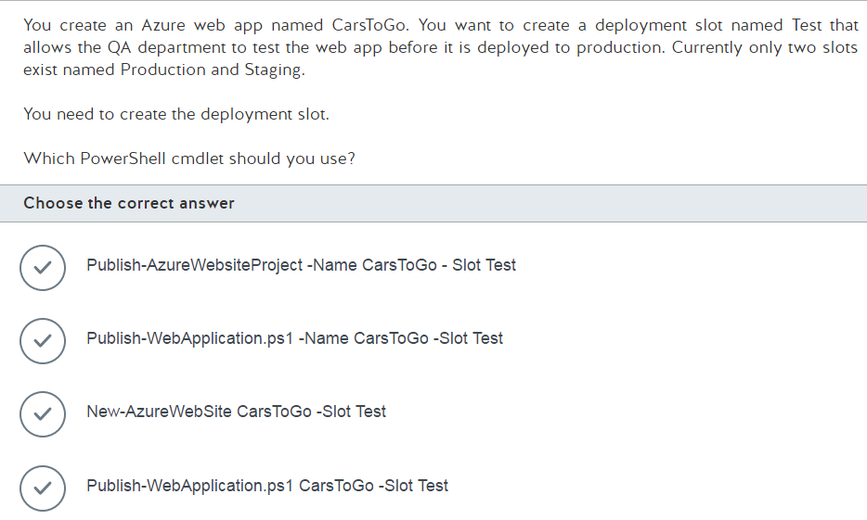

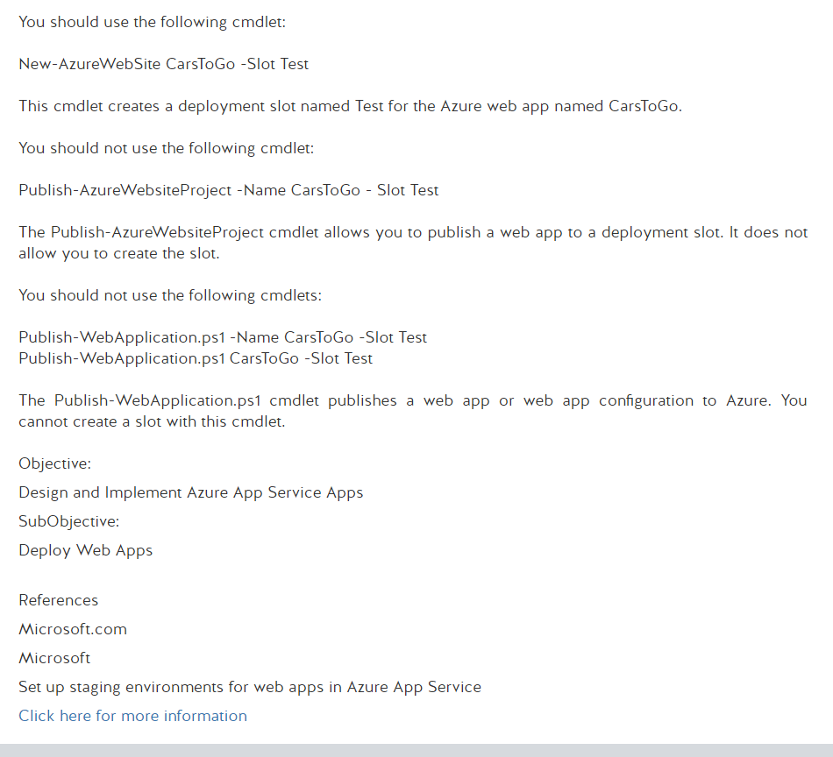

Set up staging environments in Azure App Service

From <<https://docs.microsoft.com/en-us/azure/app-service-web/web-sites-staged-publishing>>

Using Windows PowerShell scripts to publish to dev and test environments

From <<https://docs.microsoft.com/en-us/azure/vs-azure-tools-publishing-using-powershell-scripts>>

Wednesday, February 22, 2017

9:57 AM

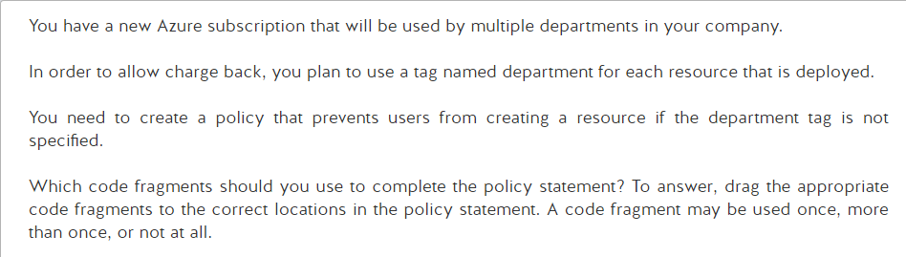

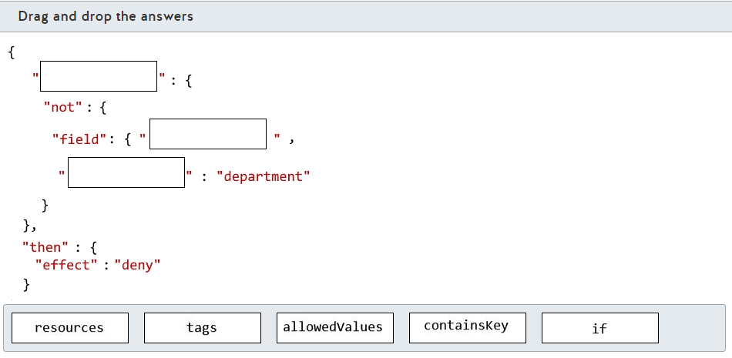

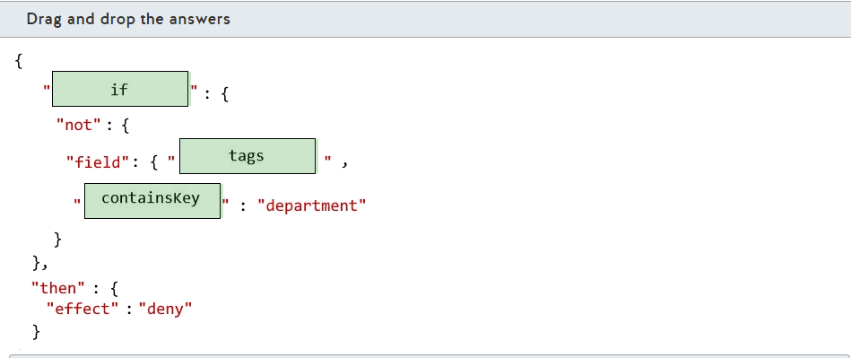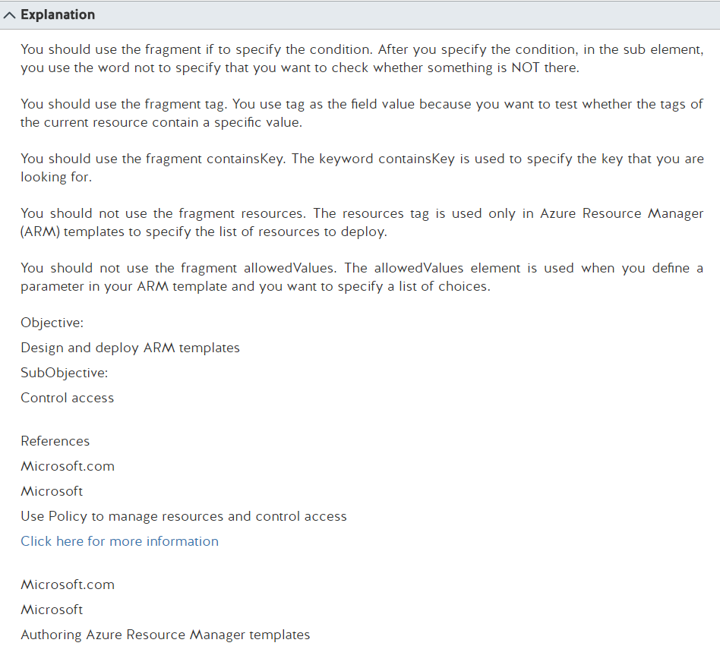

Resource policy overview

From <<https://docs.microsoft.com/en-us/azure/azure-resource-manager/resource-manager-policy>>

Authoring Azure Resource Manager templates

From <<https://docs.microsoft.com/en-us/azure/azure-resource-manager/resource-group-authoring-templates>>

Wednesday, February 22, 2017

10:04 AM

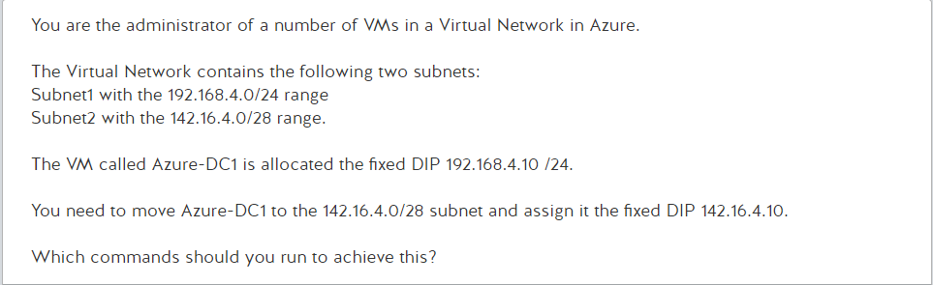

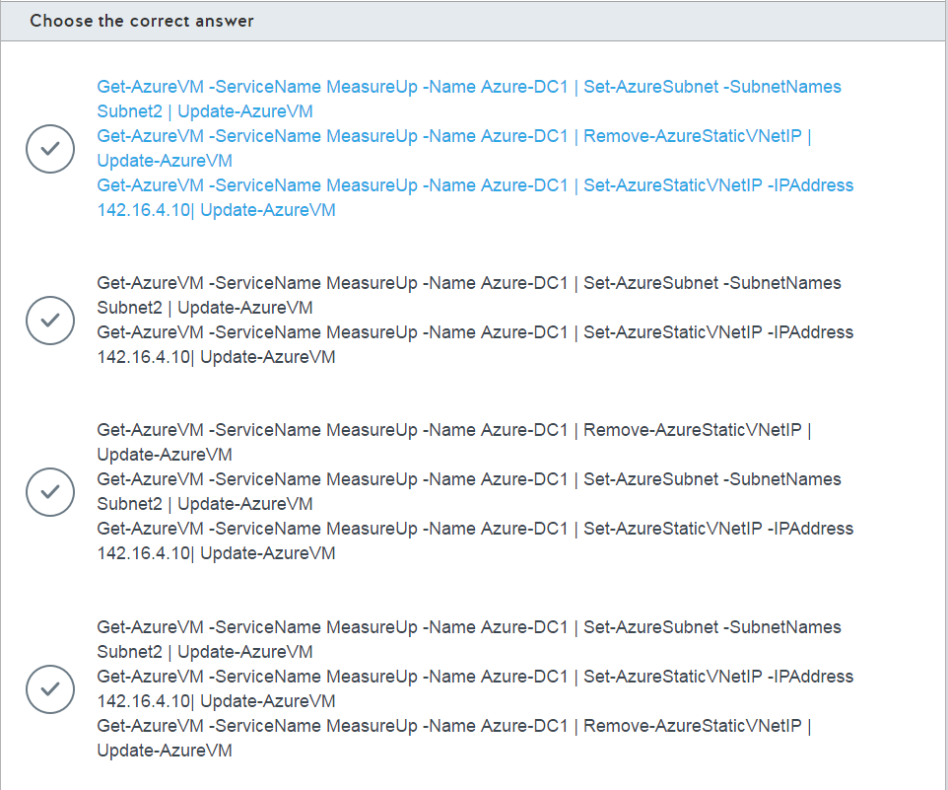

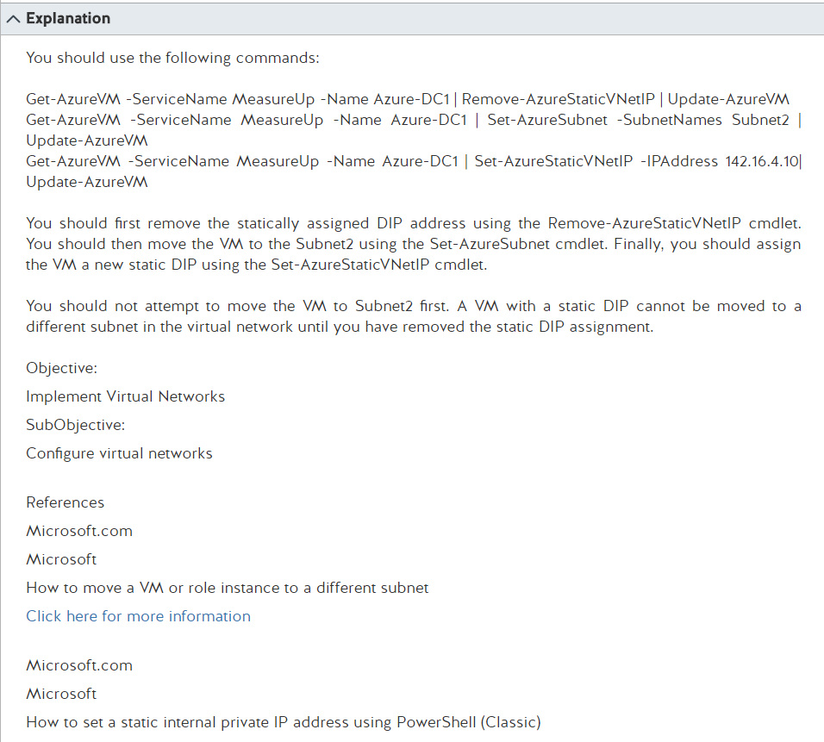

How to move a VM or role instance to a different subnet

From <<https://docs.microsoft.com/en-us/azure/virtual-network/virtual-networks-move-vm-role-to-subnet>>

How to set a static internal private IP address using PowerShell (Classic)

From <<https://docs.microsoft.com/en-us/azure/virtual-network/virtual-networks-reserved-private-ip>>

Set-AzureSubnet

From <<https://msdn.microsoft.com/en-us/library/azure/dn495213.aspx>>

Set-AzureStaticVNetIP

From <<https://msdn.microsoft.com/en-us/library/azure/dn722490.aspx>>

Azure.Compute Module

From <<https://docs.microsoft.com/en-us/powershell/servicemanagement/azure.compute/v1.6.1/azure.compute?redirectedfrom=msdn>>

Get-AzureVM

From <<https://msdn.microsoft.com/en-us/library/azure/dn495236.aspx>>

Wednesday, February 22, 2017

10:20 AM

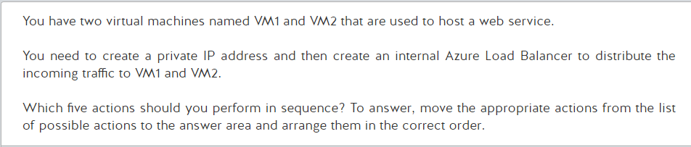

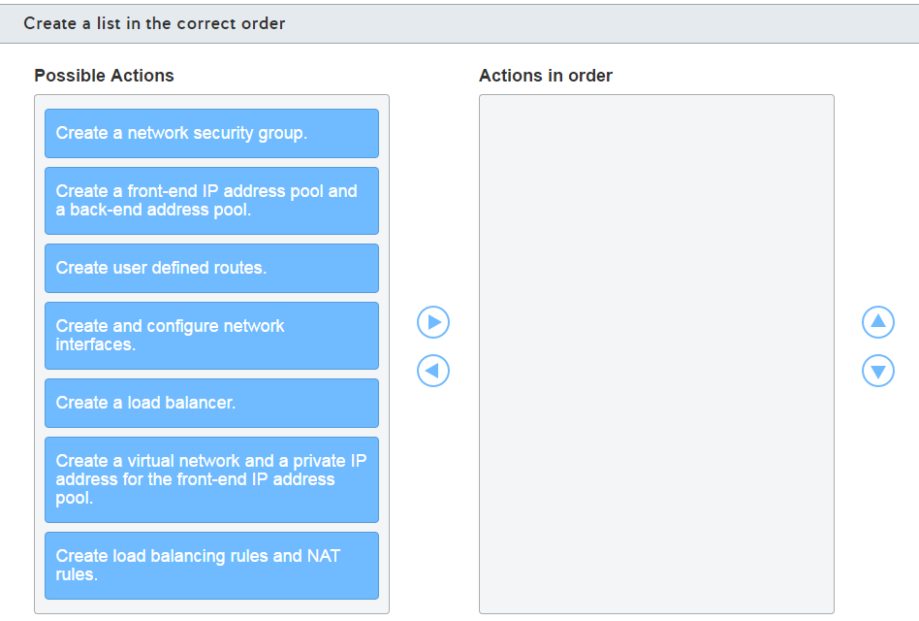

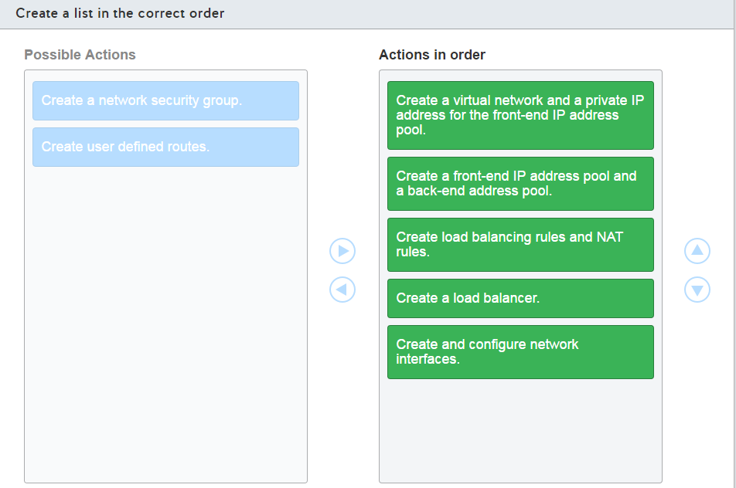

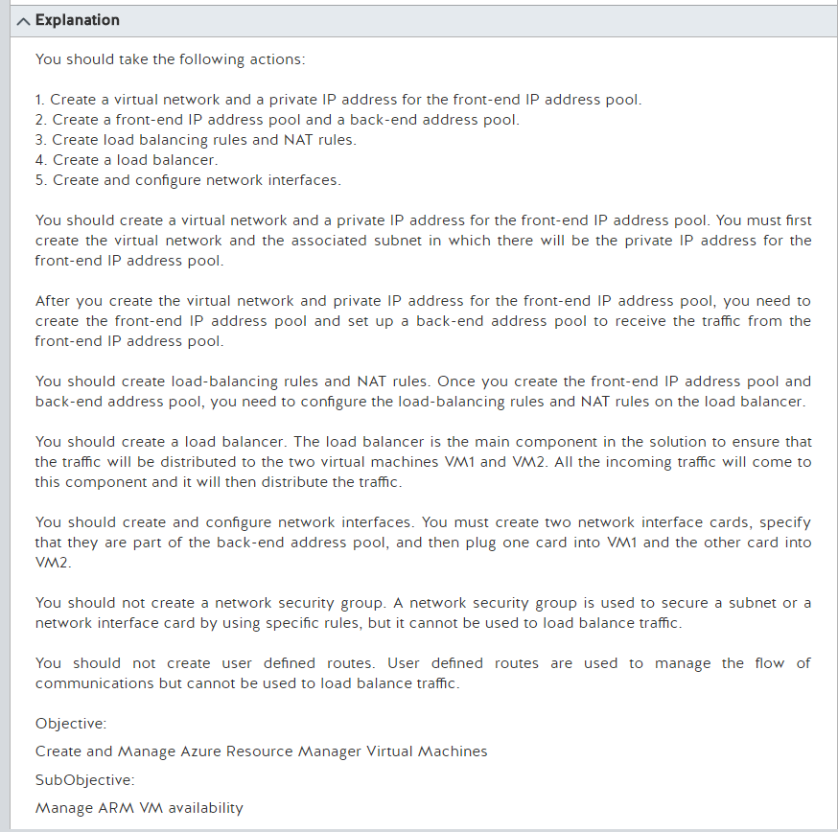

Create an internal load balancer using PowerShell

From <<https://docs.microsoft.com/en-us/azure/load-balancer/load-balancer-get-started-ilb-arm-ps>>

What are User Defined Routes and IP Forwarding?

From <<https://docs.microsoft.com/en-us/azure/virtual-network/virtual-networks-udr-overview>>

Control network traffic flow with network security groups

From <<https://docs.microsoft.com/en-us/azure/virtual-network/virtual-networks-nsg>>

Wednesday, February 22, 2017

10:23 AM

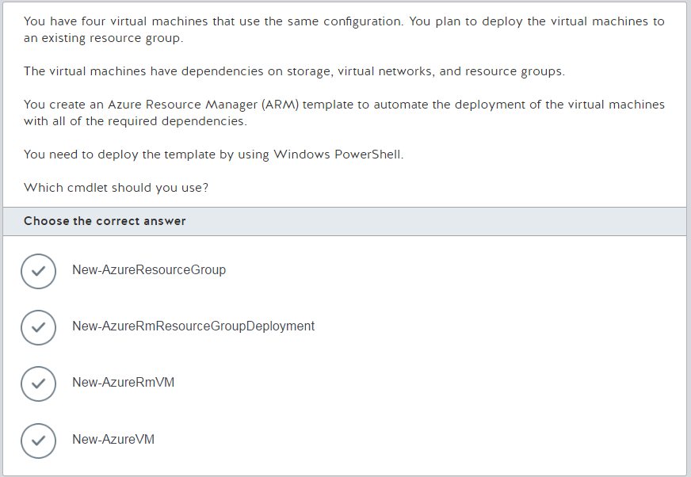

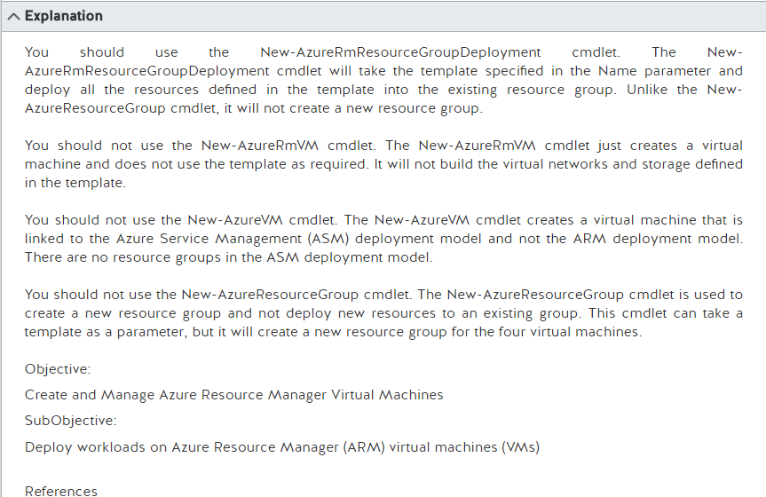

New-AzureRmResourceGroupDeployment

From <<https://msdn.microsoft.com/en-us/library/mt603823.aspx>>

New-AzureRmVM

From <<https://docs.microsoft.com/en-us/powershell/resourcemanager/azurerm.compute/v1.3.4/New-AzureRmVM?redirectedfrom=msdn>>

New-AzureVM

From <<https://msdn.microsoft.com/en-us/library/azure/dn495254.aspx>>

New-AzureResourceGroup

From <<https://msdn.microsoft.com/en-us/library/dn757682.aspx>>

Wednesday, February 22, 2017

10:27 AM

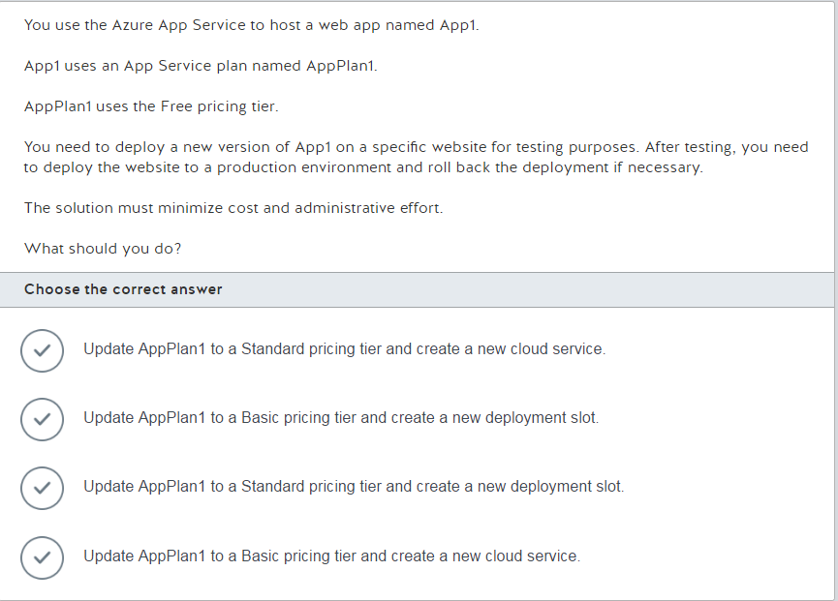

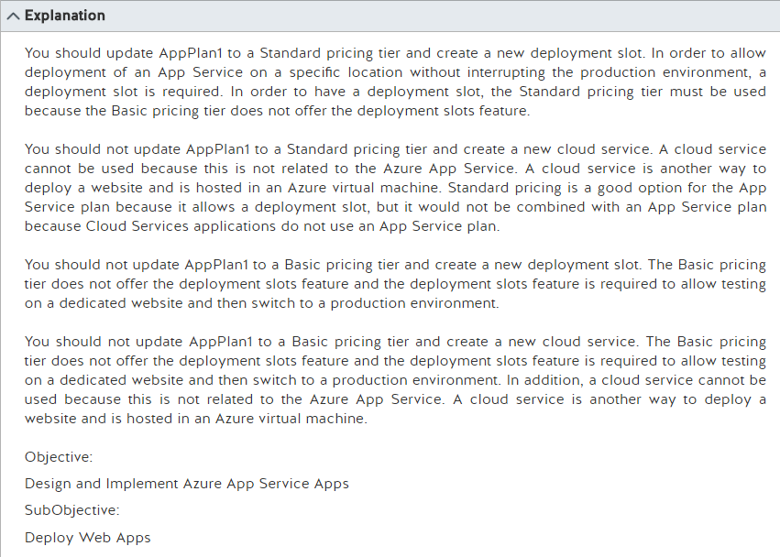

Set up staging environments in Azure App Service

From <<https://docs.microsoft.com/en-us/azure/app-service-web/web-sites-staged-publishing>>

Should I choose cloud services or something else?

From <<https://docs.microsoft.com/en-us/azure/cloud-services/cloud-services-choose-me>>

Wednesday, February 22, 2017

10:32 AM

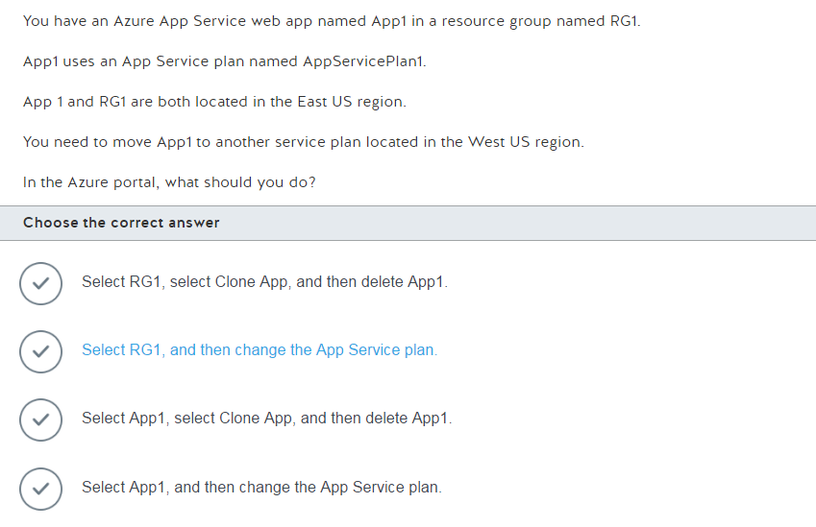

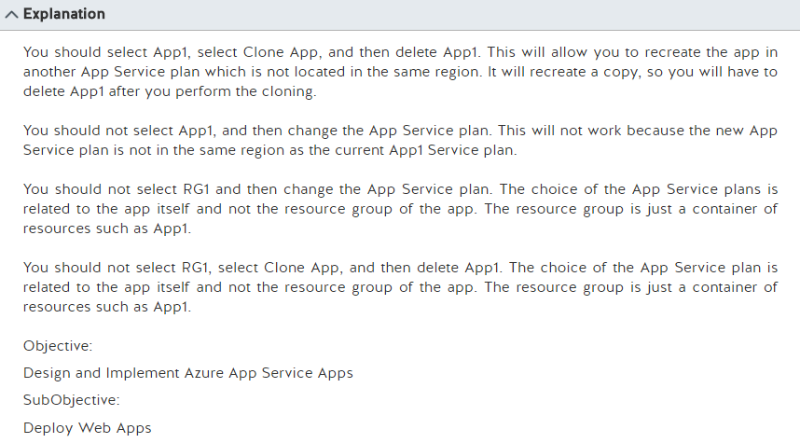

Azure App Service plans in-depth overview

From <<https://docs.microsoft.com/en-us/azure/app-service/azure-web-sites-web-hosting-plans-in-depth-overview>>

Wednesday, February 22, 2017

10:56 AM

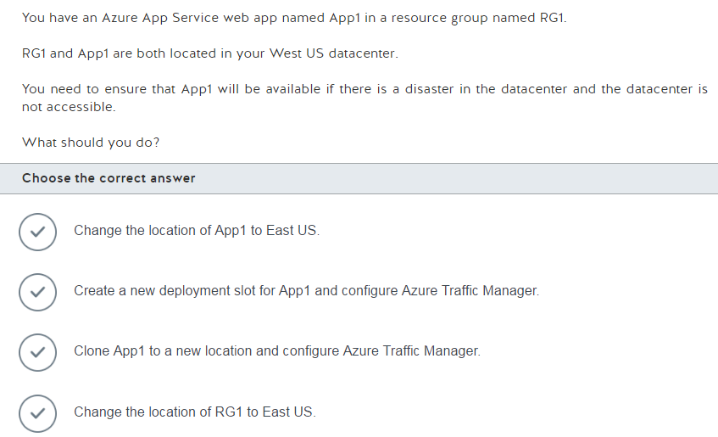

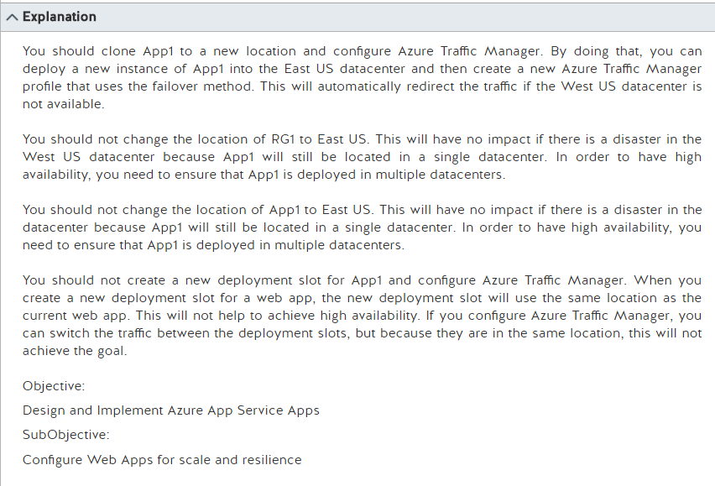

Controlling Azure web app traffic with Azure Traffic Manager

From <<https://docs.microsoft.com/en-us/azure/app-service-web/web-sites-traffic-manager>>

Set up staging environments in Azure App Service

From <<https://docs.microsoft.com/en-us/azure/app-service-web/web-sites-staged-publishing>>

Wednesday, February 22, 2017

11:14 AM

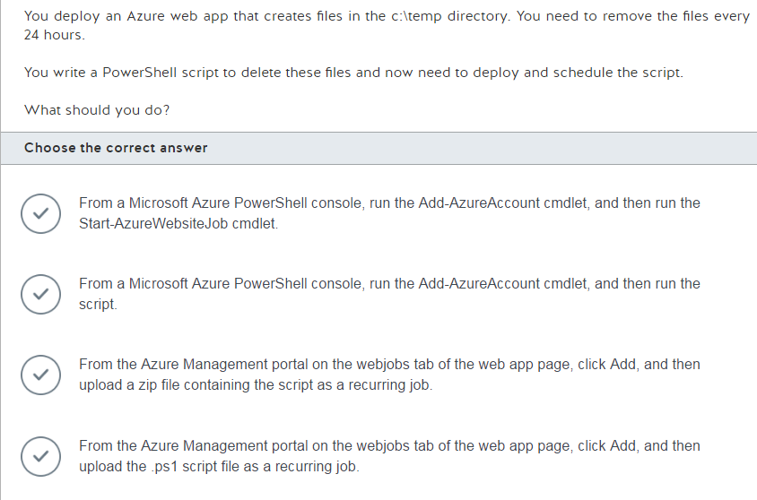

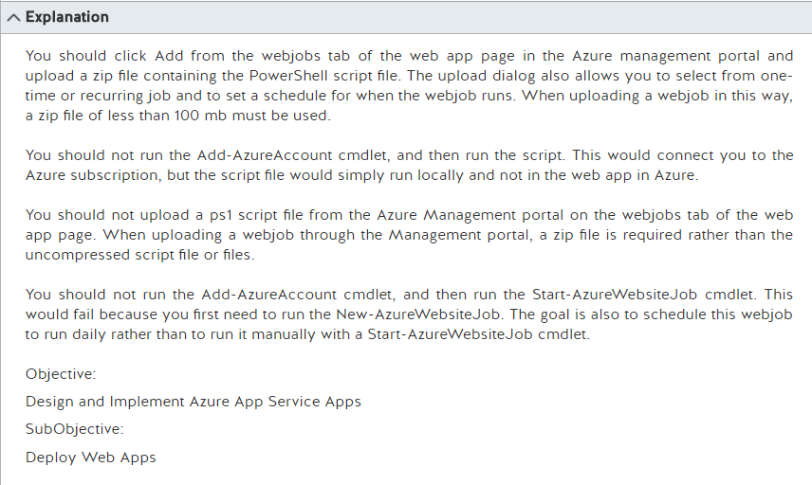

Running Powershell Web Jobs on Azure websites

From <<https://blogs.msdn.microsoft.com/nicktrog/2014/01/22/running-powershell-web-jobs-on-azure-websites/>>

Run Background tasks with WebJobs

From <<https://docs.microsoft.com/en-us/azure/app-service-web/web-sites-create-web-jobs>>

22Feb End

Wednesday, February 22, 2017

3:50 PM

Friday, February 24, 2017

12:57 PM

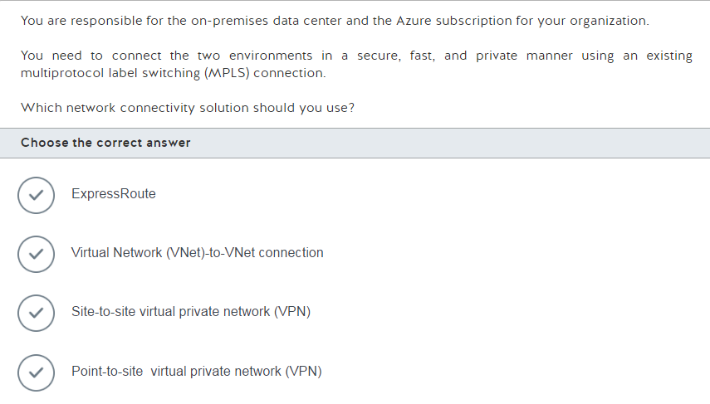

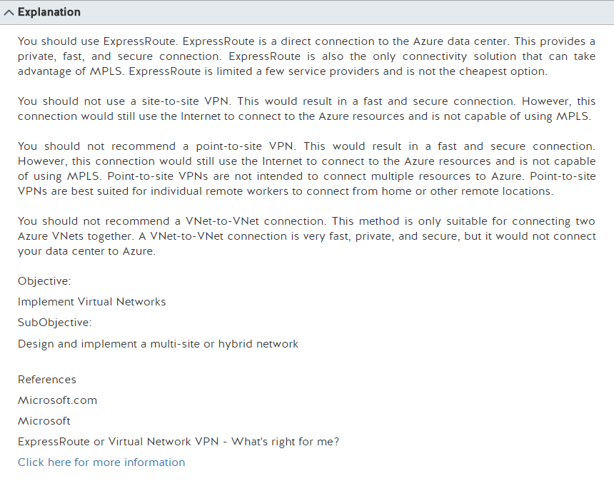

ExpressRoute or Virtual Network VPN – What’s right for me?

From <<https://azure.microsoft.com/en-us/blog/expressroute-or-virtual-network-vpn-whats-right-for-me/>>

Friday, February 24, 2017

1:02 PM

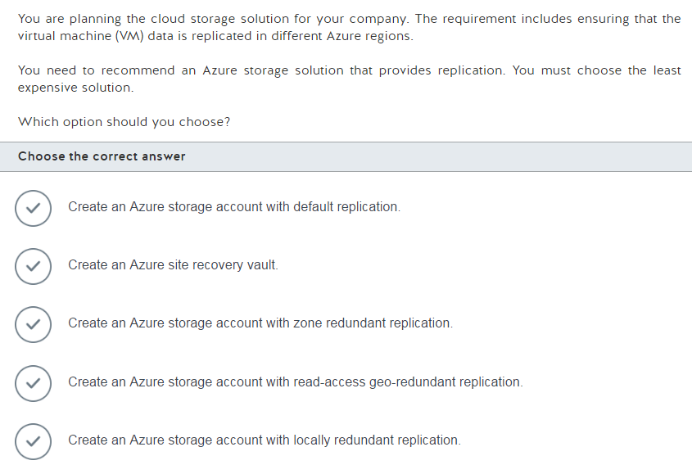

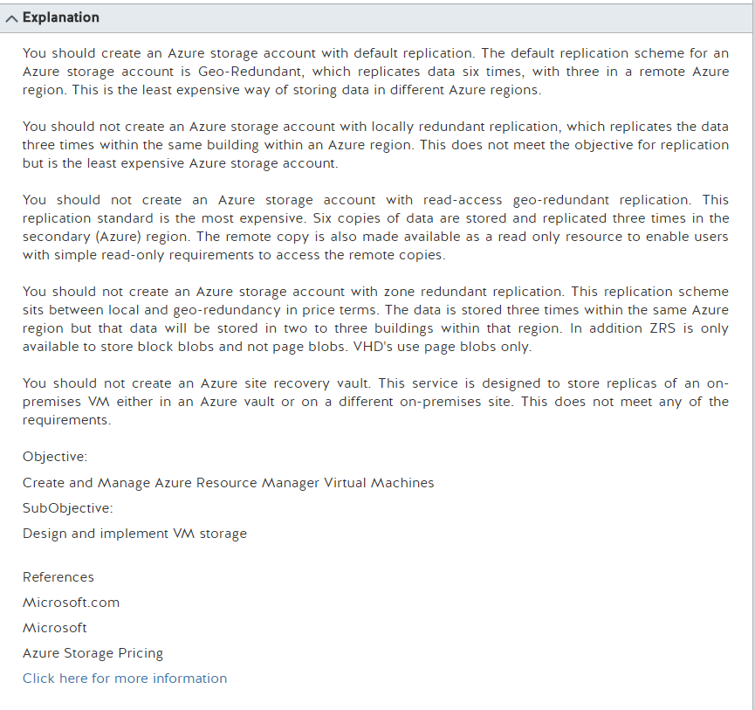

Azure Storage Pricing

From <<https://azure.microsoft.com/en-gb/pricing/details/storage/blobs/>>

From <<https://azure.microsoft.com/en-gb/pricing/details/storage/blobs/>>

Friday, February 24, 2017

1:07 PM

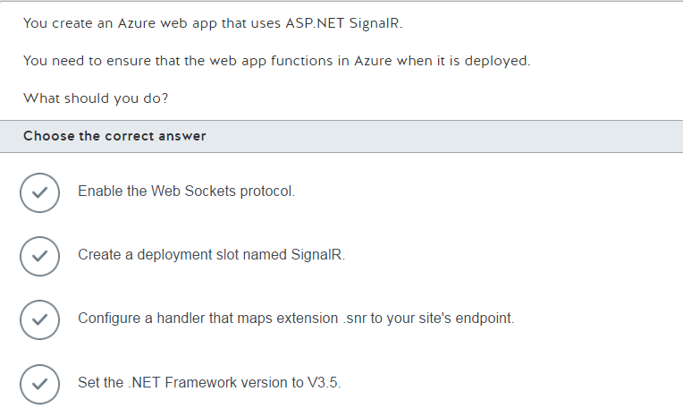

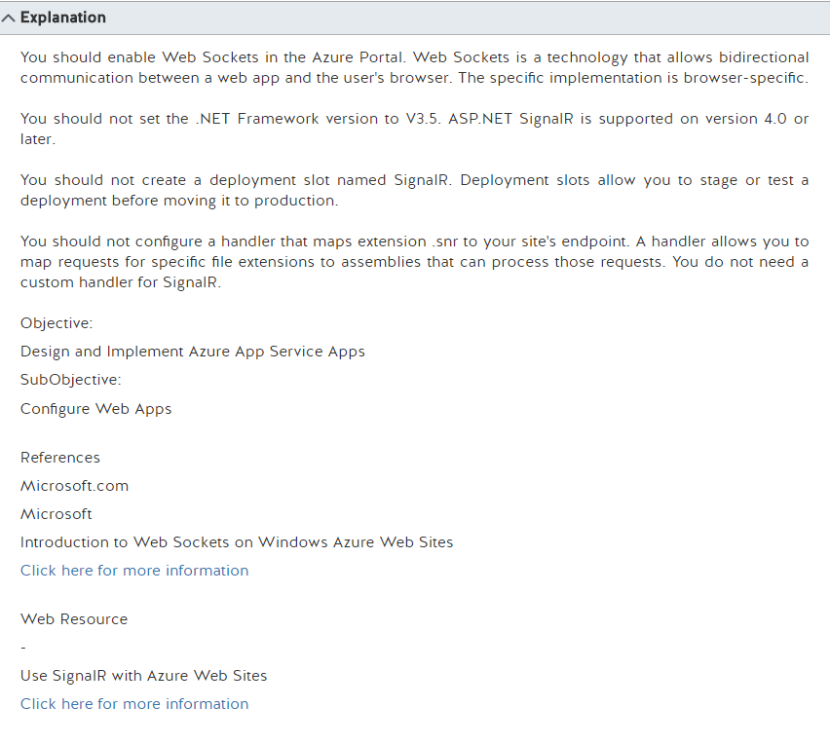

Introduction to WebSockets on Windows Azure Web Sites

From <<https://azure.microsoft.com/en-us/blog/introduction-to-websockets-on-windows-azure-web-sites/>>

Using SignalR with Web Apps in Azure App Service

From <<https://docs.microsoft.com/en-us/aspnet/signalr/overview/deployment/using-signalr-with-azure-web-sites>>

Friday, February 24, 2017

1:14 PM

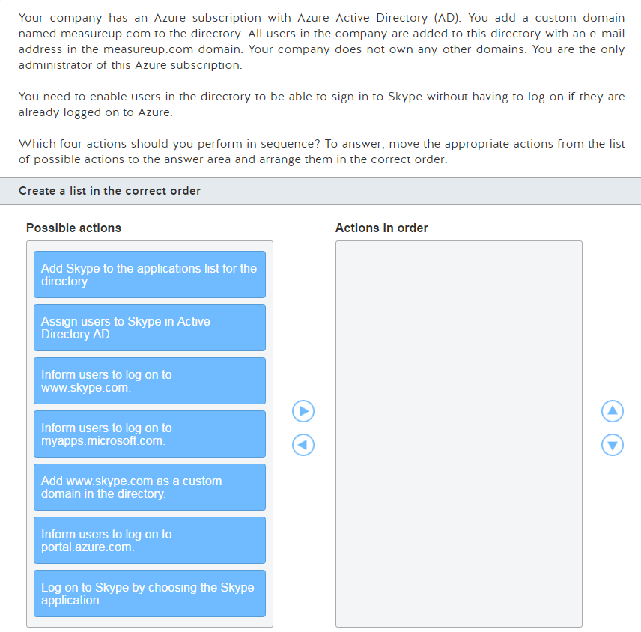

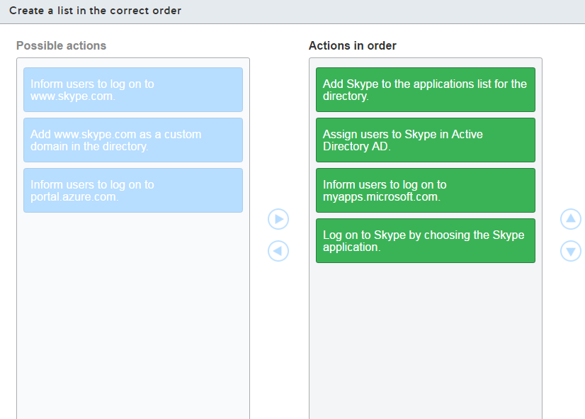

Implementing Single Sign-on with Windows Azure Active Directory

From <<https://azure.microsoft.com/en-us/blog/implementing-single-sign-on-with-windows-azure-active-directory/>>

Friday, February 24, 2017

1:41 PM

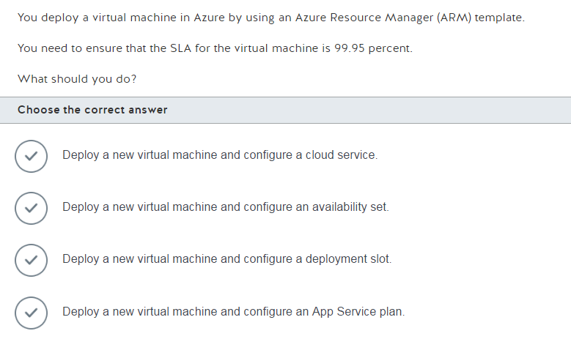

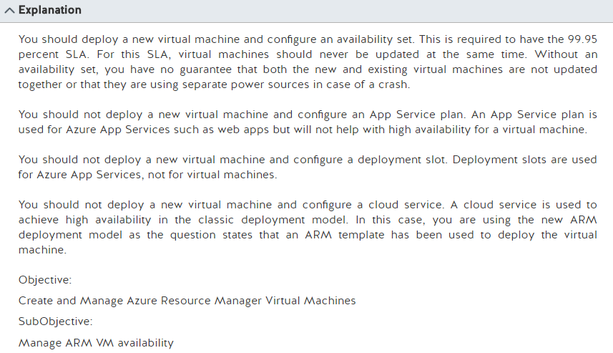

Manage the availability of virtual machines

From <<https://docs.microsoft.com/en-us/azure/virtual-machines/virtual-machines-windows-manage-availability?toc=%2fazure%2fvirtual-machines%2fwindows%2ftoc.json>>

How to configure an availability set for Windows virtual machines in the classic deployment model

From <<https://docs.microsoft.com/en-us/azure/virtual-machines/virtual-machines-windows-classic-configure-availability?toc=%2fazure%2fvirtual-machines%2fwindows%2fclassic%2ftoc.json>>

Should I choose cloud services or something else?

From <<https://docs.microsoft.com/en-us/azure/cloud-services/cloud-services-choose-me>>

Friday, February 24, 2017

1:46 PM

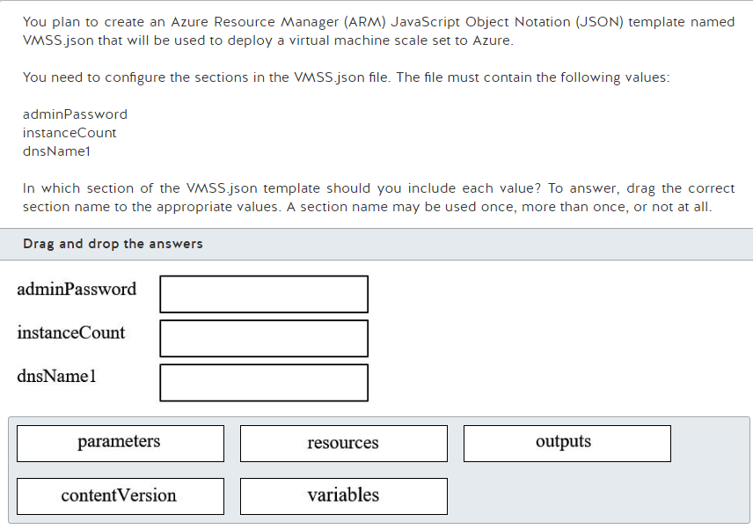

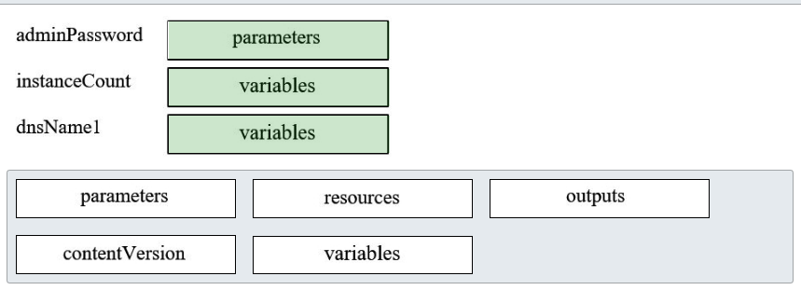

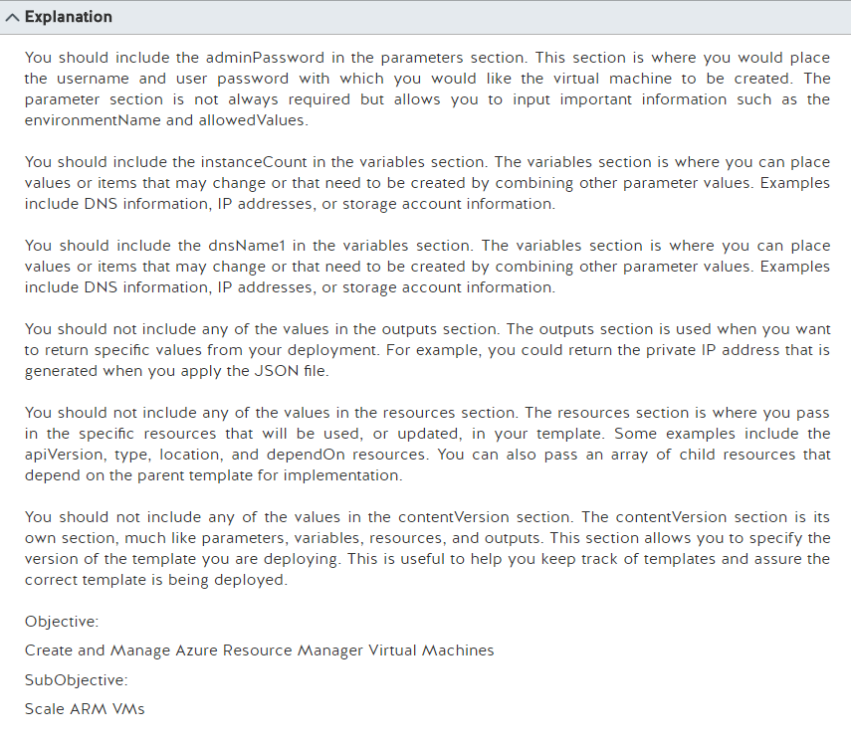

Authoring Azure Resource Manager templates

From <<https://docs.microsoft.com/en-us/azure/azure-resource-manager/resource-group-authoring-templates>>

Automatically scale machines in a virtual machine scale set

From <<https://docs.microsoft.com/en-us/azure/virtual-machine-scale-sets/virtual-machine-scale-sets-windows-autoscale>>

Share state to and from Azure Resource Manager templates

From <<https://docs.microsoft.com/en-us/azure/azure-resource-manager/best-practices-resource-manager-state>>

Friday, February 24, 2017

1:50 PM

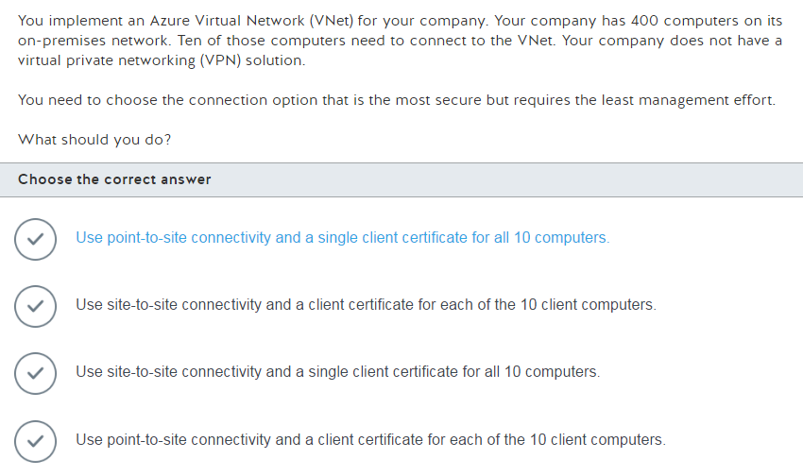

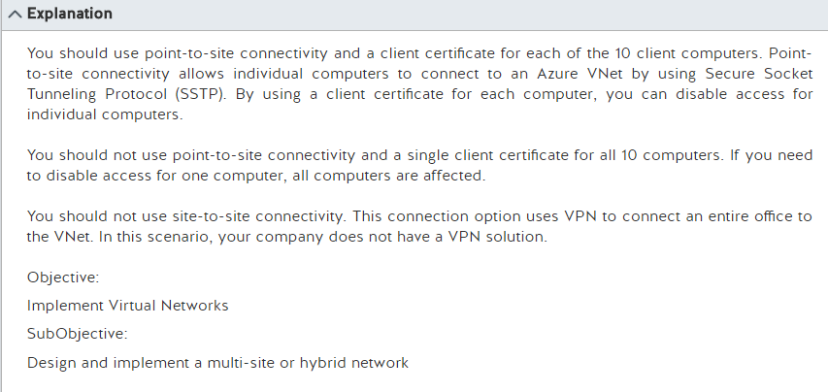

Friday, February 24, 2017

2:05 PM

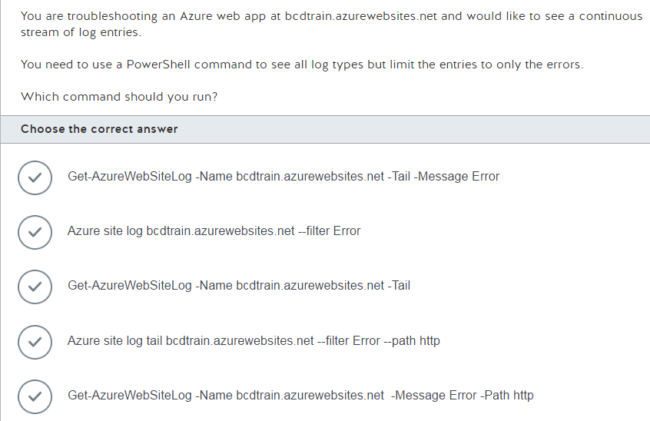

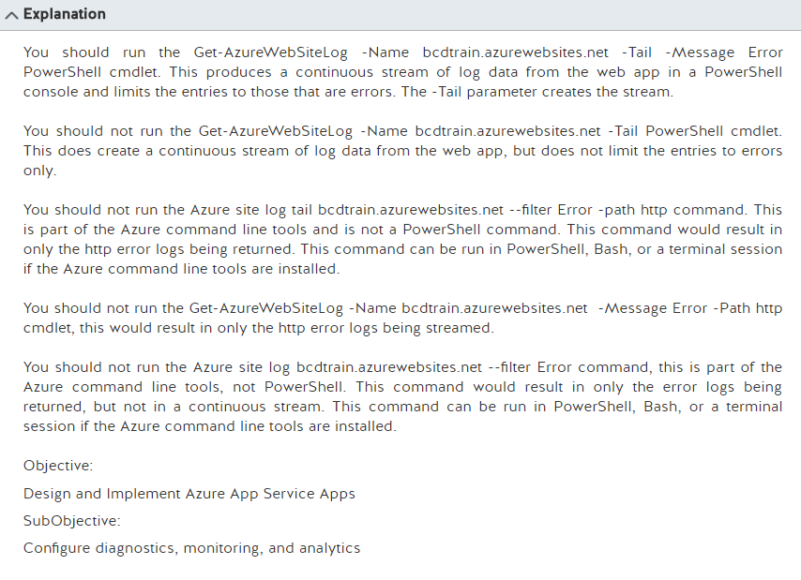

Enable diagnostics logging for web apps in Azure App Service

From <<https://docs.microsoft.com/en-gb/azure/app-service-web/web-sites-enable-diagnostic-log>>

Friday, February 24, 2017

2:07 PM

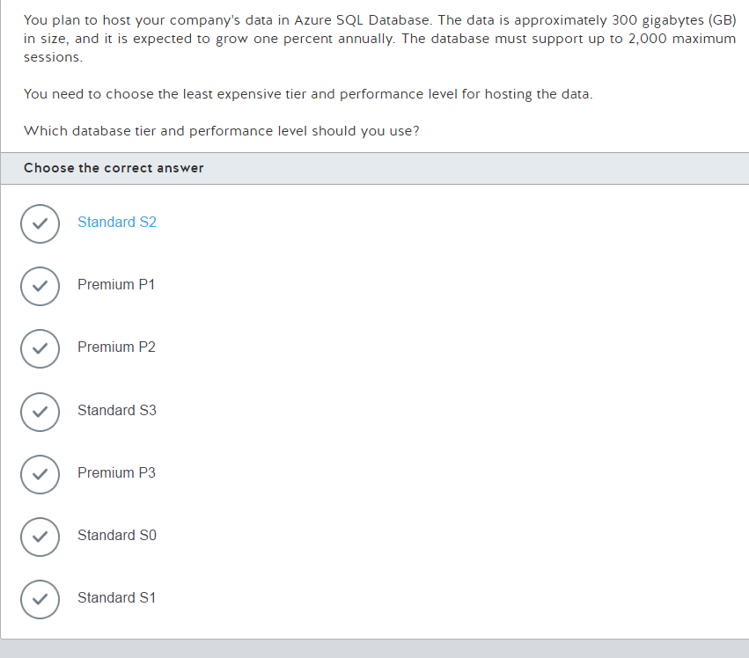

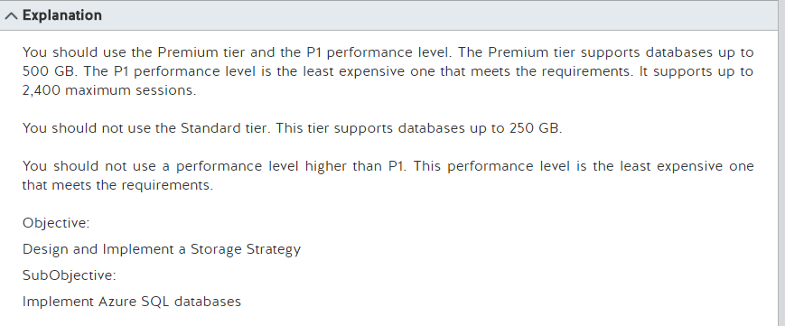

SQL Database Pricing

From <<https://azure.microsoft.com/en-us/pricing/details/sql-database/>>

SQL Database options and performance: Understand what's available in each service tier

From <<https://docs.microsoft.com/en-us/azure/sql-database/sql-database-service-tiers>>

Friday, February 24, 2017

2:17 PM

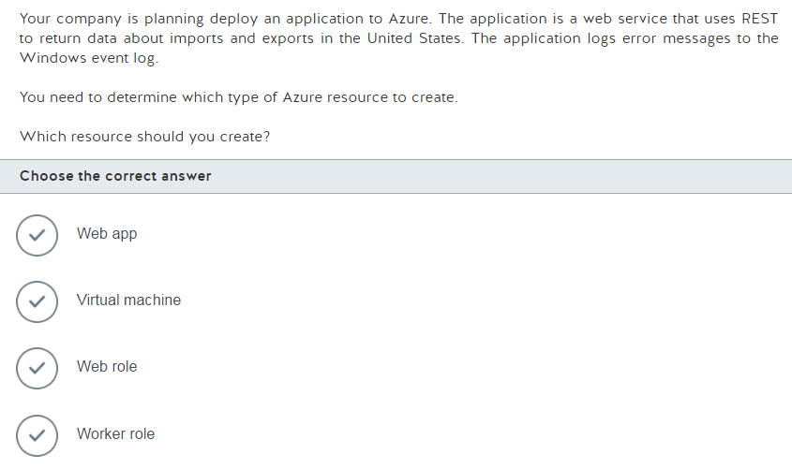

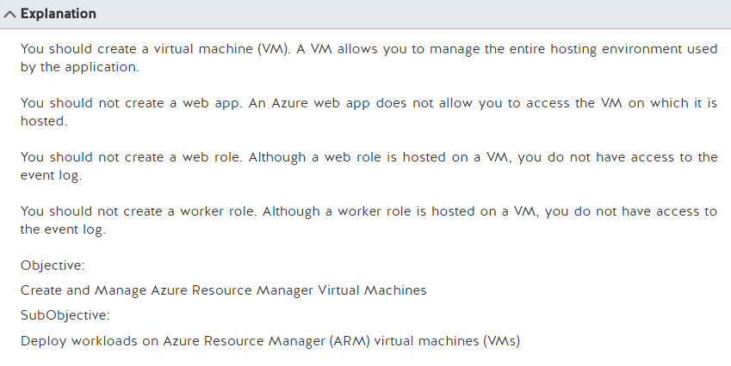

Azure App Service, Virtual Machines, Service Fabric, and Cloud Services comparison

From <<https://docs.microsoft.com/en-us/azure/app-service-web/choose-web-site-cloud-service-vm>>

Friday, February 24, 2017

2:24 PM

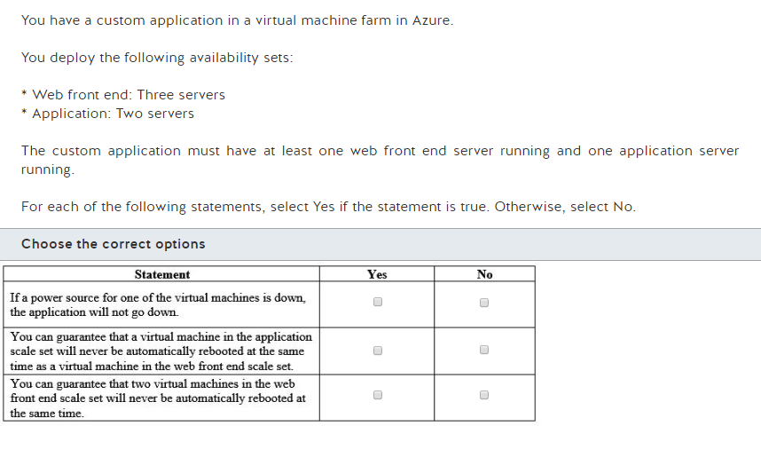

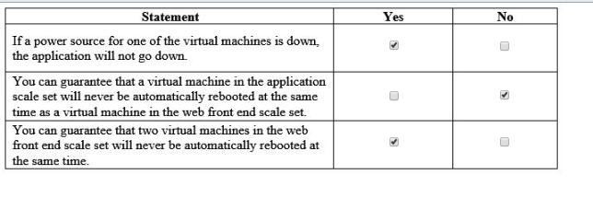

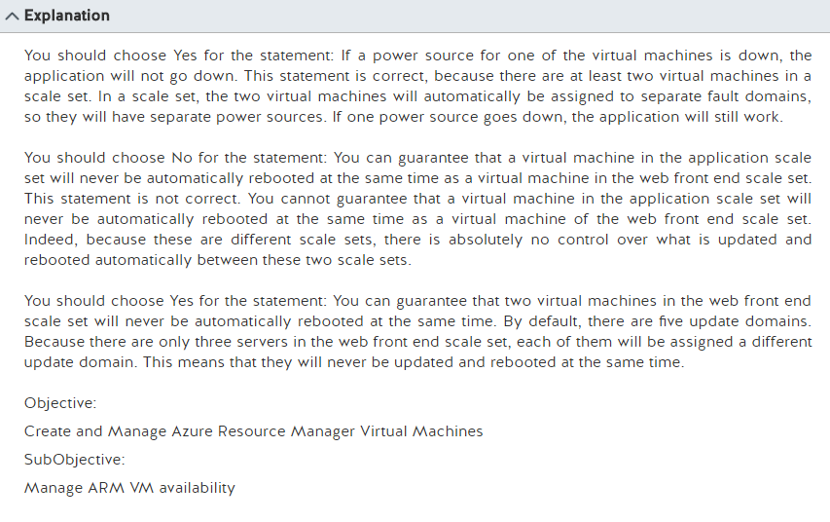

Manage the availability of virtual machines

From <<https://docs.microsoft.com/en-us/azure/virtual-machines/virtual-machines-windows-manage-availability?toc=%2fazure%2fvirtual-machines%2fwindows%2ftoc.json>>

Virtual Machine Scale Sets Overview

From <<https://docs.microsoft.com/en-us/azure/virtual-machine-scale-sets/virtual-machine-scale-sets-overview>>

Friday, February 24, 2017

2:37 PM

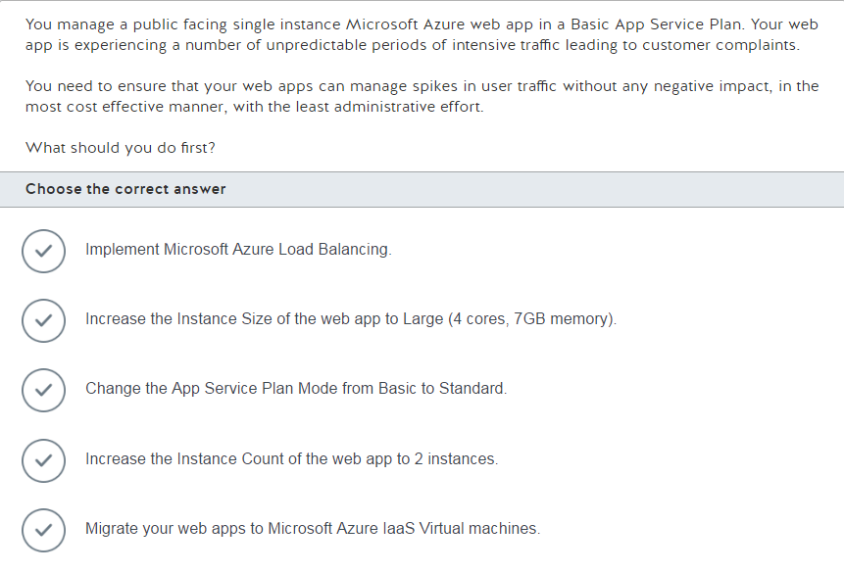

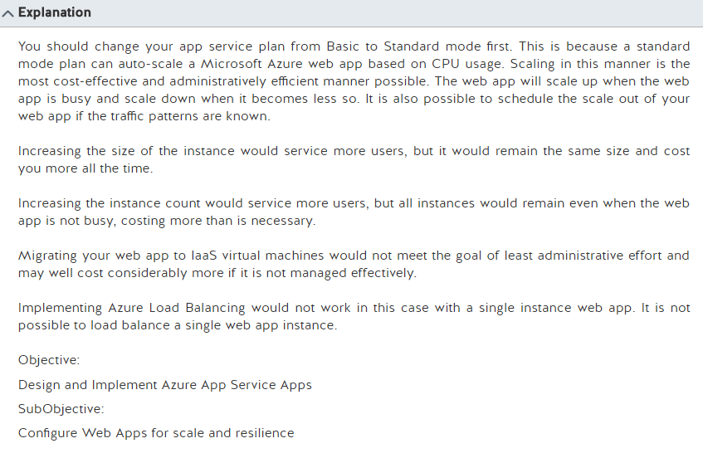

Scale up an app in Azure

From <<https://docs.microsoft.com/en-us/azure/app-service-web/web-sites-scale>>

Friday, February 24, 2017

2:46 PM

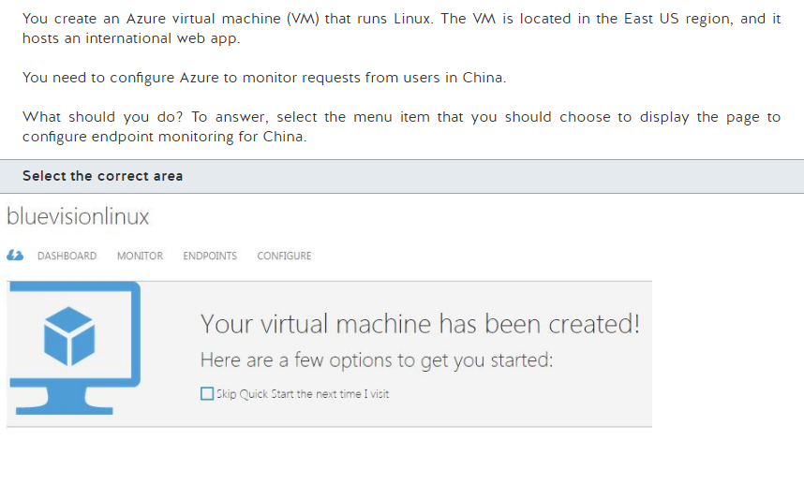

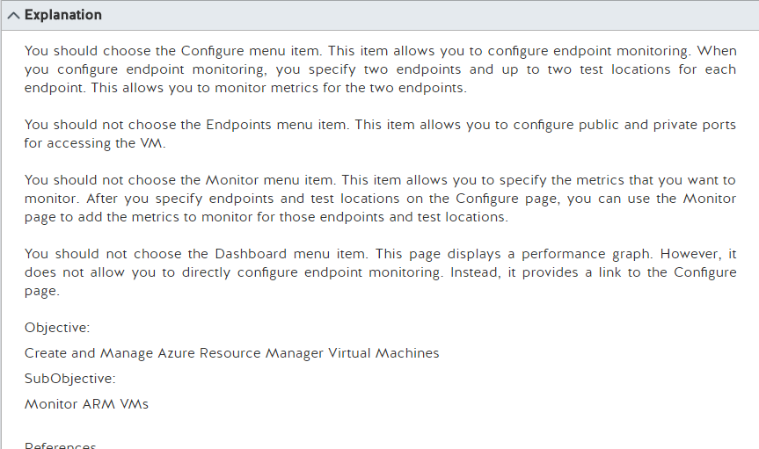

How to set up endpoints on a classic Windows virtual machine in Azure

From <<https://docs.microsoft.com/en-us/azure/virtual-machines/virtual-machines-windows-classic-setup-endpoints?toc=%2fazure%2fvirtual-machines%2fwindows%2fclassic%2ftoc.json>>

Friday, February 24, 2017

2:48 PM

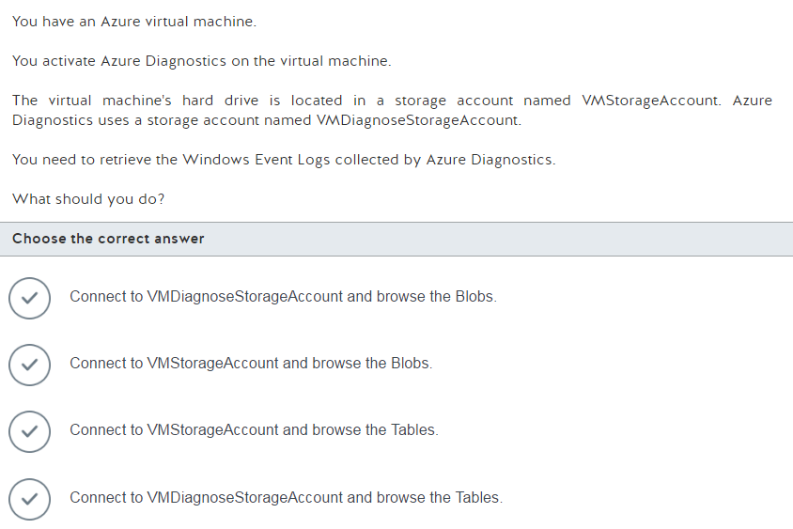

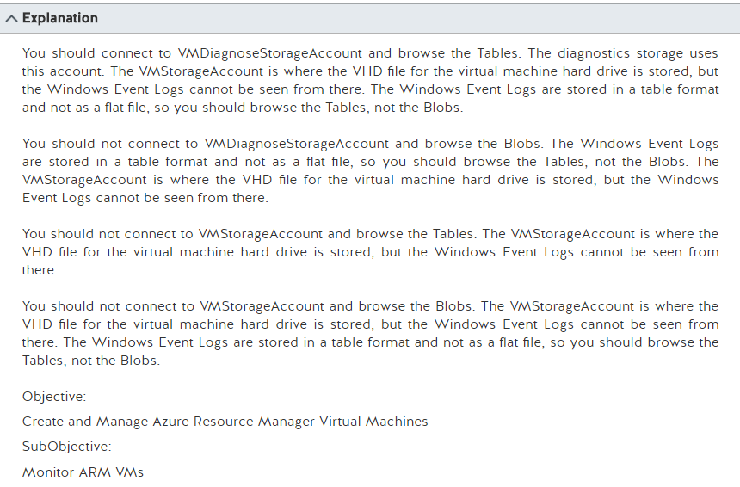

Store and view diagnostic data in Azure Storage

From <<https://docs.microsoft.com/en-us/azure/cloud-services/cloud-services-dotnet-diagnostics-storage>>

Collect logs by using Azure Diagnostics

From <<https://docs.microsoft.com/en-us/azure/service-fabric/service-fabric-diagnostics-how-to-setup-wad>>

Friday, February 24, 2017

2:58 PM

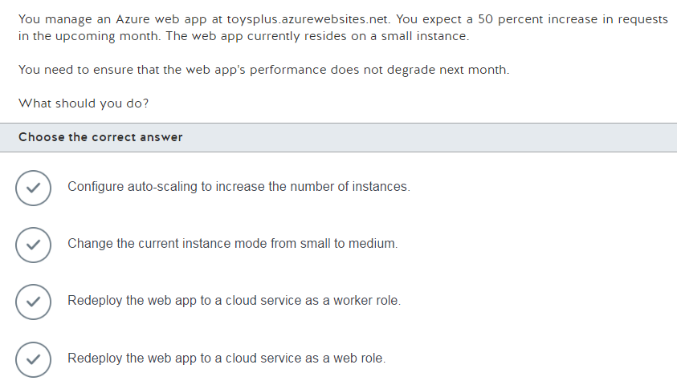

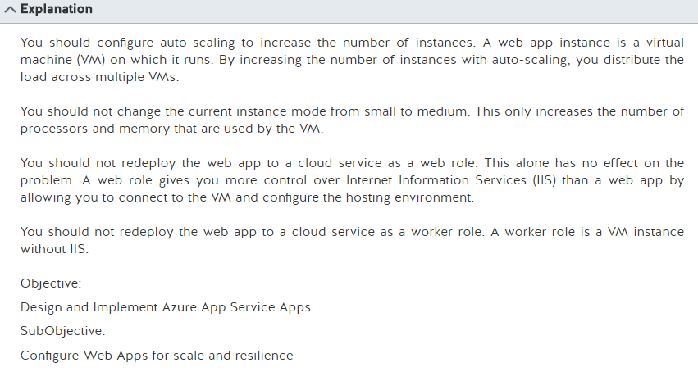

Scale up an app in Azure

From <<https://docs.microsoft.com/en-us/azure/app-service-web/web-sites-scale>>

Friday, February 24, 2017

3:08 PM

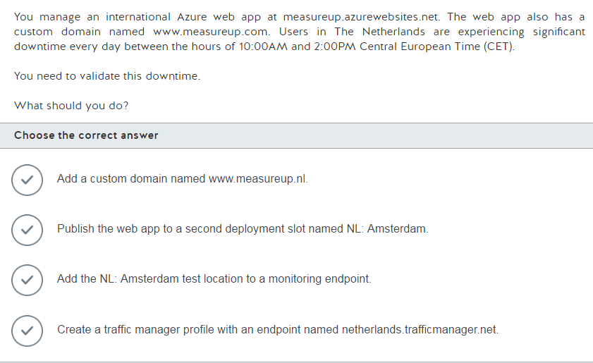

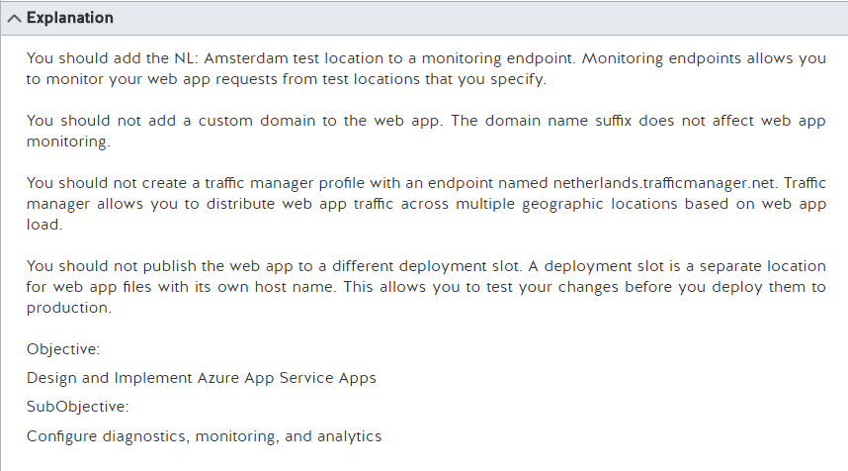

How to: Monitor Apps in Azure App Service

From <<https://docs.microsoft.com/en-us/azure/app-service-web/web-sites-monitor>>

Friday, February 24, 2017

3:11 PM

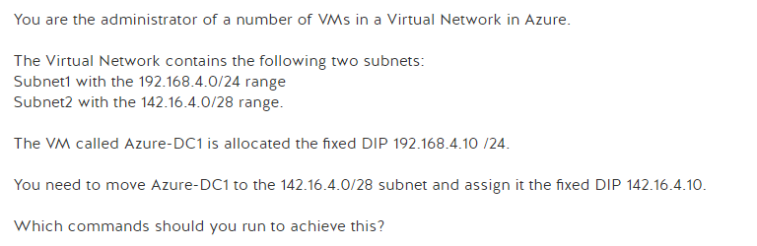

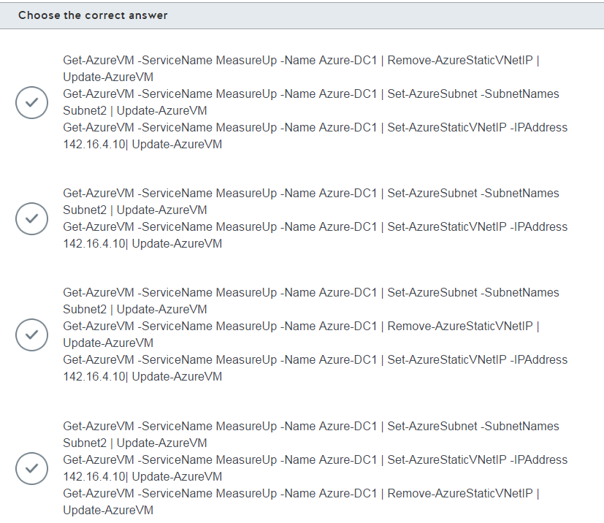

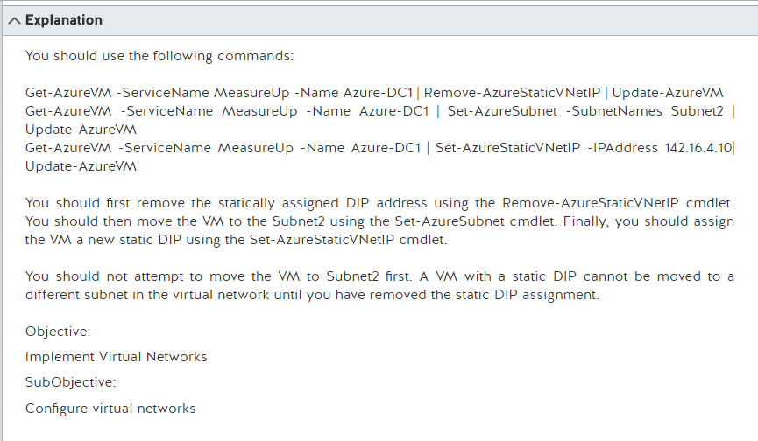

How to move a VM or role instance to a different subnet

From <<https://docs.microsoft.com/en-us/azure/virtual-network/virtual-networks-move-vm-role-to-subnet>>

How to set a static internal private IP address using PowerShell (Classic)

From <<https://docs.microsoft.com/en-us/azure/virtual-network/virtual-networks-reserved-private-ip>>

Friday, February 24, 2017

3:13 PM

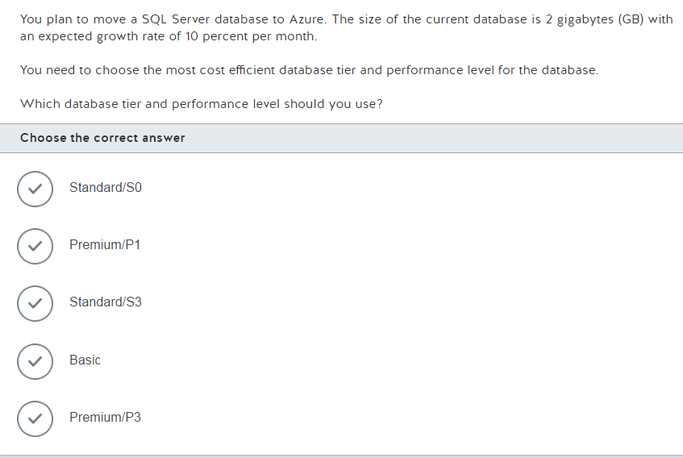

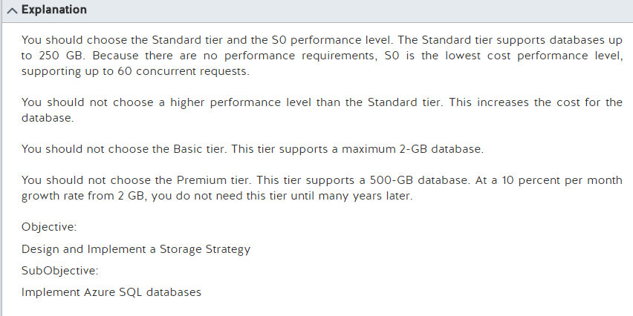

SQL Database options and performance: Understand what's available in each service tier

From <<https://docs.microsoft.com/en-us/azure/sql-database/sql-database-service-tiers>>

Friday, February 24, 2017

3:17 PM

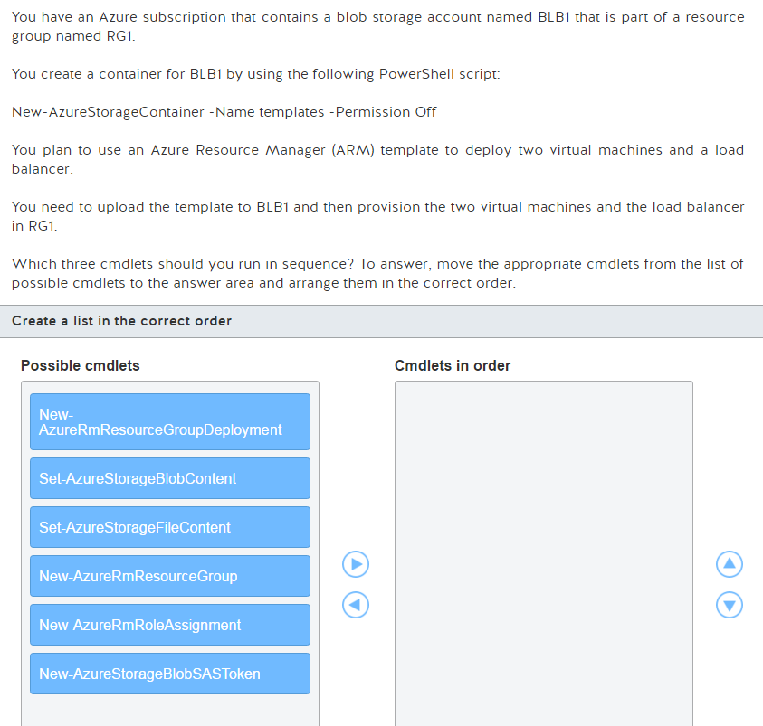

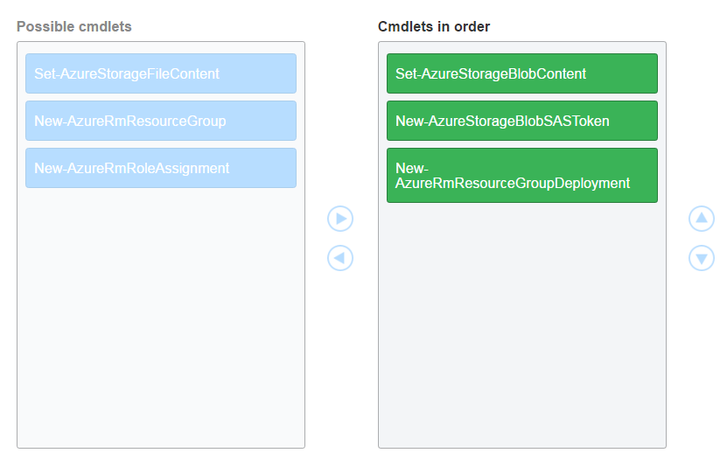

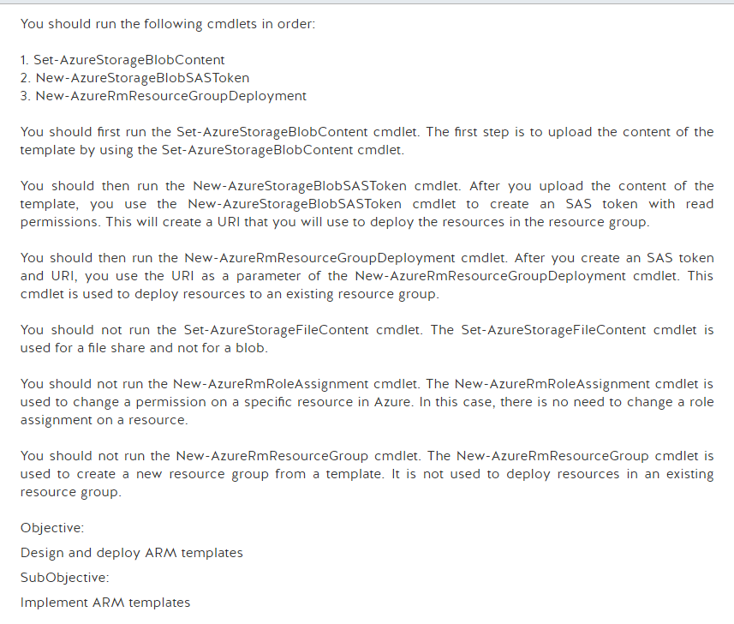

[azure-docs](https://github.com/Microsoft/azure-docs)/[articles](https://github.com/Microsoft/azure-docs/tree/master/articles)/resource-group-template-deploy.md

From <<https://github.com/Microsoft/azure-docs/blob/master/articles/resource-group-template-deploy.md>>

Get started with Azure File storage on Windows

From <<https://docs.microsoft.com/en-us/azure/storage/storage-dotnet-how-to-use-files>>

Manage Role-Based Access Control with Azure PowerShell

From <<https://docs.microsoft.com/en-us/azure/active-directory/role-based-access-control-manage-access-powershell>>

Week of 27 FEb

Monday, February 27, 2017

3:05 PM

Monday, February 27, 2017

3:05 PM

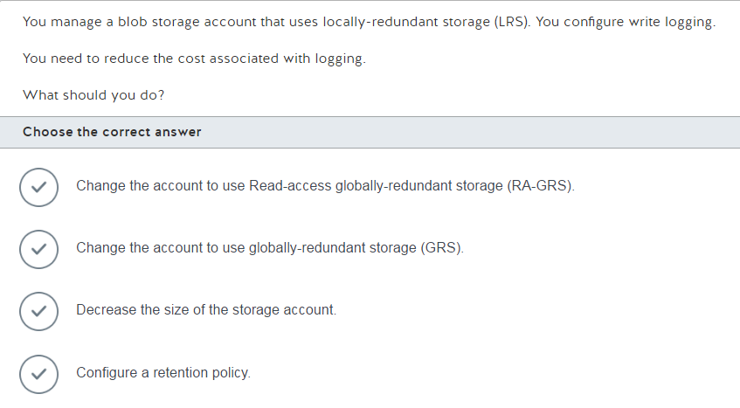

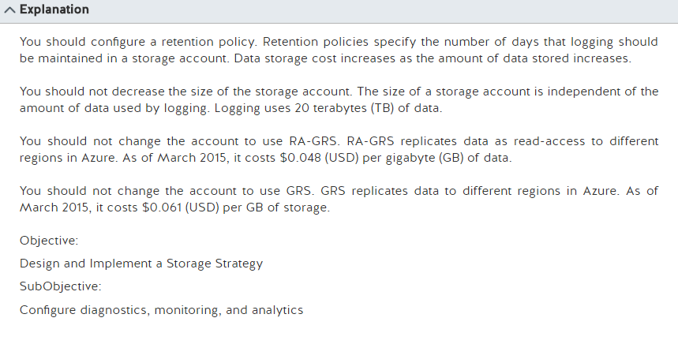

Storage Analytics and Billing

From <<https://docs.microsoft.com/en-us/rest/api/storageservices/fileservices/Storage-Analytics-and-Billing?redirectedfrom=MSDN>>

Azure Storage Pricing

From <<https://azure.microsoft.com/en-us/pricing/details/storage/blobs/>>

Monday, February 27, 2017

3:09 PM

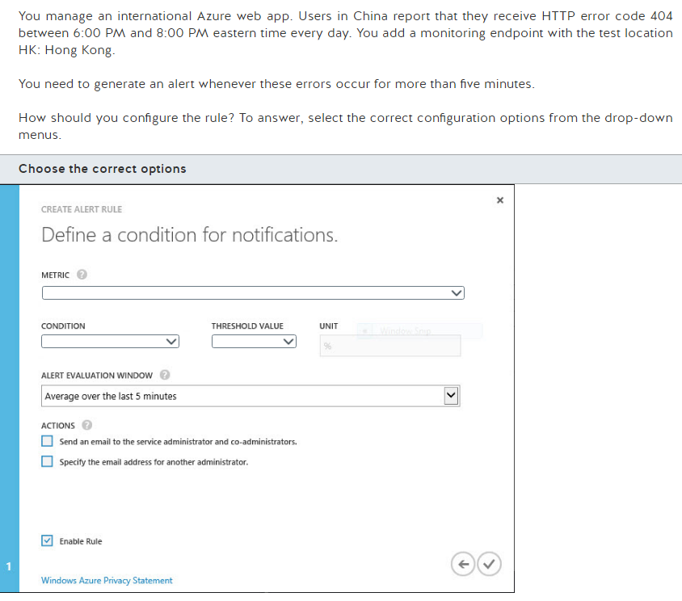

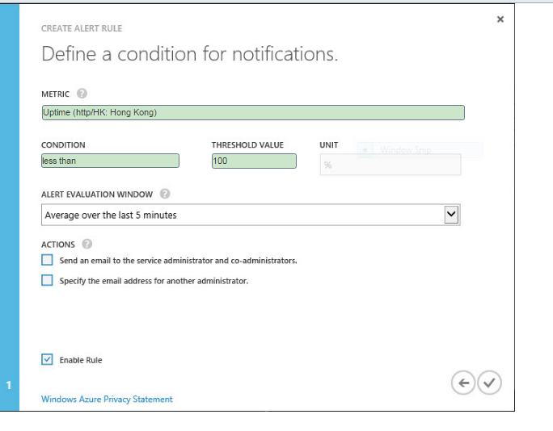

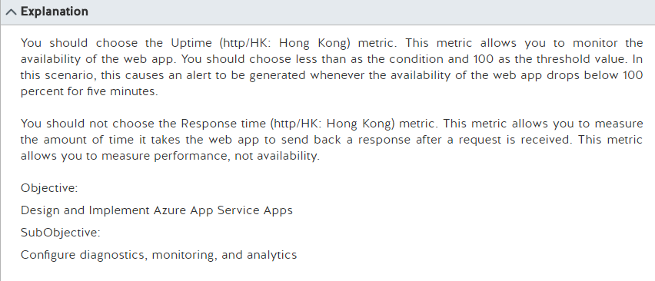

Keeping Azure Web Sites up plus Endpoint Monitoring - with Stefan Schackow

From <<https://azure.microsoft.com/en-us/resources/videos/azure-web-sites-endpoint-monitoring-and-staying-up/>>

How to: Monitor Apps in Azure App Service

From <<https://docs.microsoft.com/en-us/azure/app-service-web/web-sites-monitor>>

Monday, February 27, 2017

3:21 PM

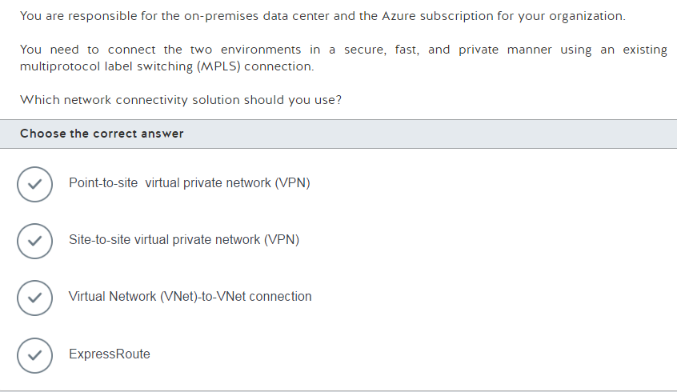

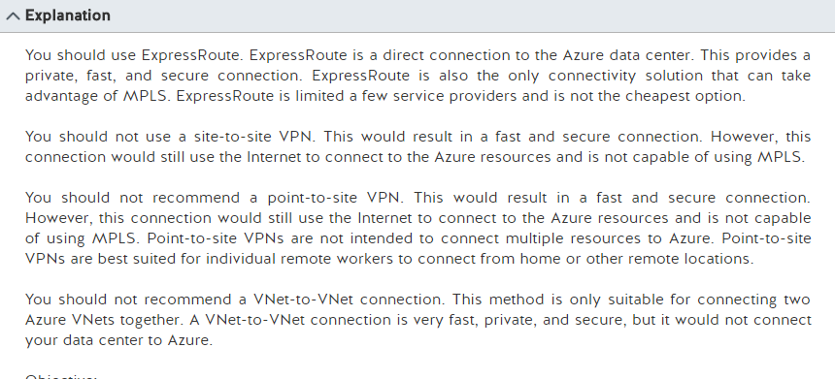

ExpressRoute or Virtual Network VPN – What’s right for me?

From <<https://azure.microsoft.com/en-us/blog/expressroute-or-virtual-network-vpn-whats-right-for-me/>>

Monday, February 27, 2017

3:29 PM

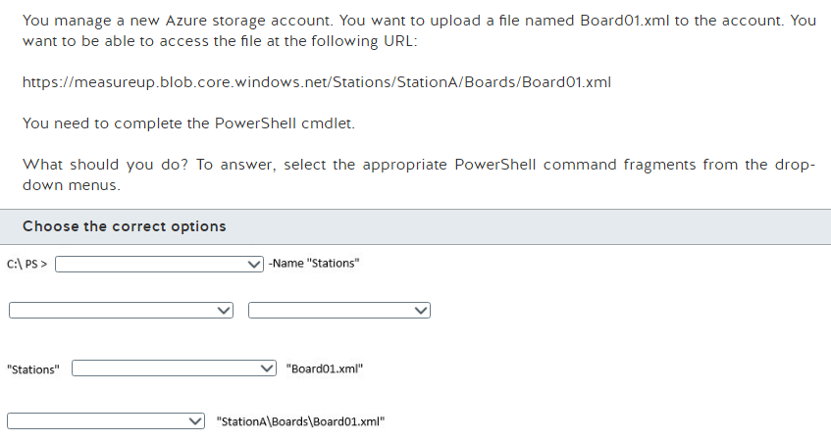

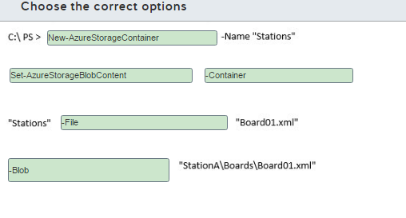

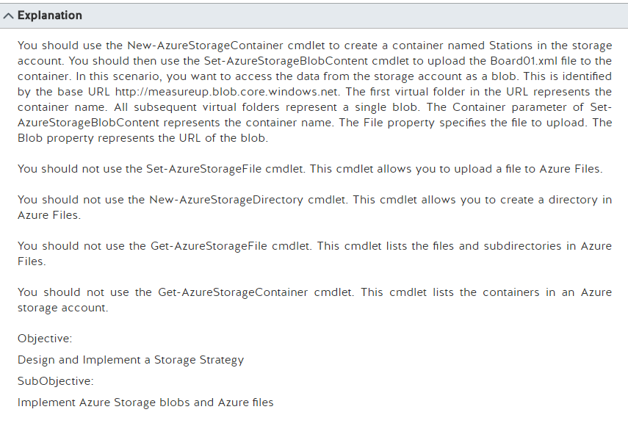

Introduction to Microsoft Azure Storage

From <<https://docs.microsoft.com/en-us/azure/storage/storage-introduction>>

Azure.Storage Module

From <<https://docs.microsoft.com/en-us/powershell/storage/azure.storage/v2.1.0/azure.storage?redirectedfrom=msdn>>

Monday, February 27, 2017

3:37 PM

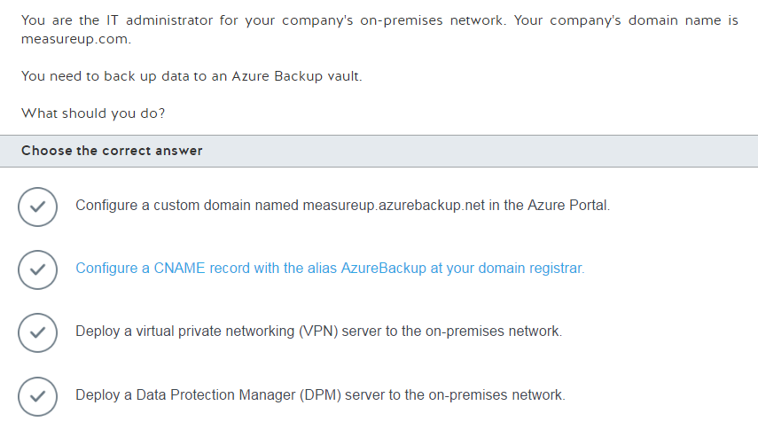

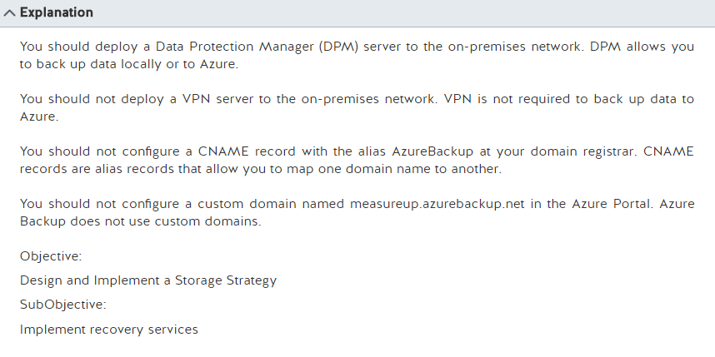

Configure Azure backup for DPM data

From <<https://technet.microsoft.com/en-us/library/jj728752.aspx>>

Monday, February 27, 2017

3:41 PM

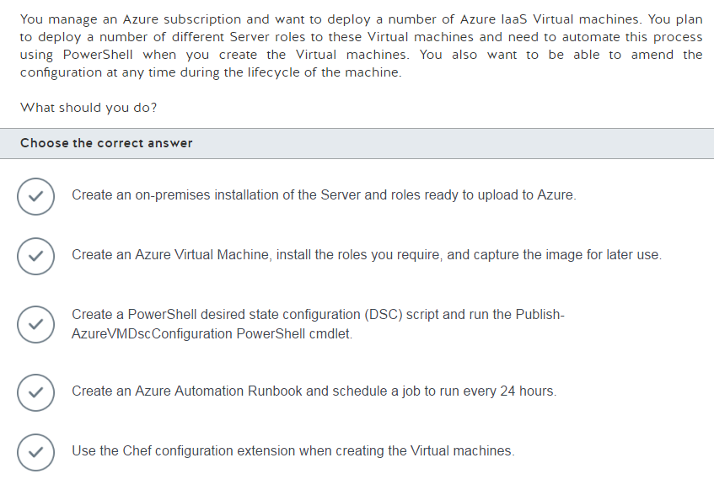

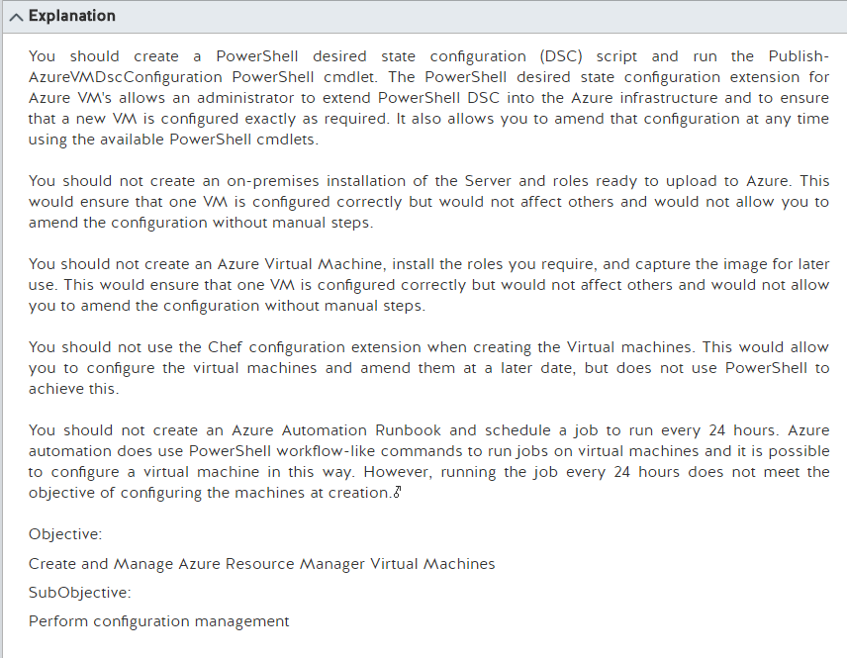

**Azure PowerShell DSC (Desired State Configuration) extension**

From <<https://blogs.msdn.microsoft.com/powershell/2014/08/07/introducing-the-azure-powershell-dsc-desired-state-configuration-extension/>>

Monday, February 27, 2017

3:45 PM

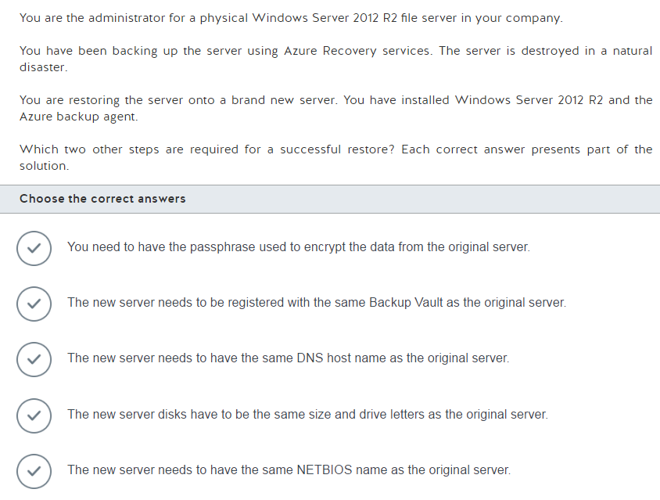

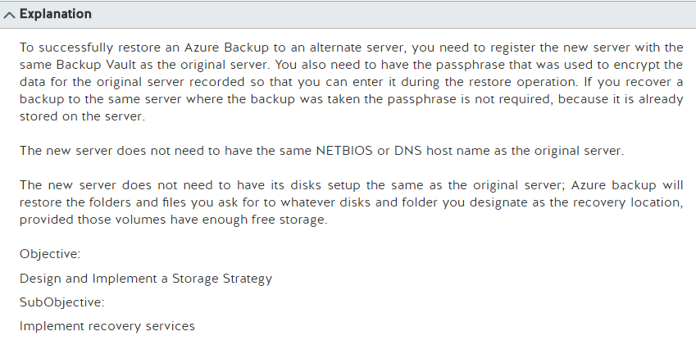

What is Azure Backup?

From <<https://docs.microsoft.com/en-us/azure/backup/backup-introduction-to-azure-backup>>

Using and Monitoring Azure Backup for Windows Server

From <<https://blogs.technet.microsoft.com/hybridcloud/2014/05/08/using-and-monitoring-azure-backup-for-windows-server/>>

Azure Backup service- FAQ

From <<https://docs.microsoft.com/en-us/azure/backup/backup-azure-backup-faq>>

Back up a Windows Server or client to Azure using the Resource Manager deployment model

From <<https://docs.microsoft.com/en-us/azure/backup/backup-configure-vault#BKMK_alternateserverrecovery>>

Tuesday, February 28, 2017

6:15 AM

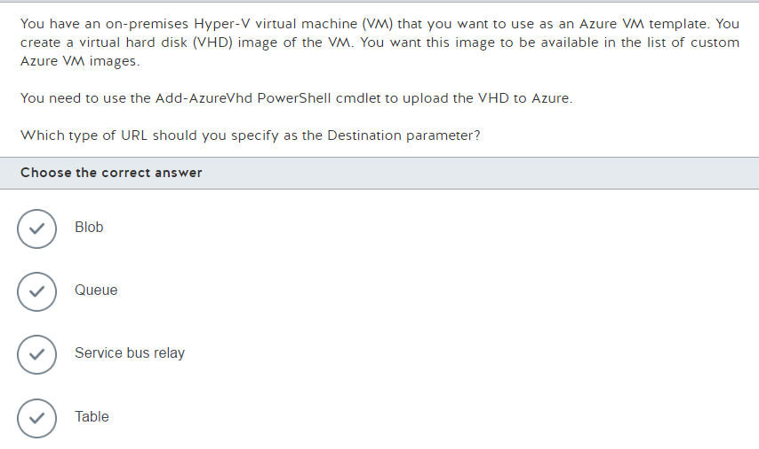

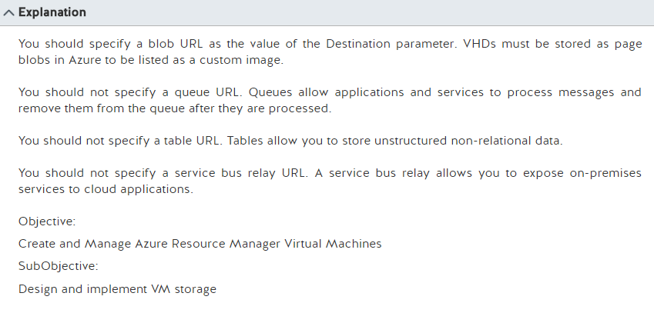

Create and upload a Windows Server VHD to Azure

From <<https://docs.microsoft.com/en-us/azure/virtual-machines/virtual-machines-windows-classic-createupload-vhd?toc=%2fazure%2fvirtual-machines%2fwindows%2fclassic%2ftoc.json>>

Tuesday, February 28, 2017

6:17 AM

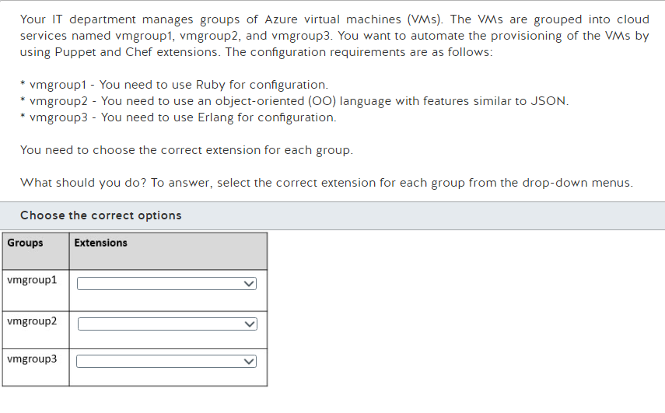

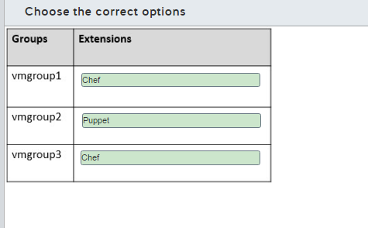

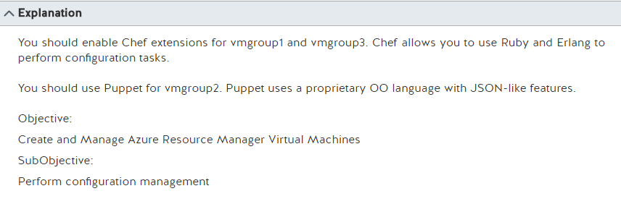

**Puppet or Chef: The configuration management dilemma**

From <<http://www.infoworld.com/article/2614204/data-center/puppet-or-chef--the-configuration-management-dilemma.html>>

Tuesday, February 28, 2017

6:20 AM

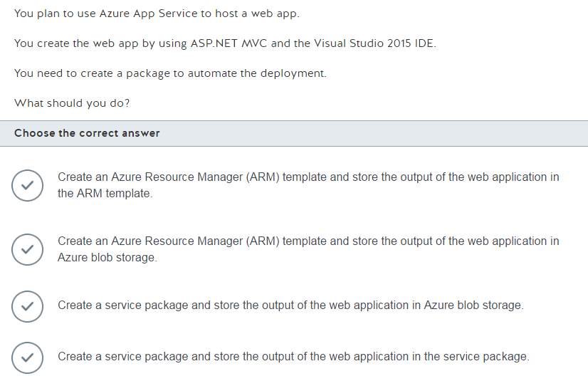

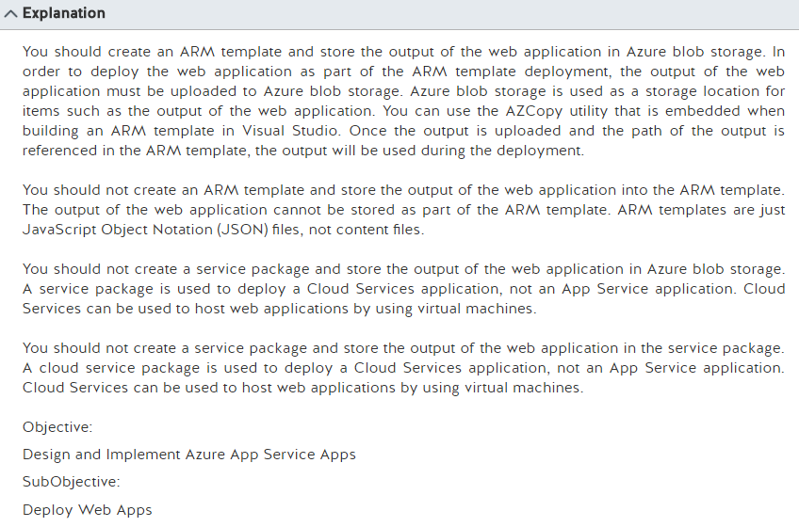

Deploy Azure Web App using ARM Template from Visual Studio 2015

From <<http://blogs.perficient.com/microsoft/2016/03/deploy-azure-web-app-using-arm-template-from-visual-studio-2015/>>

Should I choose cloud services or something else?

From <<https://docs.microsoft.com/en-us/azure/cloud-services/cloud-services-choose-me>>

Authoring Azure Resource Manager templates

From <<https://docs.microsoft.com/en-us/azure/azure-resource-manager/resource-group-authoring-templates>>

Transfer data with the AzCopy Command-Line Utility

From <<https://docs.microsoft.com/en-us/azure/storage/storage-use-azcopy>>

28 Feb

Tuesday, February 28, 2017

6:27 AM

Tuesday, February 28, 2017

6:27 AM

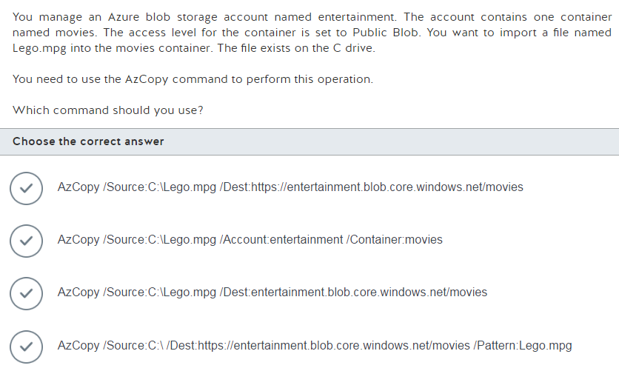

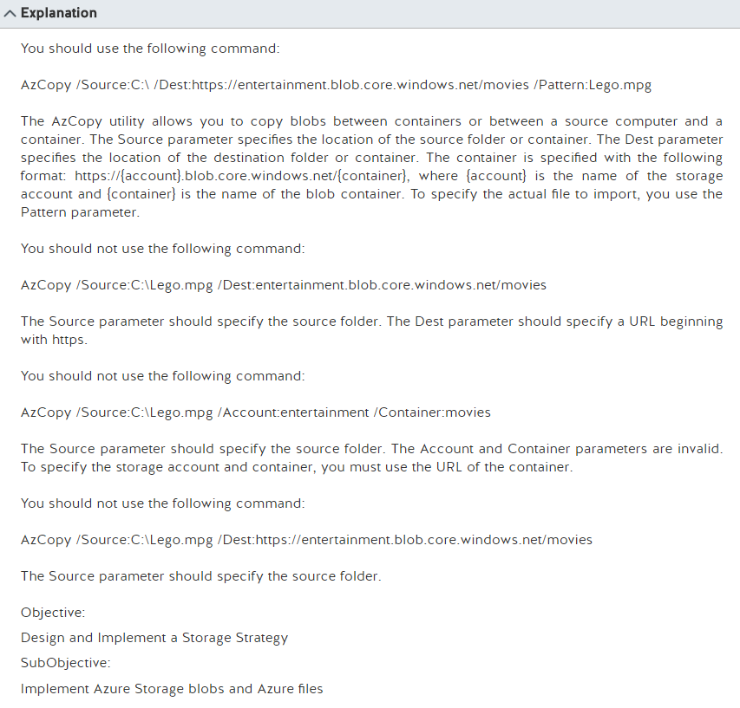

Transfer data with the AzCopy Command-Line Utility

From <<https://docs.microsoft.com/en-us/azure/storage/storage-use-azcopy>>

Tuesday, February 28, 2017

6:36 AM

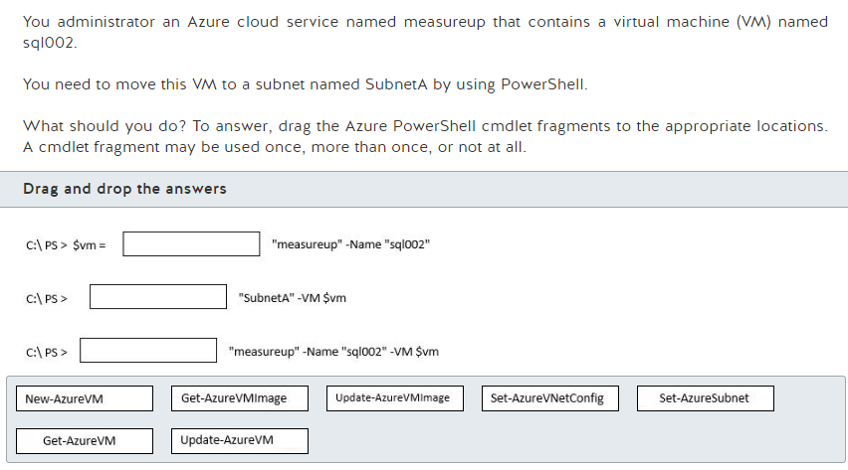

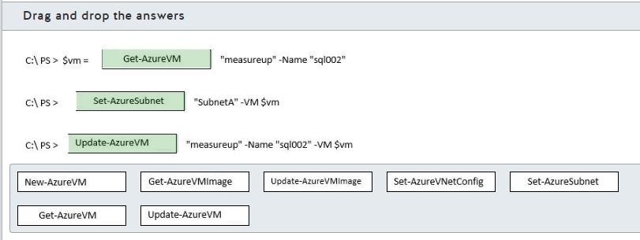

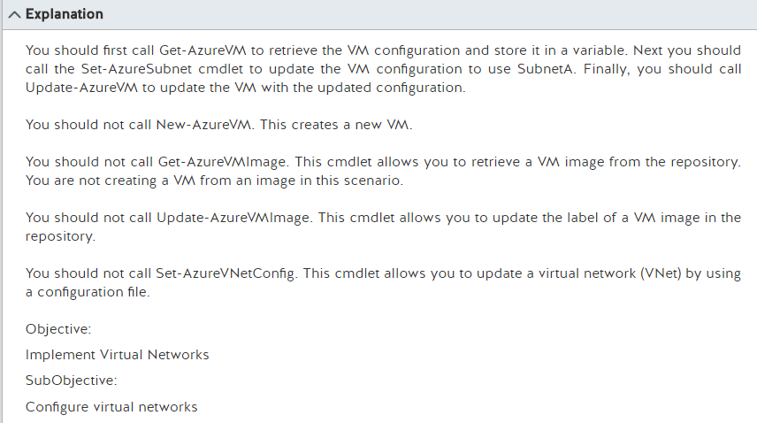

Move a VM (Classic) or Cloud Services role instance to a different subnet using PowerShell

From <<https://docs.microsoft.com/en-us/azure/virtual-network/virtual-networks-move-vm-role-to-subnet>>

Set-AzureSubnet

From <<https://msdn.microsoft.com/en-us/library/azure/dn495213.aspx>>

Tuesday, February 28, 2017

6:43 AM

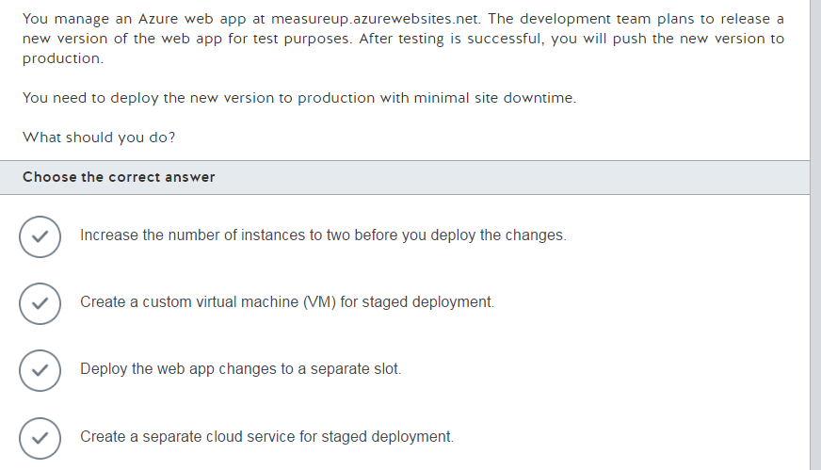

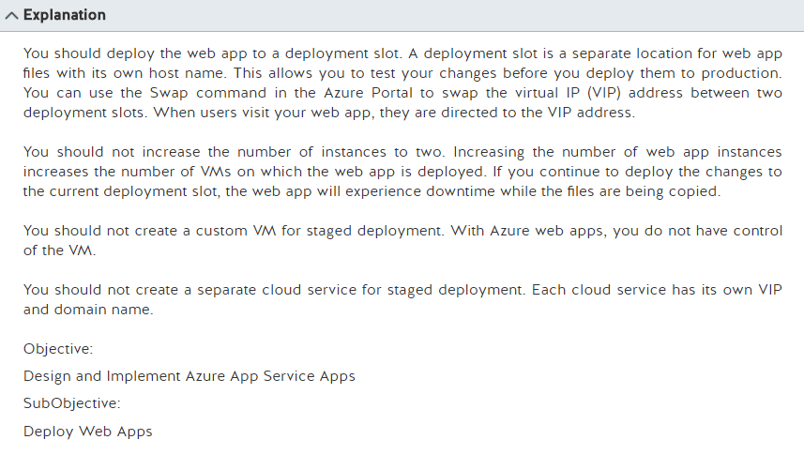

Set up staging environments in Azure App Service

From <<https://docs.microsoft.com/en-us/azure/app-service-web/web-sites-staged-publishing>>

Tuesday, February 28, 2017

6:54 AM

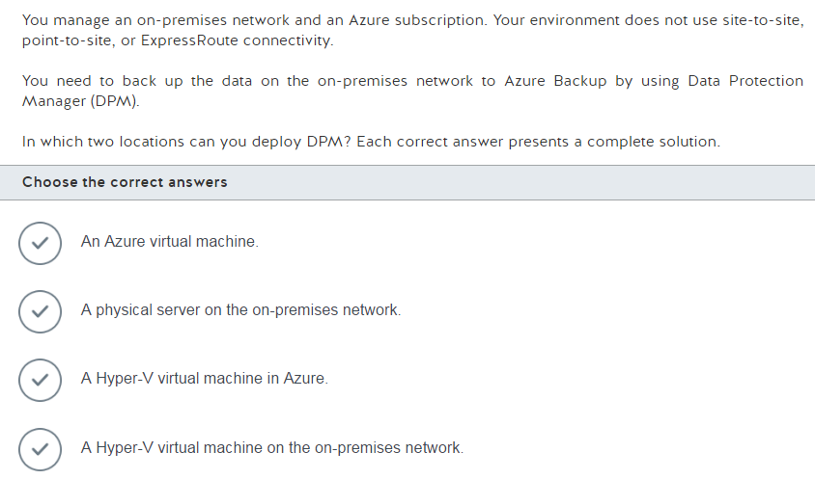

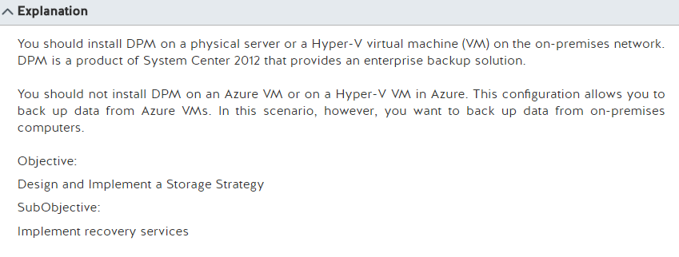

DPM overview

From <<https://technet.microsoft.com/en-us/library/hh758104.aspx>>

Configure Azure backup for DPM data

From <<https://technet.microsoft.com/en-us/library/jj728752.aspx>>

Tuesday, February 28, 2017

6:57 AM

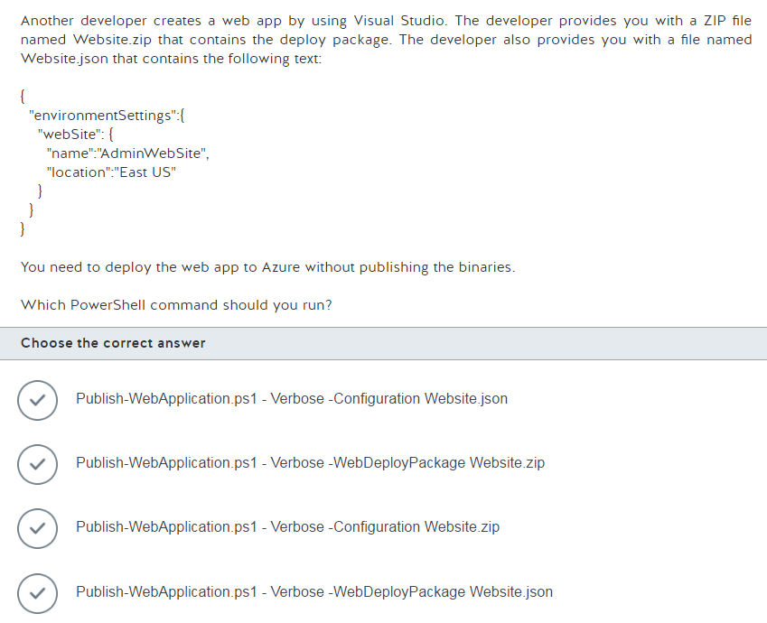

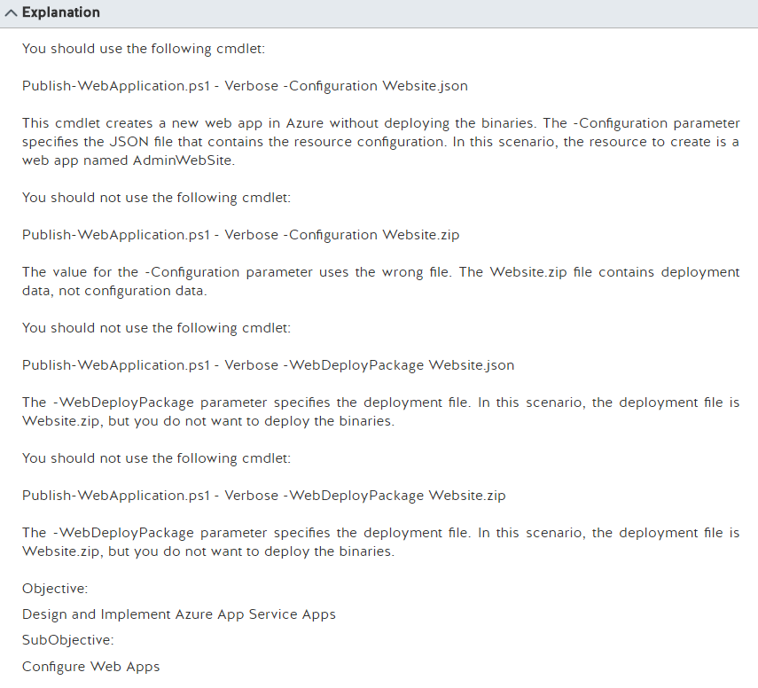

Using Windows PowerShell scripts to publish to dev and test environments

From <<https://docs.microsoft.com/en-us/azure/vs-azure-tools-publishing-using-powershell-scripts>>

Tuesday, February 28, 2017

7:13 AM

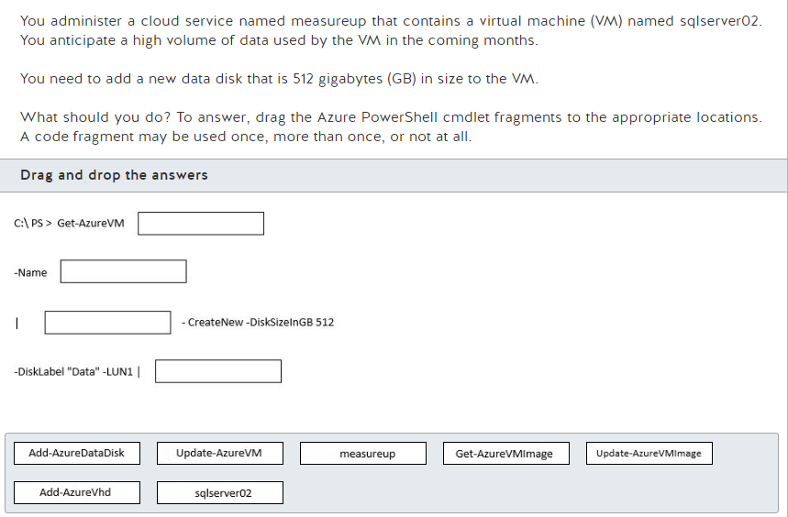

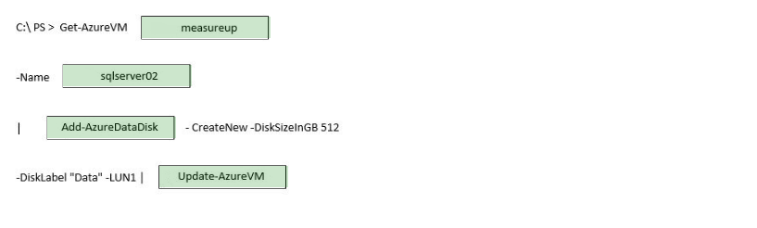

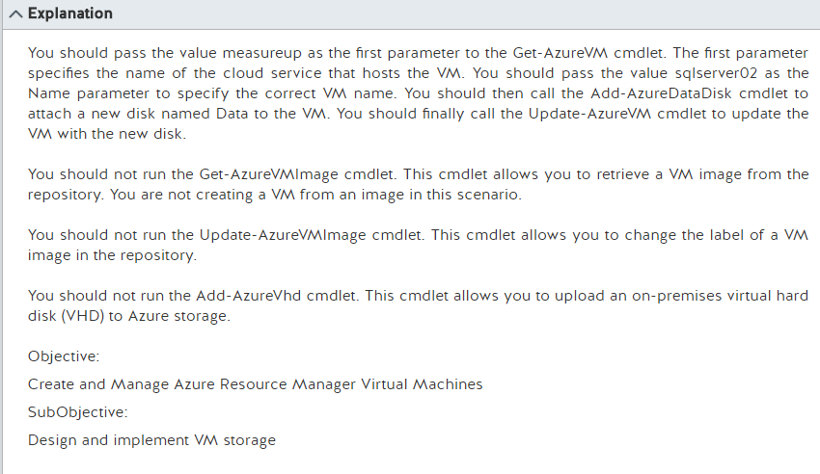

Update a Azure vm using Powershell

From <<https://docs.microsoft.com/en-us/azure/virtual-machines/virtual-machines-windows-ps-manage#update-a-virtual-machine>>

Get started with Azure PowerShell cmdlets

From <<https://docs.microsoft.com/en-us/powershell/>>

Tuesday, February 28, 2017

7:20 AM

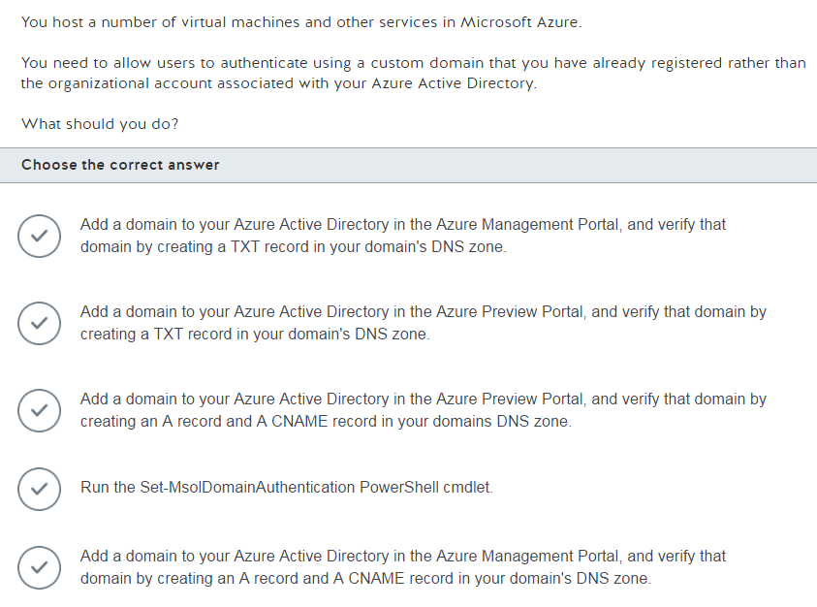

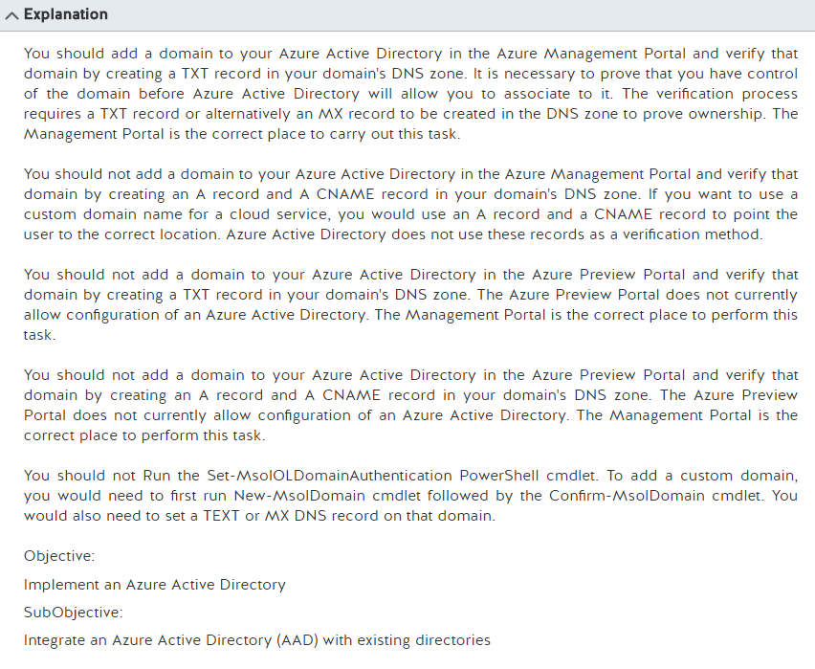

Manage domains in Azure AD

From <<https://msdn.microsoft.com/en-us/library/azure/e1ef403f-3347-4409-8f46-d72dafa116e0>>

Add a custom domain name to Azure Active Directory

From <<https://docs.microsoft.com/en-us/azure/active-directory/active-directory-add-domain>>

Tuesday, February 28, 2017

7:25 AM

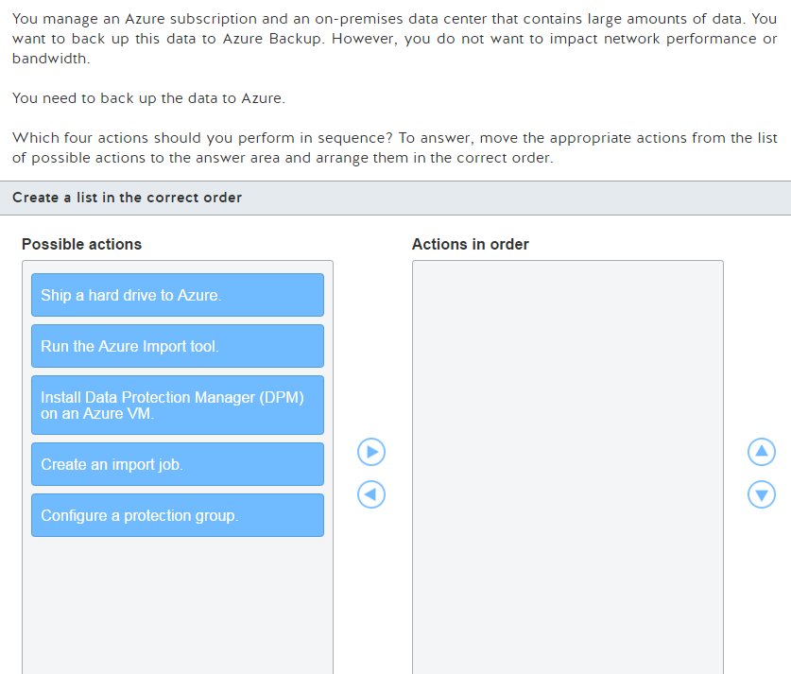

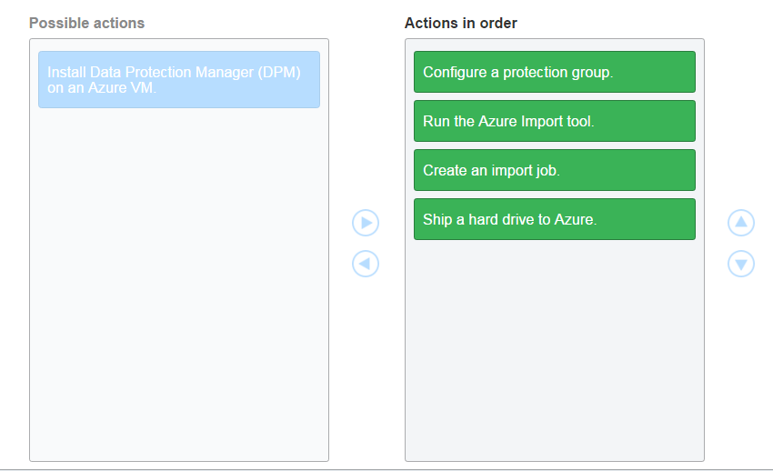

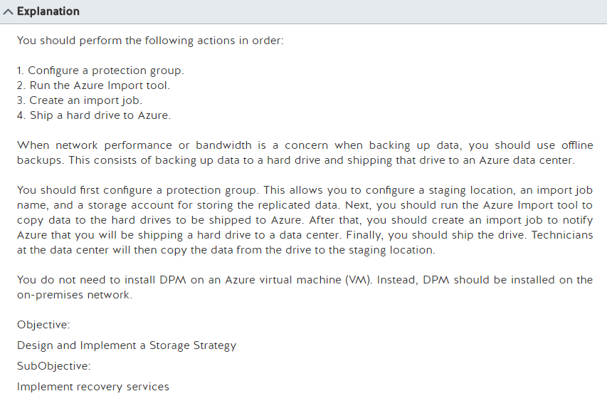

Preparing to back up workloads to Azure with DPM

From <<https://docs.microsoft.com/en-us/azure/backup/backup-azure-dpm-introduction>>

Configure Azure backup for DPM data

From <<https://technet.microsoft.com/en-us/library/jj728752(v=sc.12).aspx>>

Tuesday, February 28, 2017

7:39 AM

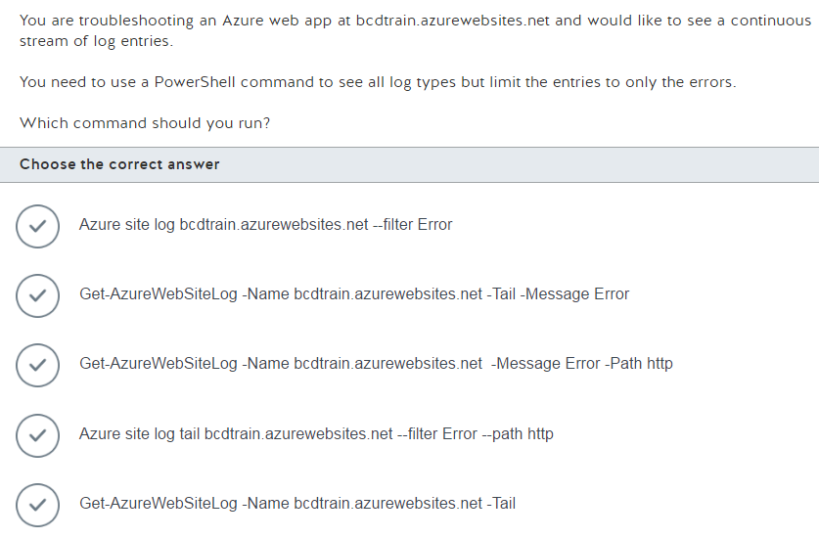

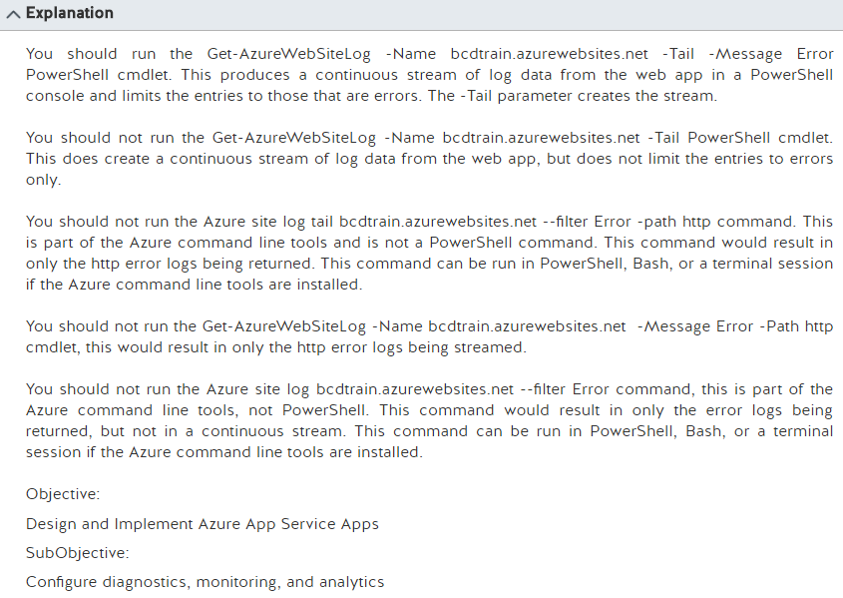

Enable diagnostics logging for web apps in Azure App Service

From <<https://docs.microsoft.com/en-gb/azure/app-service-web/web-sites-enable-diagnostic-log>>

Tuesday, February 28, 2017

1:21 PM

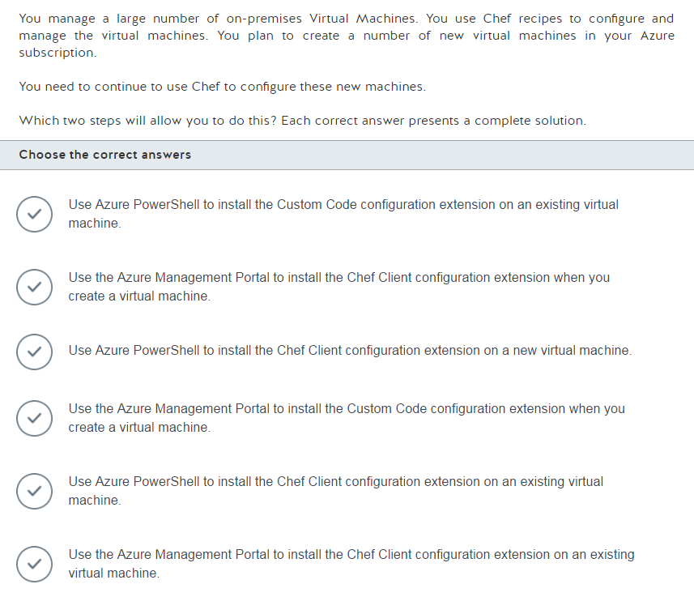

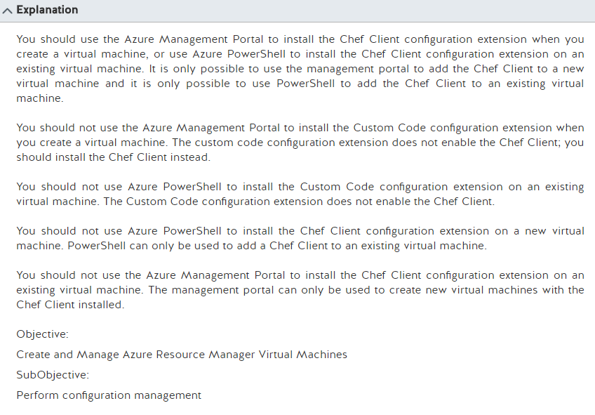

Virtual machine extensions and features for Windows

From <<https://docs.microsoft.com/en-gb/azure/virtual-machines/virtual-machines-windows-extensions-features?toc=%2fazure%2fvirtual-machines%2fwindows%2ftoc.json>>

Tuesday, February 28, 2017

2:00 PM

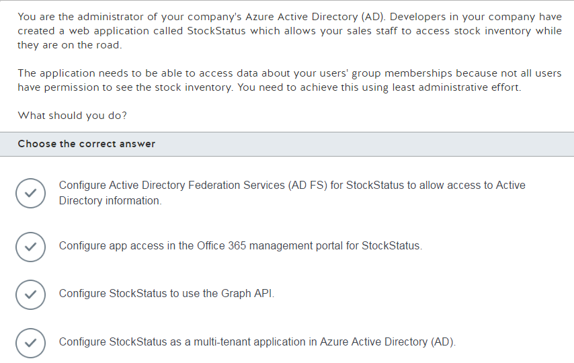

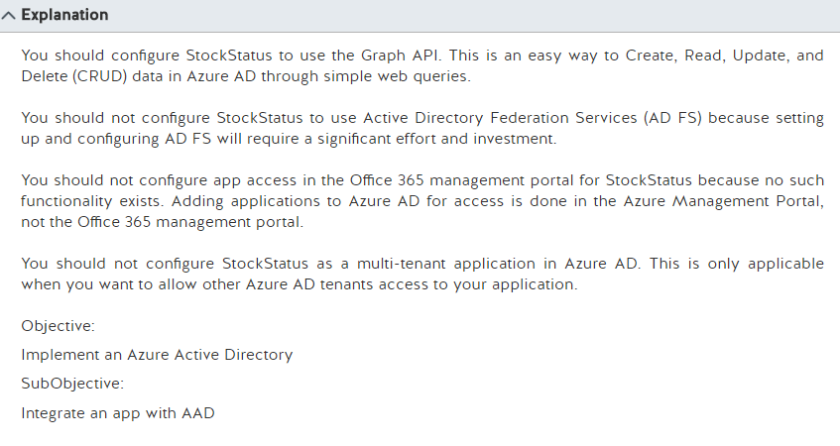

Integrating applications with Azure Active Directory

From <<https://docs.microsoft.com/en-us/azure/active-directory/develop/active-directory-integrating-applications>>

Active Directory Graph API REST

From <<https://msdn.microsoft.com/en-us/library/azure/hh974476.aspx>>

Tuesday, February 28, 2017

2:03 PM

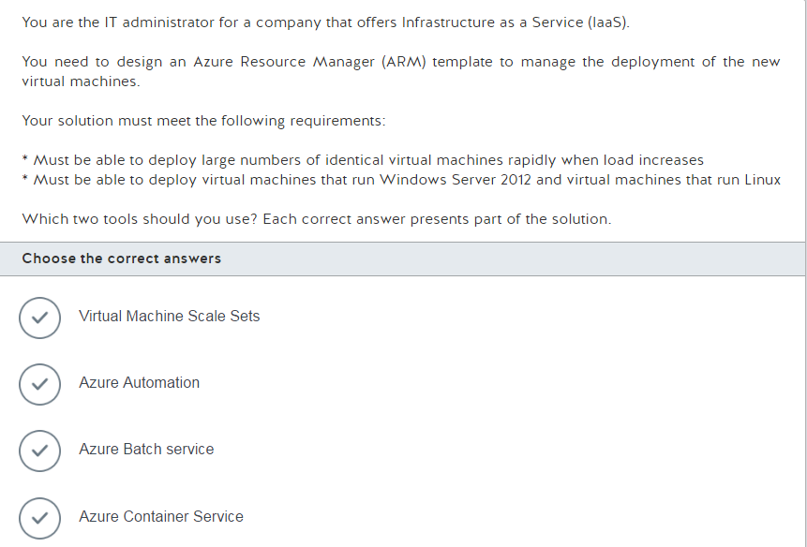

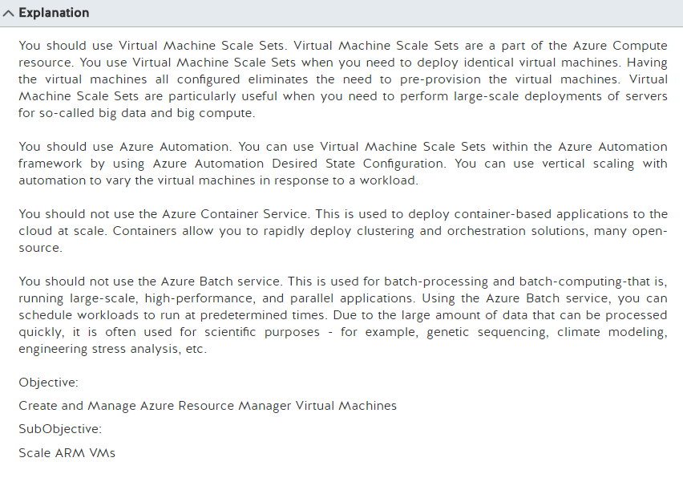

Vertical autoscale with Virtual Machine Scale sets

From <<https://docs.microsoft.com/en-us/azure/virtual-machine-scale-sets/virtual-machine-scale-sets-vertical-scale-reprovision>>

VM Scale Set Configuration managed by Azure Automation

From <<https://azure.microsoft.com/en-us/resources/templates/201-vmss-automation-dsc/>>

Deploy an Azure Container Service cluster

From <<https://docs.microsoft.com/en-us/azure/container-service/container-service-deployment>>

Run intrinsically parallel workloads with Batch

From <<https://docs.microsoft.com/en-us/azure/batch/batch-technical-overview>>

Tuesday, February 28, 2017

2:07 PM

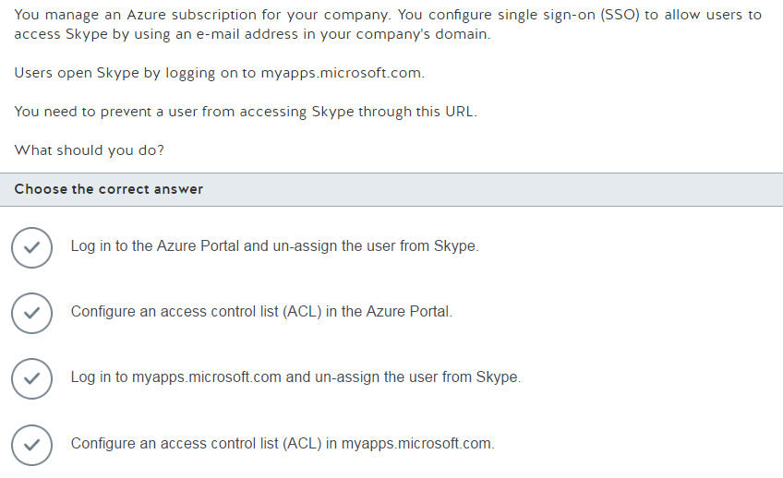

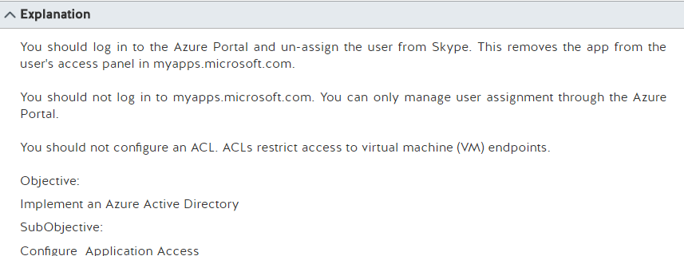

Introduction to the Access Panel

From <<https://docs.microsoft.com/en-us/azure/active-directory/active-directory-saas-access-panel-introduction>>

Using the Access Panel

From <<https://msdn.microsoft.com/en-us/library/azure/dn756411.aspx>>

Tuesday, February 28, 2017

2:15 PM

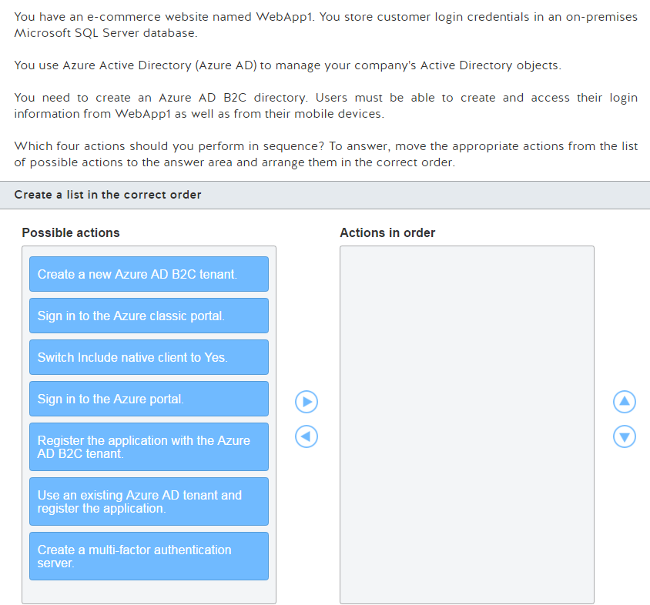

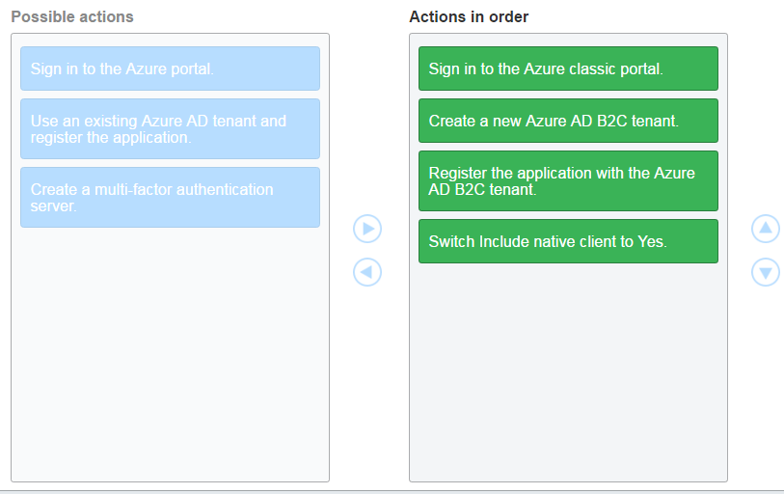

![Machine generated alternative text:
Explanation 
You should perform the following actions in order: 
I Sign in to the Azure classic pc—.al 
2 Create a new Azure AD B2C tenant. 
3. Register the application with the Azure AD B2C tenant. 
Switch Include native client to Yes. 
You should sign into the Azure classic portal. The Azure AD B2C directory is created by using the Azure 
classic portal at manage.windowsazure_com_ 
You should create new Azure AD B2C tenant After vou sign in to the Azure classic portal, you create a 
new tenant You cannot use an existing Azure AD tenant in your organization as an Azure AD B2C tenant. 
You should register the application with the Azure AD B2C tenant. After ycw create the new Azure AD B2C 
tenant, you can register the application. 
You should switch Include native client to Yes. After ycw register the application, if ycw are going to have 
mobile devices access your AD B2C tenant, then you must have the Include native client switch set to Yes. 
The Azure AD B2C directory is cloud identity management service that is meant to public facing and is 
meant to be used by customers who want to access web or mobile applications. Users can also use 
existing social media accounts such as Facebook end Linkedln to sign up for your application. 
You should not use an existing Azure AD tenant and register the application. You need to create a new Azure 
AD tenant and then implement the Azure AD B2C inside of the new tenant. 
You should not sign in to the Azure por.al at Creating a new Azure AD B2C tenant is 
currently only supported in the Azure classic portal at manage.windowsazure.com, not in the Azure portal 
at portal.azure.com. 
You should not create a multi-factor authentication server. Multi-factor authentication is an additional level 
of security provided by some highly-secure sites. An example of multi-factor authentication is when ycw 
change password at banking website, and the website sends vou text verification message on your 
phone that ycw must enter to proceed. is not applicable in this scenario. 
Objective: 
Implement an Azure Active Directory 
SubObjective: 
Implement AAD B2C and AAD B2B ](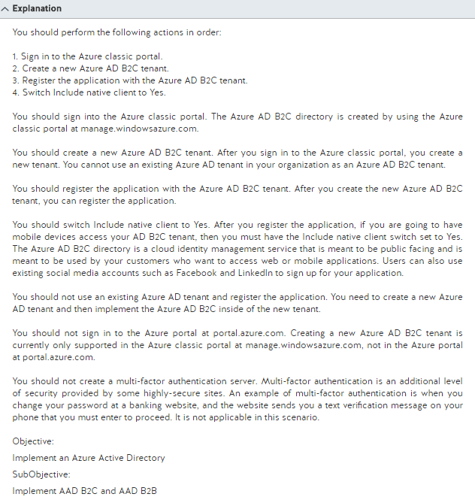)

Azure Active Directory B2C: Create an Azure AD B2C tenant

From <<https://docs.microsoft.com/en-us/azure/active-directory-b2c/active-directory-b2c-get-started>>

Azure Active Directory B2C: Register your application

From <<https://docs.microsoft.com/en-us/azure/active-directory-b2c/active-directory-b2c-app-registration>>

What is Azure Multi-Factor Authentication?

From <<https://docs.microsoft.com/en-us/azure/multi-factor-authentication/multi-factor-authentication>>

Tuesday, February 28, 2017

2:38 PM

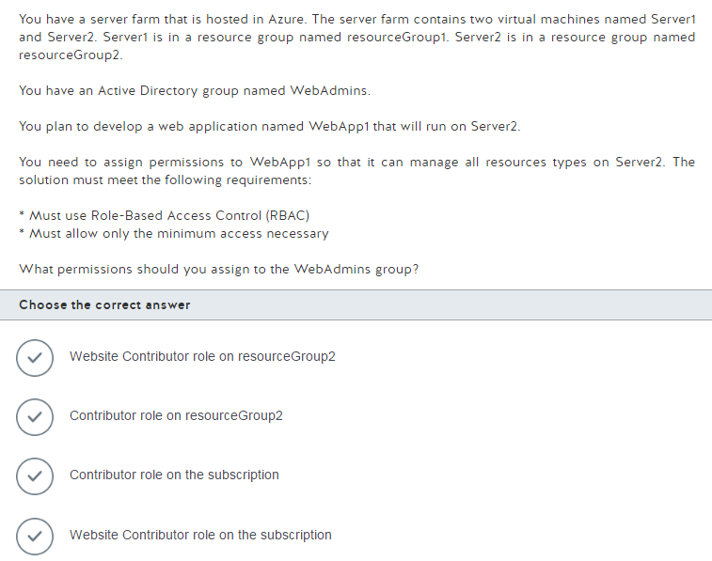

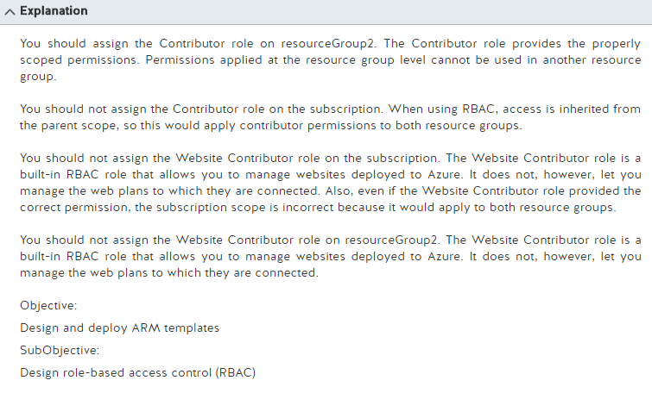

Built-in roles for Azure Role-Based Access Control

From <<https://docs.microsoft.com/en-us/azure/active-directory/role-based-access-built-in-roles>>

Create custom roles for Azure Role-Based Access Control

From <<https://docs.microsoft.com/en-us/azure/active-directory/role-based-access-control-custom-roles>>

Tuesday, February 28, 2017

2:40 PM

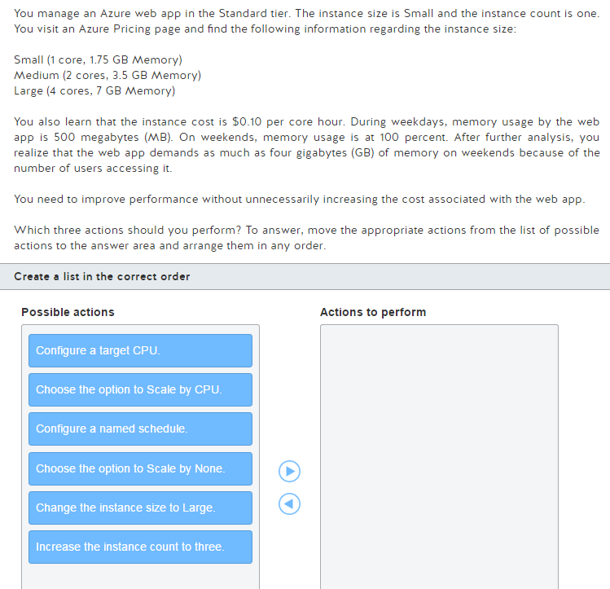

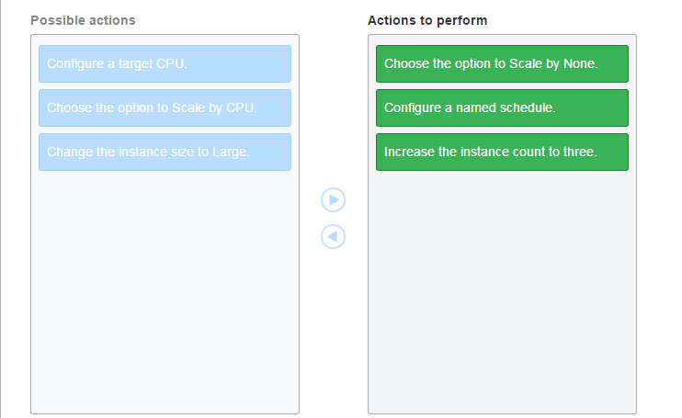

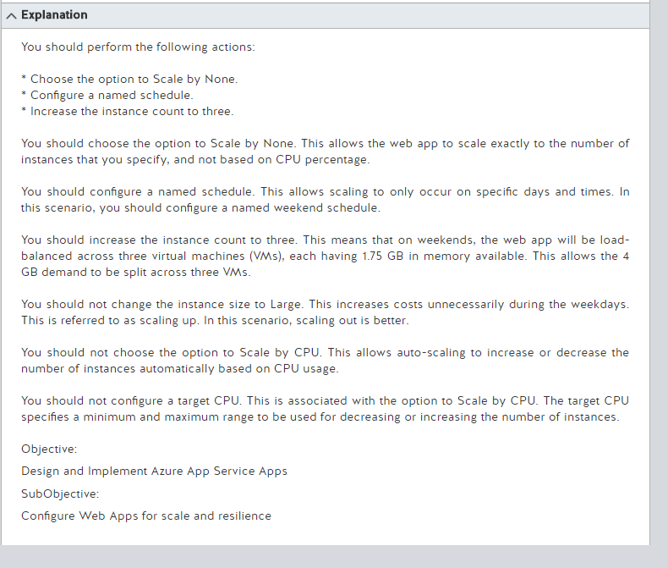

Auto Scaling Azure Web Sites, CPU or Scheduled - with Stefan Schackow

Web Sites can auto-scale either on

From <<https://azure.microsoft.com/en-us/resources/videos/auto-scaling-azure-web-sites/>>

Scale up an app in Azure

From <<https://docs.microsoft.com/en-us/azure/app-service-web/web-sites-scale>>

Tuesday, February 28, 2017

2:45 PM

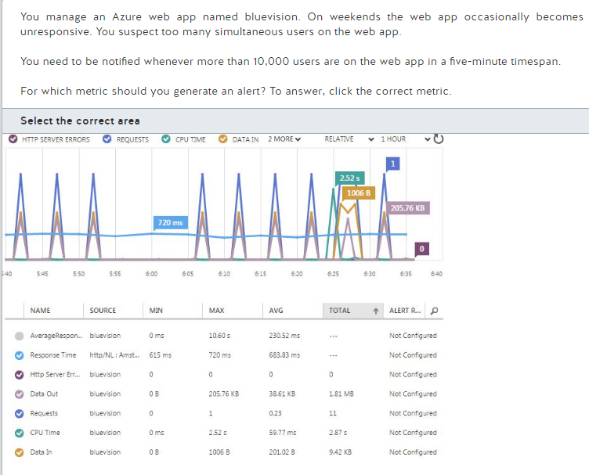

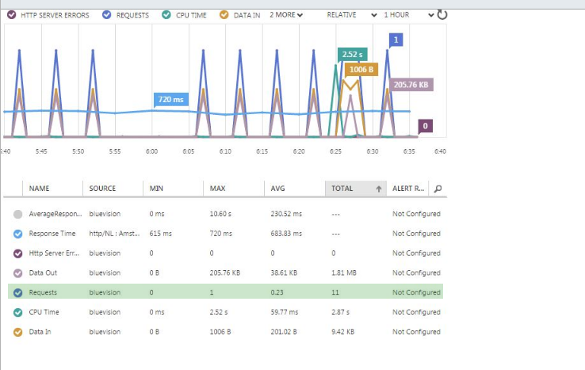

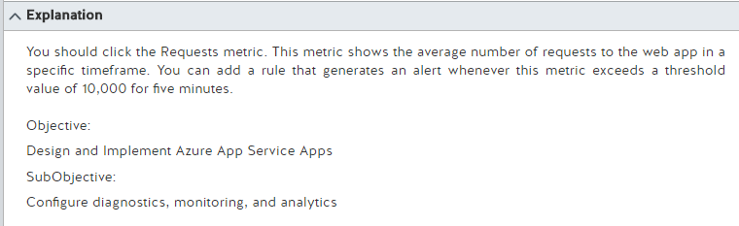

How to: Monitor Apps in Azure App Service

From <<https://docs.microsoft.com/en-us/azure/app-service-web/web-sites-monitor>>

**Measuring all the things with Azure Web Sites and friends**

From <<https://www.troyhunt.com/measuring-all-things-with-azure-web/>>

Tuesday, February 28, 2017

2:52 PM

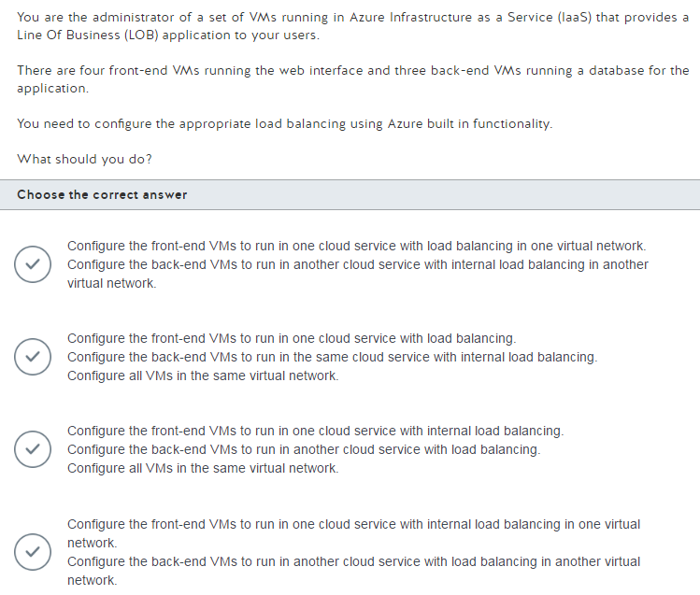

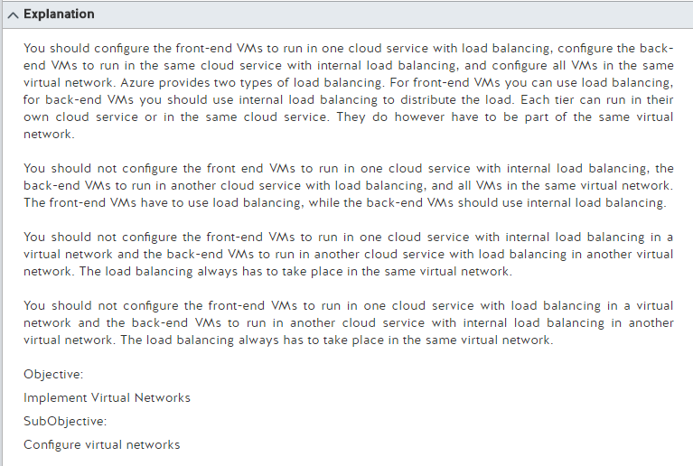

Internal load balancer overview

From <<https://docs.microsoft.com/en-us/azure/load-balancer/load-balancer-internal-overview>>

Create an internal load balancer using PowerShell

From <<https://docs.microsoft.com/en-us/azure/load-balancer/load-balancer-get-started-ilb-arm-ps>>

Azure Load Balancer overview

From <<https://docs.microsoft.com/en-us/azure/load-balancer/load-balancer-overview>>

Tuesday, February 28, 2017

2:57 PM

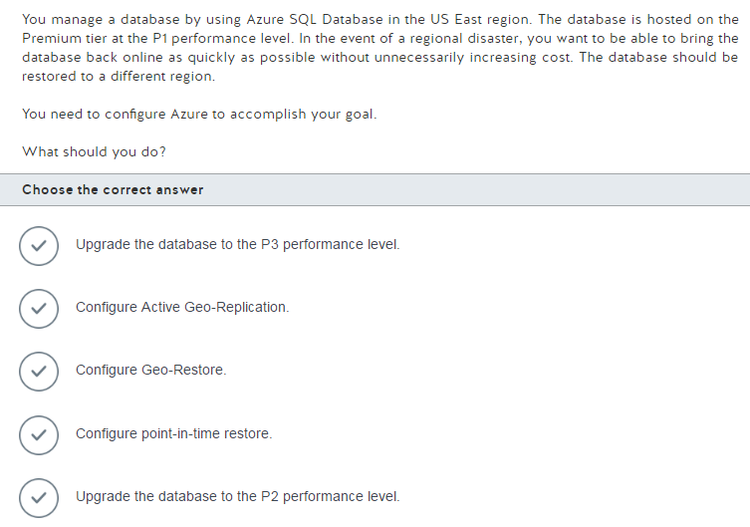

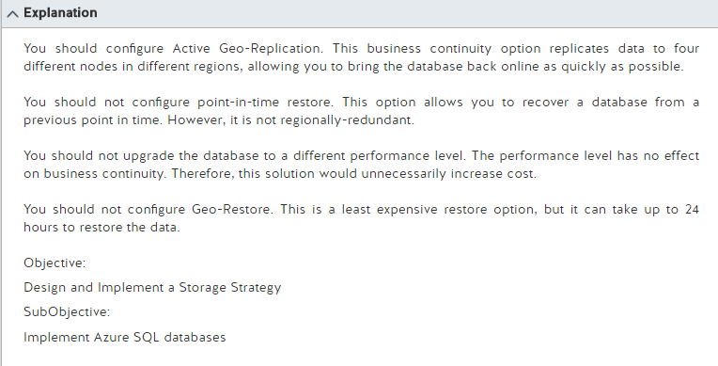

Overview of business continuity with Azure SQL Database

From <<https://docs.microsoft.com/en-us/azure/sql-database/sql-database-business-continuity>>